|  |  |  |
| --- | --- | --- |
| Volume 03  ***This is your committee*** | Edition D25 | September 2013 |

***Geoff Linck - Parker - President***

***Bert Bowden - V/President***

***Ted Newton - Treasurer***

***Gail Staniland – Assistant Treasurer***

***Delwyn Linck- Parker – Secretary***

***Ken McCulloch – Providore***

***Margie Webber - Co-Providore***

***Julie McCulloch – Newsletter Editor***

***Maureen Miller – Clogging Rep***

***Glenn Wilson - Caller***

***Rod Dinte - Co-Caller***

*The “committee” is working hard to make our club the very best it can be, “Please help us”, - by making suggestions, on how to make it even better! This is your club how would you like it to be run?*

**Something to think about! ;** As we are now in the later part of the square dancing year and the time is fast approaching where we will be calling on nominations for the committee for 2014.

 I encourage each and every one of our members to seriously consider nominating for a position on the committee so our club can keep providing the dancing we all enjoy.

Most of the present committee has held office for a number of years and some will not be standing for election for the coming year. As our club is a committee run club we need a functioning committee to maintain a functioning club.

Geoff Linck-Parker - President

**Dates to Remember;**

**22nd Sept** -Car Observation Run

**27th-29th Sept-33rd** Qld State Square Dance Convention venue: Ferny Hills

**29th Oct -** Party night theme “Nautical but Nice”

**29th Oct -** Light House Squares visit to our club

**12th Nov –** Family and Friends night

**19th Nov -** Graduation and Club Birthday

**26th Nov** - AGM

**3rd Dec -** Xmas Dance break up

**Party night**

Don’t forget our clubs party night on the 29th October which is also a visit from the Light House Squares, theme “Nautical but Nice”

[](http://www.google.com/url?sa=i&source=images&cd=&docid=QwCZH6CdHOVnZM&tbnid=STjYNYR-X2lLGM:&ved=0CAgQjRwwAA&url=http://bestclipartblog.com/29-cars-clip-art.html/cars-clip-art-6&ei=Y74qUt_XE87QkAX31YCADw&psig=AFQjCNFFZzQZH38QEseoZ8a8Ps-SaRLpUw&ust=1378619363358224) **Car Observation Run**

22nd September will be E.Z. Squares next social event. Come and join in the fun as all will follow instructions and cryptic clues – to find our way to our destination. Byo food and drink, join us for lunch and a chat.

See notice board for more details

***BE KIND TO THE BEGINNERS* Be kind to the beginners even though they often flub, With courtesy, let's greet'em; they're the new blood of the club, And when we see them struggling, let us lend a willing hand, Guide them o'er the rough spots and to help them understand, Be good to the beginners when they join you in a square, And introduce your partner to the gent and his lady fair, And though they may be strangers when we walk into the set, Remember that a stranger is a friend you haven't met.**

**33rd Queensland State Square Dance Convention 27th – 29th September 2013**

**Venue:**  *Ferny Hills State School*

*Illuta Avenue, Ferny Hills Qld 4055*

**Extra Venue:** *Hills District Community Centre*

*291 Dawson Parade, Arana Hills 4054*

*Squares – Rounds – Clogging – Contras*

*Spectators are welcome at all sessions – free of charge* See Notice board for more details

**FAMILY AND FRIENDS NIGHT**

We invite family and friend to come and join a

Fun night of dance: - You will be introduced to a unique group that enjoys Square Dance, Companionship, Friendship, all while having fun dancing, afterwards join us at supper, and meet the people that make this club work.

** In case of an accident**

**We don’t ever plan on having an accident,**

**However! In the event of such an incident,**

**Please see a committee member to record this miss fortune so we can document and have on file.**

**Kitchen News**

This is to the kind selected few that bring a little something for supper each and every week; I know that we all like to have a cuppa and a little something to nibble on. That goes well with the pleasant company and conversation. I thank you!

At the end of each night for which some supper may remain untouched, this is the providors job to either distribute perishables out/ or to salvage, for use at a later date.

Weekly Admission once annual membership is paid:

Child: $2.50

Adult: $5.00

Family: $12.50

Annual Membership Fees Due NOW for 2013

Child: $5.00

Adult: $10.00

Family: $25.00

If annual membership has not been paid:

Child: $3.50

Adult: $7.00

Family: $15.00

**Something New**

On the 4th Tuesday of the month, a small celebration shall take place for all those who have had or are having a birthday in that month.

The **exception** being for milestone, which we will celebrate accordingly.

[](http://www.google.com/url?sa=i&source=images&cd=&docid=zaucFnrKx3ztCM&tbnid=ZN-xynv3jtEhMM:&ved=0CAgQjRwwAA&url=http://www.highexpectationsballoons.com/&ei=4roqUrazFsfAkgXq5oCABA&psig=AFQjCNE03Uyo97nxitfU_qfIT3dpbIOXJw&ust=1378618466484098)

***Happy Birthday/Anniversary for all those special people that celebrate in the months of***

***Sept &Oct ☺***

***Clogging News.***  
For those cloggers going to the 18th National Australian Clogging Convention 13th-15th September, 2013, in Queanbeyan, have a really great time, and those of you not going, please don't forget there will be NO CLOGGING 15th September.  
Stephen will be going away in October, but classes will continue, so come along and join the fun. Dian will take the class 13th October and the following week, we will have a social.  
Bookings are being taken now for the 19th. ACA Convention in June 2014, in Darwin. If you think you may like to go, please see me for details. I will bring some convention packs back from Queanbeyan.  
We are looking out for new cloggers to join our "Happy Clogging Family." If you know someone who would like to learn, please see me or Stephen. It is nice to start with a group and we have a lady waiting now.  
Look out for the new routines that we will be dancing over the next few weeks. If you have a favourite from Storm King, Aussie Clog or the Convention, make sure we know about it.  
Keep on Clogging

Maureen

Clogging Representative.

***THE SQUARE DANCER’S PLEDGE***

**"With all my ability I will do my best to help keep square dancing the enjoyable, wholesome, friendly and inspiring activity I know it to be.**

**This I pledge in the sincere desire that it may grow naturally and unexploited in the coming years and be available to all those who seek the opportunity for friendship, fun and harmony - through square dancing."**

**SENIOR’S WEEK AT KILCOY**

On 21st August we had 2 squares of dancers put on a demonstration of square dancing at the Kilcoy Memorial Hall for Senior’s Week. This was arranged by the “Kilcoy Country Companions”.

Upon arrival we were treated to morning tea of coffee & shortbread, we were then entertained by a bush band. Our turn was next on the agenda and we danced to Rod’s great calling. After we finished our bracket we then went into the audience and encouraged some of them to give it a try and we finished up with 5 squares on the floor.

Next we saw the local Line Dancers perform some of their dances, this was followed by some songs and dance by the local school,

It was then lunch time and the menu consisted of roasted local beef on a fresh roll with yoghurt & strawberries for desert.

After lunch we again danced, but, only a short bracket this time. Following on after us was a bracket of old time dancing.

The band brought the day to a close and we all joined in the last song singing “You’ve Done Us Proud”.

A great day was had by all who attended and the feedback we received from the event organisers was extremely positive.

A big thank you to all our dancers who willingly gave up their time to help make this day a success for them and us.

**EZ SQUARES VISIT TO LIGHTHOUSE SQUARES**

Monday 26th August was our yearly club visit to Lighthouse Squares at Caloundra, 21 dancers from our club ventured up to help them celebrate their 33rd birthday.

The hall was decorated with shining decorations and the tables all set with lace tablecloths. The evening started with soup and crusty bread. They really did themselves proud with about twelve varieties of soup to choose from, most of us tasted three or four different types and all were scrumptious. Desert was either pavlova or apple crumble.

We then had a wonderful night dancing all the food off. Unfortunately their caller David Smythe had taken ill so our own Rod & Glenn called for the evening.

The evening ended with a birthday cake and supper.

*A reminder to all our dancers to please use the sanitizer on hands between dances, and before supper. The sanitizer bottles are provided at various locations around the hall. “ Keep those germs at bay!” NO ONE wants to be sick!!*

*Please! While our Officials* are talking- show some consideration and listen *to what they are saying.*

*Check the notice board for: Information on upcoming events for our club and also other clubs’ events.*

*Party Nights are Theme Nights, if you choose not to come in costume, please if possible wear square dance attire as other clubs may join us*

*For these special occasions. : )*

**Margaret Baines;- Black and White Theme**

Saturday 31st of August was the night planned for this theme, what a great night all wearing; you guessed it – “Black and White”! Margaret, Jan, Glenn and Ken made the evening a great success. There was plenty of dancing and the rolling supper was delicious.

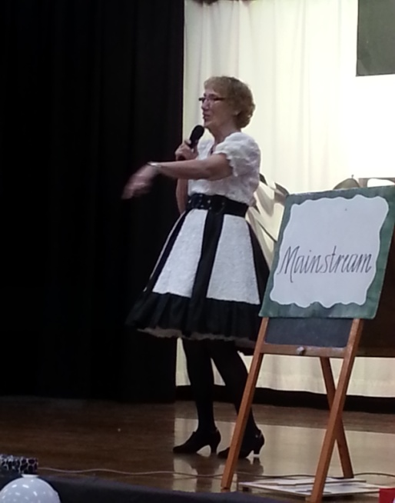[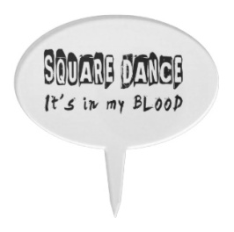](http://www.google.com.au/url?sa=i&source=images&cd=&docid=BXpELz2LZVIYjM&tbnid=qnvHHFmyUqRncM:&ved=0CAgQjRwwAA&url=http://www.zazzle.com/dance+caketoppers&ei=fMMqUqu-E8rdkgW9qIH4CQ&psig=AFQjCNHnSvyEkQbD0PXXU5VSSAJz9_lHCQ&ust=1378620668366100)

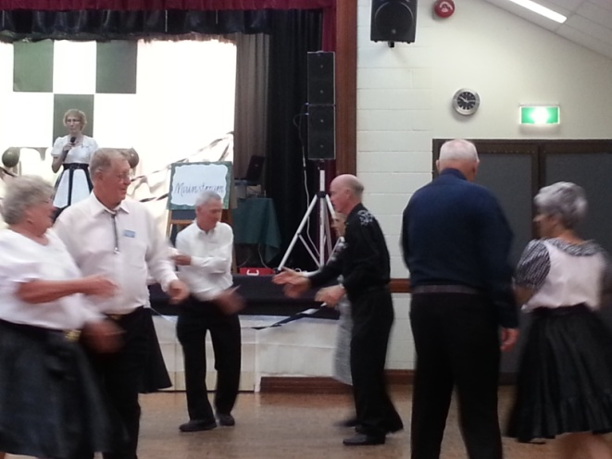

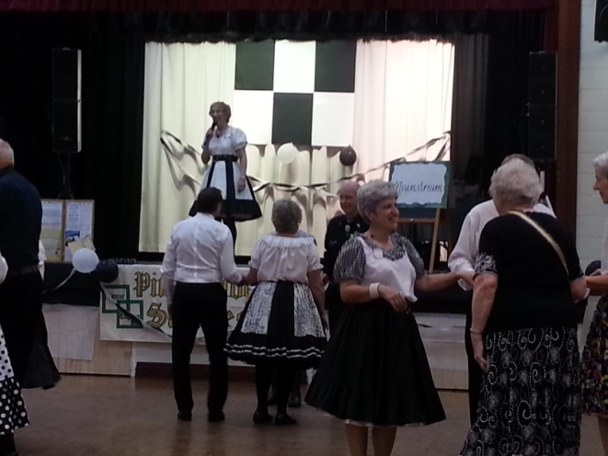

**Five Steps to Better Dancing**

*Helpful hints to make*

*Your Square Dancing*

*More Enjoyable*

**Keep Both Feet On The Floor – Don’t Walk!!!!!!!!**

1. Walking is **Not** dancing!

When you walk, one foot is off the floor for a time and you can easily be put off balance. Using the traditional shuffle step, with both feet gliding along the floor, you act perfectly balanced. Remember, the toe should slide on the floor first.

1. **Keep Your Weight Forward**

Stay “on your toes”, don’t jar your heels and body. Smooth movement is a mark of a polished dancer.

1. **Stand Tall, Move Lightly**

Shoulders back, stomach in. Don’t “trudge”, let the music “carry” you along.

1. **Take Smaller Steps**

Men especially! You have a longer stride than the ladies have. Smaller steps make it easier to shuffle and maintain balance, and they look better! Don’t rush, there is plenty of time. Besides, the caller has to be a call ahead of you so you can dance smoothly.

1. **Listen to the Music, and Dance to the Music –**

That’sthe point of dancing. The square is simply the framework in which you move.

Take one gliding step for each downbeat of music.

Learn to pick out and start on the phase whenever possible.

Most comfortable moves are done in 8 steps or multiples or divisions of eight steps.

**☺AND…. DON’T FORGET TO SMILE** **☺**

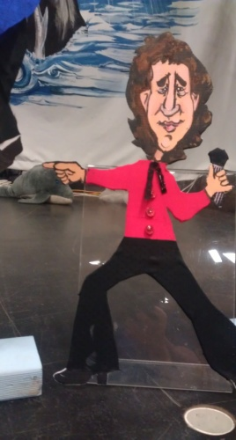 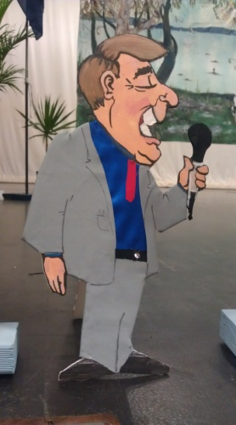

***Do WE REALLY KNOW OUR CALLERS?***

***Glenn, Rod & Peter***

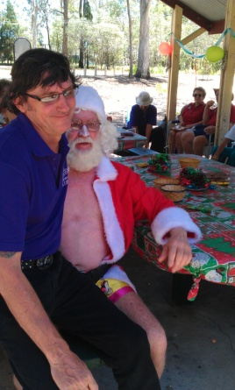

**What to know about Glenn?**

Profile: - Glenn Wilson - Square Dance Caller

Born in Hull England 8th November 1961.   Moved to Australia 25th May 1965.

While I was at Zillmere State School in the late 60’s, I was first introduced to Square Dancing as a compulsory part of the curriculum.

It was while at Pine Rivers High School in 1976, I went to my first real Square Dance with a live caller. It was here I became hooked.

The club was “Pine Rangers” run by Alan Leighton and his wife Jenny. Alan’s brother Sid is still calling at “Wavell Whirlaways”.

I entered and won the club’s Amateur Callers contest in 1976, this contest was judged by legendary Queensland caller Eric Wendell.

In 1978, I joined the Royal Australian Navy and was immediately sent to junior recruit training in

Western Australia. I danced most Saturday nights that year at a club called “White Gum Valley” in Fremantle.  After this I had a long break from square dancing.

After my naval career was over, in 1993, I started square dancing again at “Caboolture E.Z. Squares”.

By the end of that year, I did my first (very bad) singing call.

During 1994, I called anywhere that anyone would let me, still not sure whether I wanted to be a “proper” caller.

I started my first teaching class for “Caboolture E.Z. Squares” in early 1995. I’m still calling there now.

In 2001, “Rock ‘n’ Roll Squares” at Bald Hills came into being, this club continued for 4 years on the 2nd Friday of every Month.

   During 2003 I was asked to be the club caller for a new club at Geebung.

“Northside Promenaders” started in early 2004 and is still going strong today. This club moved to Zillmere in 2013 and kept the same name.

I have called At 9 Australian National Conventions - 1999, 2001, 2003, 2005, 2006, 2008, 2009, 2012 & 2013.

I was the Assistant Venue Manager at the ANSDC Caloundra 2003, I was also the Program Manager at the ANSDC Brisbane 2008. I’ve called at most Queensland State Conventions since 1995. I was Sound Manager at 2 of them.

I’ve been a member of the Queensland Callers Association since 1994; I was Vice President in 1999 thru 2000 and again from 2002 thru 2003 and again from 2012 to present. I was also President of the Association in 2009 and 2010.  I have been a QCA Assistant Caller Training Officer since 2009. I’ve been a Member of The Australian Callers Federation since 1994 and I’ve been an ACF board member since 2011.

I’ve been a Callerlab Member since 2007. I am also a member of the Callerlab Mainstream Committee.

I have attended numerous Caller Training sessions. I have attended most QCA training sessions since 1994 and have been involved in presenting QCA caller training sessions since 2004.

I have also presented 3 caller training sessions in Cardwell, North Queensland

I have attended 5 Brian Hotchkies 5-day callers schools (2003, 2006, 2009, 2010 & 2013) and helped with a Sight Resolution presentation at the latest.

I have been privileged to be invited to call for the following clubs:-

Summerland Larrikins - Lismore        Logan City Square Dancers Inc. - Logan City

Hervey Bay Dancers - Hervey Bay       Heritage City Hoedowners - Maryborough

Happy Hoedowners - Gladstone          Rocky Twirlers - Rockhampton

Salad Bowl Squares – Brisbane            Gumdale Grand Sliders  - Brisbane

Uniting Squares - Brisbane                   Upbeat Chaos - Deception Bay

I was the first caller in Queensland to use CD’s as my principal music player and in June 2004, I was the first Queensland caller (as far as I am aware) to switch completely digital and use a laptop computer as my music player.

**Laughter is the Best Medicine**

**What** is free, does not require a prescription, yet could be just what the doctor ordered? It’s a “laugh”.

**Your** body responds to laughter by increasing your heart rate; contracting muscles in your heart, lungs, torso and abdomen; and releasing neurochemicals into the blood - all of which have healthy effects.

**Studies** reveal that laughter releases immune system boosters that protect against respiratory and other illnesses.

**The release** of the body’s natural painkillers also is triggered by laughter. Laughter works like exercise to reduce stress and strengthen the cardiovascular system.

**Laughter is contagious!** So don’t keep your humor to yourself. Everyone loves a good joke or funny story.

http://slickstiletto.com/wp-content/uploads/2013/01/laughter.jpghttp://slickstiletto.com/wp-content/uploads/2013/01/laughter.jpghttp://slickstiletto.com/wp-content/uploads/2013/01/laughter.jpghttp://slickstiletto.com/wp-content/uploads/2013/01/laughter.jpghttp://slickstiletto.com/wp-content/uploads/2013/01/laughter.jpghttp://slickstiletto.com/wp-content/uploads/2013/01/laughter.jpg

***FACTS YOU MAY NOT KNOW:***

***If you stop getting thirsty, you need to drink more water. When a human body is dehydrated, its thirst mechanism shuts off.***

***Zero is the only number that cannot be represented by Roman numerals.***

***The roar that we hear when we place a seashell next to our ear is not the ocean, but rather the sound of blood surging through the veins in the ear***

***The tooth is the only part of the human body that cannot heal itself.***

***Intelligent people have more zinc and copper in their hair.***

***Caffeine increases the power of aspirin and other painkillers that is why it is found in some medicines.***

***If you get into the bottom of a well or a tall chimney and look up, you can see stars, even in the middle of the day.***

***The Earth gets 100 tons heavier every day due to falling space dust.***

***For every extra kilogram carried on a space flight, 530 kg of excess fuel are needed at lift-off.***

**Newsletter Editor**

Julie

*E.Z. Squares would like to thank* ***Darren Grimwade MP*** *for the use of his facilities when printing our newsletters ☺*

