|  |  |  |
| --- | --- | --- |
| Volume 04 | Edition D26 | November 2013 |

|  |  |  |
| --- | --- | --- |
| ***This is your committee***  ***Geoff Linck - Parker - President***  ***Bert Bowden - V/President***  ***Ted Newton - Treasurer***  ***Gail Staniland – Assistant Treasurer***  ***Delwyn Linck- Parker – Secretary***  ***Ken McCulloch – Providore***  ***Margie Webber - Co-Providore***  ***Julie McCulloch – Newsletter Editor***  ***Maureen Miller – Clogging Rep***  ***Glenn Wilson - Caller***  ***Rod Dinte - Co-Caller***  *The “committee” is working hard to make our club the very best it can be, “Please help us”, - by making suggestions, on how to make it even better! This is your club how would you like it to be run?*  ***THE SQUARE DANCER’S PLEDGE***  **"With all my ability I will do my best to help keep square dancing the enjoyable, wholesome, friendly and inspiring activity I know it to be.**  **This I pledge in the sincere desire that it may grow naturally and unexploited in the coming years and be available to all those who seek the opportunity for friendship, fun and harmony - through square dancing."**  **Something to think about! ;**  As we are now in the later part of the square dancing year and the time is fast approaching where we will be calling on nominations for the committee for 2014.   I encourage each and every one of our members to seriously consider nominating for a position on the committee so our club can keep providing the dancing we all enjoy.  Most of the present committee has held office for a number of years and some will not be standing for election for the coming year. As our club is a committee run club we need a functioning committee to maintain a functioning club.  Geoff Linck-Parker - President  **Dates to Remember;**  **12th Nov –** Family and Friends night  **19th Nov -** Graduation and Club Birthday  **26th Nov** - AGM  **3rd Dec -** Xmas Dance break up  **8th Dec –** Xmas break up in the park - Buchanan’s Park Burpengary  **4th Feb 2014 -** 1st night back for **mainstream only**  **11th 18th 25th Feb 2014** beginners  **3x free nights dancing**  **FAMILY AND FRIENDS NIGHT - 12th Nov 2013**  ***We invite family and friends to come and join a***  ***Fun night of dance: - You will be introduced to a unique group that enjoys Square Dance, Companionship, Friendship, all while having fun dancing, afterwards join us at supper, and meet the people that make this club work.***  ***Do WE REALLY KNOW OUR CALLERS?***  ***Glenn, Rod & Peter***  ***C:\Users\Julie\Pictures\IMAG0237.jpgC:\Users\Julie\Pictures\IMAG0795.jpg***  ***What to know about - Peter Clarke***  ***Pete was born at Woodford (the old place is still there on the road to Kilcoy ) in 1937.***  ***His Dad was a motor mechanic who moved to Kilcoy in 1939. Pete went to school at Kilcoy State School until high school when he moved to Brisbane to live with an aunt to do Junior High as it was in those days. He continued living with his aunt to do his 5 year apprenticeship as a fitter and turner. While employed by Rapson Engineering he met Val who was an office girl/ typist. She had gone to do that after her eyes started to give her problems as a photographic colourist. After their marriage in 1958, Pete left the engineering and went to be an Oil Company Representative with Shell oil, whom he worked with for 4 years, stationed in Ayr and base office in Townsville. Gave that away in 1964 and went back to Kilcoy to work as a motor mechanic with Hobarts Garage, which is still there. After a couple of years, he looked after the spare parts there, for another 8 years. He decided this wasn't for him and he went into teaching at Kilcoy High School in 1977 starting as a manual arts teacher, after doing 2 years of college in Brisbane, and then later, after about 8 years, into Special education, which involved another year of college in, Brisbane starting with 4 years teaching in deaf education at Cornwell Street, and then onto Bundaberg as a special needs support teacher at Kepnock High in 1989.. He Transferred to the Bundaberg Special School in 1991 and worked with special needs students there and at Bundaberg TAFE College until early retirement in 1999. Over the period of those years at Kilcoy, he did part time fire officer and part time theatre projectionist. During the years of their union, he and Val ran a cub scout group as well as Pete doing scouts and senior scouts at different intervals over the years.***  ***His square dance career started in Bundaberg  with Cane Country Squares in 1992, learning basic and main stream dancing and starting calling in 1993 after the club  caller, Shirley Kelly, heard him calling along with her singing calls He called at Cane Country Squares and Bundaberg Promenaders. He did a few guest caller weekends at Gladstone and Rockhampton while living in Bundy. Attended a few caller schools with David Smythe and the QCA and then in 1999, decided to move down to Sandstone Point to be nearer family when he and Val joined Bribie Island Squares and Caboolture EZ Squares, calling at both these clubs. He attended more caller schools with the QCA and one at Casino with Brian Hotchkies. He did a bit of calling at Various clubs including Glenn's Rock and Roll Squares at Bald Hills, a Police Club square dance at Deception Bay,  and a retirement village at Deception Bay.and of course, Caboolture EZ Squares. He and Val were granted club Life membership after doing stints in various positions on committee. A few club dancers still recall learning with Pete's teaching in the little supper hall at the showgrounds***  ***He resigned as a club caller in 2010 after having leg and back operations and not being able to be actively involved in the club. Returned to club in 2013 and now does a guest call when able to do so at the invitation of the different club callers? He is still a member of the QCA and ACF having retained membership during the off years and has retained his club membership, hopefully for some years to come.***  ***Cheers Peter***  ***Clogging News***  **We have all settled down after attending the Annual Clogging Convention in Queanbeyan, and everyone arrived back safely. We have been kept busy since, looking at some of the dances that were taught.  Stephen has just been away on holiday, so we continued dancing.  Our guest Cuer/ teacher, Dian Young helped us out on the first week, a big Thank you to Dian, and with the help of Kath, Donna and Vicki, we had a Social Night the next week.  Thank you for all who attended, and all who cued and kept the clogger’s on the floor.  I hope Stephen doesn't think we can do without him, because we can't!  We really missed him.  We are now into our next phase, decided which dances we would like to vote off the ACA Dance list, then what we would like to put on the list to replace those dances.  If you have any favourite dances that you have done at any of the Camps or the Convention in 2013, please let us know.**  **Happy clogging,**  **Maureen**  **Clogging Representative:**  **3 Day First Aid at Work - (Belfast) In case of an accident**  **We don’t ever plan on having an accident,**  **However! In the event of such an incident,**  **Please see a committee member to record this miss fortune so we can document and have on file.**  **Kitchen News**  ***This is to the kind selected few that bring a little something for supper each and every week; I know that we all like to have a cuppa and a little something to nibble on. That goes well with the pleasant company and conversation. I thank you!***  ***At the end of each night for which some supper may remain untouched, this is the providors job Ken or Maggie to either distribute perishables out or to salvage, for use at a later date. Again please see Ken or Maggie.***  **Something New**  On the 4th Tuesday of the month, a small celebration shall take place for all those who have had or are having a birthday in that month.  The **exception** being for milestone, which we will celebrate accordingly.  [http://t1.gstatic.com/images?q=tbn:ANd9GcR05l0b9kUdZyiAAlMIEbdq8zloeED_m2lapIsLB2PoCv6Tq7FagA](http://www.google.com/url?sa=i&source=images&cd=&docid=zaucFnrKx3ztCM&tbnid=ZN-xynv3jtEhMM:&ved=0CAgQjRwwAA&url=http://www.highexpectationsballoons.com/&ei=4roqUrazFsfAkgXq5oCABA&psig=AFQjCNE03Uyo97nxitfU_qfIT3dpbIOXJw&ust=1378618466484098)  http://stockmedia.cc/party_celebration/slides/DSC_8245.jpg  ***Happy Birthday/Anniversary for all those special people that celebrate in the months of***  ***Oct & Nov☺*** | **Dates to Remember;**  **22nd Sept** -Car Observation Run  **27th-29th Sept-33rd** Qld State Square Dance Convention venue: Ferny Hills  **29th Oct -** Party night theme “Nautical but Nice”  **29th Oct -** Light House Squares visit to our club  **12th Nov –** Family and Friends night  **19th Nov -** Graduation and Club Birthday  **26th Nov** - AGM  **3rd Dec -** Xmas Dance break up |  |

*Please! While our Officials* are talking- show some consideration and listen *to what they are saying.*

*Check the notice board for: Information on upcoming events for our club and also other clubs’ events.*

*Party Nights are Theme Nights, if you choose not to come in costume, please if possible wear square dance attire as other clubs may join us*

*For these special occasions. : )*

*A reminder to all our dancers to please use the sanitizer on hands between dances, and before supper. The sanitizer bottles are provided at various locations around the hall. “ Keep those germs at bay!” NO ONE wants to be sick!!*

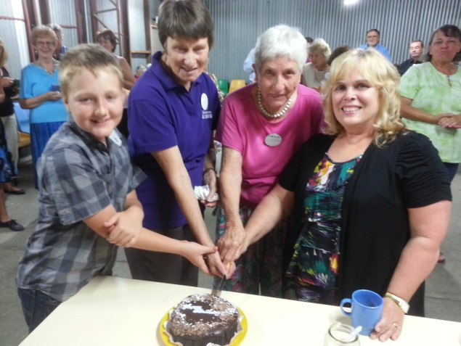

***September 2013 Birthdays***

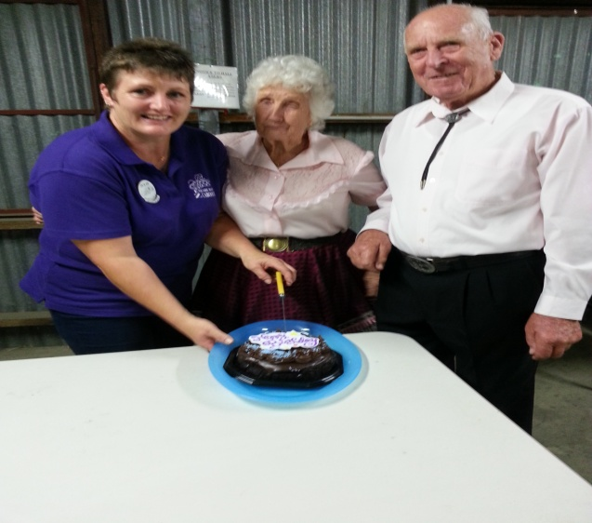

***October 2013 Birthdays***

***[](http://www.google.com/url?sa=i&source=images&cd=&docid=QwCZH6CdHOVnZM&tbnid=STjYNYR-X2lLGM:&ved=0CAgQjRwwAA&url=http://bestclipartblog.com/29-cars-clip-art.html/cars-clip-art-6&ei=Y74qUt_XE87QkAX31YCADw&psig=AFQjCNFFZzQZH38QEseoZ8a8Ps-SaRLpUw&ust=1378619363358224)* Car Observation Run**

22nd September was E.Z. Squares last social event

10am start at Buchanan’s Park Burpengary:

This was the starting point where Arthur gave all the eager contenders their directions and IF needed the get home envelope. All contenders clocked in, with each car staggered, so we couldn’t cheat and follow one another.

With cryptic clues in hand away we went – Find water tower? Name a taxation office! What sports are played here? Phone number of Kindergarten? Turn right, - looking left for Clues - closely followed - right by more clues. Oh no! What was that back on the table at the start in front of Arthur? How are we supposed to remember that! “YES” I have it! 10 cent pieces x 5. Turn right at the school, how many badges live here? “What”! Who lays drive ways? Left again past small shopping complex – What is the name of the convenience store? Turn right - then Left at the purple house, name people - Phone numbers! And how many solar panels? More right turns / More left turns O’ my! In and out of the car, looking left/ right and straight ahead, “What”?! How many trees? - Back at the last round about. Turn up Queens sister’s street!

Not and old road “young”. I’m ready for lunch! Home straight here we come! “**North Pine Dam”** how exciting we have arrived! What a wonderful sightseeing adventure. All contenders arrived, some taking a little longer than others:

1st place Tapioca “Clair”

2nd place M&M’s “Ken & Julie”

3rd place “Loure & John”

Last place “Ivan & Alicia”

Lunch was picnic or bbq which was byo.

Good company and many laughs were had.

A Great Big THANK YOU to Arthur for his generous time given and maybe even for the frustration as he put together this cryptic course. You know I can’t wait for the next one! I have had so much fun [http://t2.gstatic.com/images?q=tbn:ANd9GcRJx5kWSlTKVxow-QxMiDiGxQxirRRKT1DVhOJtTaGV-uB76Bnszw](http://www.google.com/url?sa=i&source=images&cd=&cad=rja&docid=sj1nN6r1pT3bwM&tbnid=1G-eOnBsFggtMM:&ved=0CAgQjRwwAA&url=http://onlinewallpapersstore.blogspot.com/2012/11/smiley-face-pictures-images-free.html&ei=67xrUpPZCOSgigfyq4DIAQ&psig=AFQjCNEKb7hXnf7QeEFdES5YVWtS6lLkzQ&ust=1382878827227563)

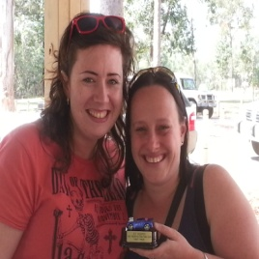 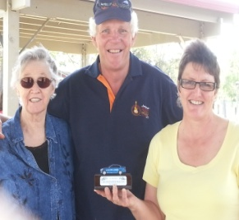

***1st place 2nd place***

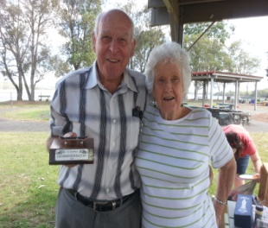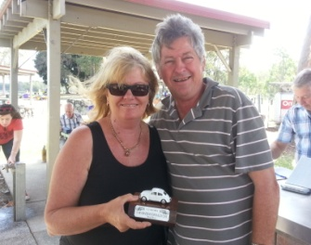

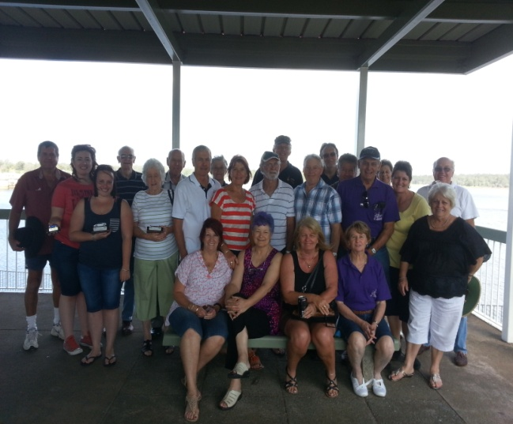***3rd place last place***

***E.Z. Squares/Car observation rally North Pine Dam 2013***

Weekly Admission once annual membership is paid:

Child: $2.50

Adult: $5.00

Family: $12.50

Annual Membership Fees Due NOW for 2013

Child: $5.00

Adult: $10.00

Family: $25.00

If annual membership has not been paid:

Child: $3.50

Adult: $7.00

Family: $15.00

***Christmas break up in the park 8th Dec***

**Please indicate if you would be coming as we require numbers for catering purposes. See Ted**

***This goes without say;*** *I’m sure by now, that our dances have noticed the dedication of many of our experienced ladies, stepping up to take on the roll of the Left hand dancer. With the passion of seeing the newer dances up and enjoying square dancing. The committee extends their gratitude and appreciation…..*

*We thank you for putting in the time to bring out the enjoyment, laughter, companionship and friend ship while having fun.* [http://www.natreview.com/wp-content/uploads/2010/10/thumbs_up_bciy.jpg](http://www.google.com/url?sa=i&source=images&cd=&cad=rja&docid=sE-Ttniy1j2MdM&tbnid=zgstjXDNp3c1PM:&ved=0CAgQjRwwAA&url=http://www.natreview.com/2013/07/29/hair-products-thumbs-upthumbs-down/&ei=Hw1vUpDSC6H6iwLsuIDwAw&psig=AFQjCNE3byLcuhku3ZobsORSgqzVdi6HUg&ust=1383095967233547)

*Check the notice board for: Information on upcoming events for our club and also other clubs’ events.*

*Party Nights are Theme Nights, if you choose not to come in costume, please if possible wear square dance attire as other clubs may join us*

*For these special occasions. : )*

***Graduation 2013***

*This year we welcomed many new dances to our club, good dancing, good friendship has developed along the way, with some laughter as we are all put through our paces by our incredible callers. All having fun, smiling lots as that is what it is all about! ☺*

*Well done to all who will graduate on 19th of November 2013*

***Party Night – 29th October 2013 and Official visit for Light House Squares:***

***Theme “Nautical but Nice”***

*Firstly, I would like to thank those of us who gave time to help create and set the scene, by either making props or setting up the hall for the evening, your time is priceless and appreciated. As always, I am gob smacked and imp*

*ressed with the amount of our dances who take the time to dress for the occasion.*

*Great dancing was had by all; it was wonderful to see the newest members of our club, dancing every dance with confidence. Thanks also goes out to all the club and guest dances that brought supper along, its appreciated more then you can ever know.*

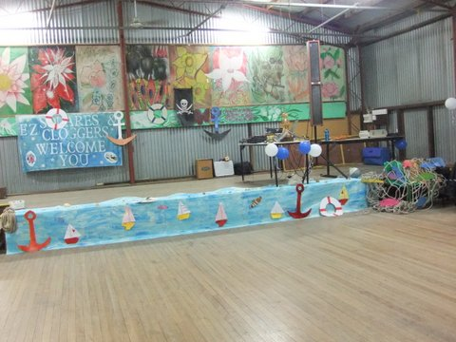

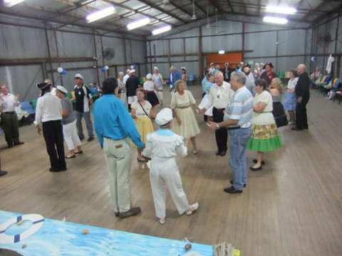

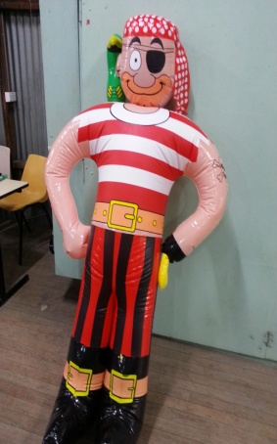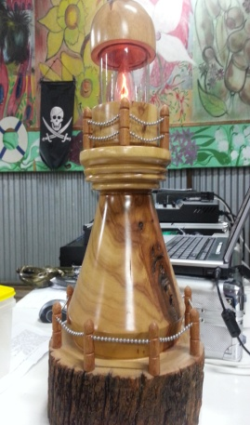

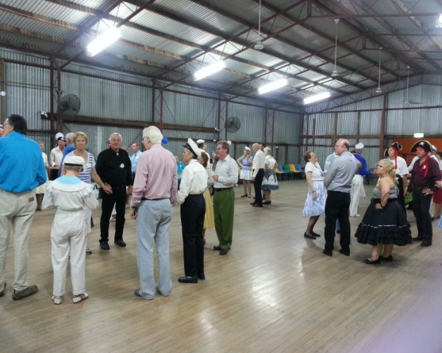

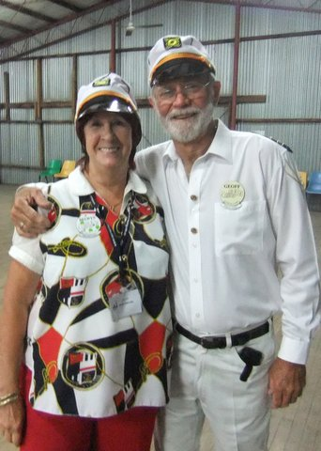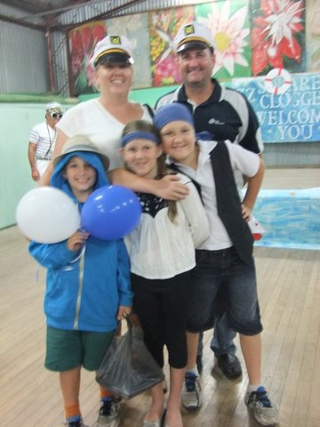

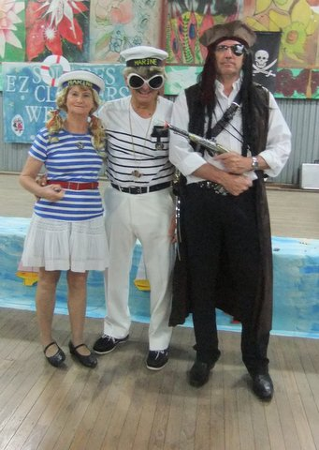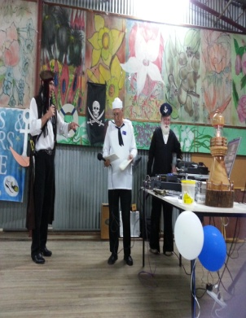

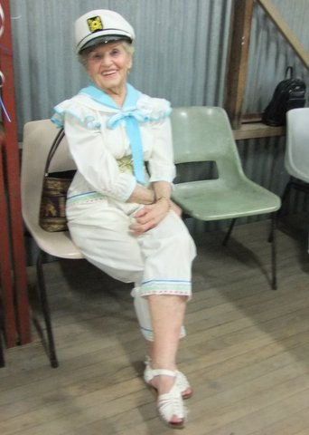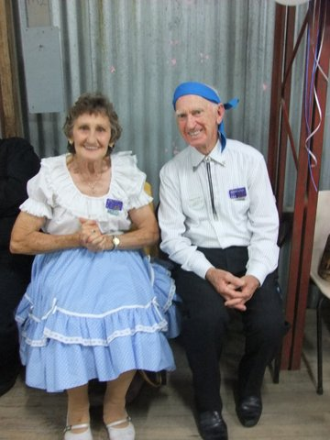

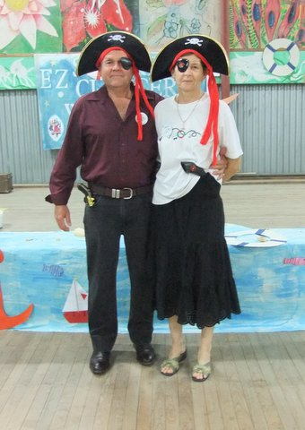

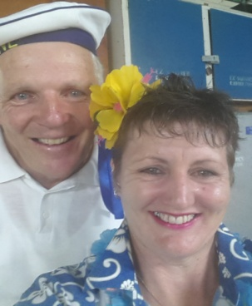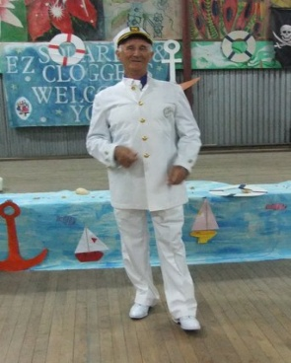

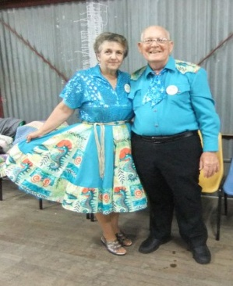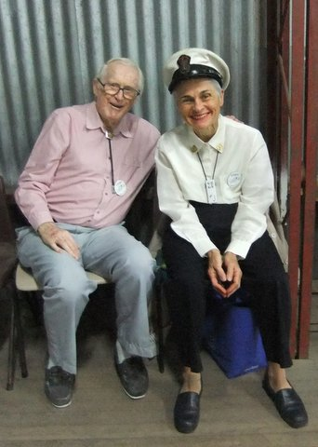

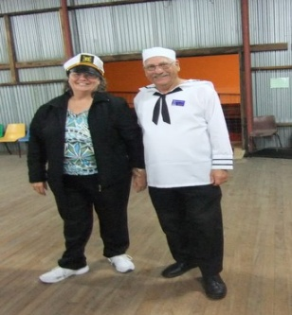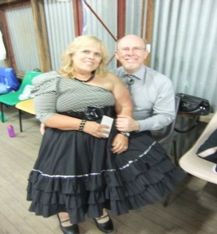

**NEWS FROM E.Z. SQUARES CABOOLTURE.**

We recently held a car observation run, all participants arrived safely and all managed to arrive at the destination without getting lost. The run started from Burpengary Park and after travelling through many suburbs and looking out for key clues finished at North Pine Dam where we all enjoyed a bar-b-q or picnic lunch. Quite a few of our dancers attended the State Convention at Ferny Hills and a fabulous time was had by all.

As the year draws to a close we are getting close to our graduation night.  We started off the year with 16 new dancers and we have 13 graduating including 4 children, we are so proud of them all.

Our local Minimbah School has three squares of children learning to square dance, our club sponsors these children with the hope they will be future members of our club thus advancing the enjoyment of square dancing for all ages.

These children are taught in their lunch hour by our own Ken McCulloch who is affectionately known to them as Mr Mac.

Our last dance for the year will be our Christmas Dance on 3rd December and we hope to see lots of visitors in their Christmas attire.

Article taken from the Bugle, October 2013

**Newsletter Editor**

Julie

*E.Z. Squares would like to thank* ***Darren Grimwade MP*** *for the use of his facilities when printing our newsletters ☺*

