Volume 01 | Edition A01 | March 2015

COMMITTEE:
Geoff Linck-Parker -President
John Twining – Secretary
Ted Newton - Treasurer
Gail Stanilan – Assist Treasurer
Julie McCulloch – Providore/Newsletter Editor
Margaret Webber - Co-Providore
Maureen Miller – Clogging Rep

CALLERS:
Glenn Wilson - Caller
Rod Dinte - Co-Caller

Welcome back to another fun filled year of Square Dancing. This year we hope to welcome many new dancers to our club, good dancing, and good friendship will develop along with some laughter as we are all put through our paces by our incredible callers. Have fun, smile lots as that is what it is all about!
BE KIND TO THE BEGINNERS
Be kind to the beginners even though they often flub, With courtesy, let's greet'em; they're the new blood of the club, And when we see them struggling, let us lend a willing hand, Guide them o'er the rough spots and to help them understand, Be good to the beginners when they join you in a square, And introduce your partner to the gent and his lady fair, And though they may be strangers when we walk into the set, Remember that a stranger is a friend you haven't met.
Graduates of 2014
Congratulation to the following - Julie-Anne Weimers, Noela-Parsons, Vicki- Bouna, Bethany- Stanyer & Irene-Locke. We look forward to another great year of dancing with all of our new and experienced dancers.

PRESIDENT’S REPORT 2015
Welcome back to a new year of square dancing. Great to see all our dancer’s back again as well as our graduates from last year. A special welcome to all the new dancers who have joined us for the first time this year, I hope your stay with us will be a long and happy one. Please don’t be discouraged if you feel you are not learning quickly, as it takes a full year to learn all the moves. The main thing is to enjoy yourself and have fun.
Wow we certainly started the year off with a bang.
Our 25th Anniversary dance was a huge success with over 80 dancers attending from as far away as Bundaberg in the north to Casino in the south.
We were also fortunate enough to have 11 first class callers to keep the night rolling along.
Thanks must go to all who helped with this event, especially to Delwyn, Julie, Maggie, Pete & Val, Linda, John T & Gail who gave up their time on Saturday afternoon to help decorate & clean the hall, and also those who helped with the catering and supper preparation, and clean up. Not forgetting all those who donated goods for the raffle, from which we made over $200.00. Great job everyone.
Our first fun night for the year is on 17th March (St Patrick’s Day) so get out all your Irish attire and come dressed for the occasion.
Our first Party night will be on 31st March. The theme is “Italian Night”.
Following from that we are in the process of organising our first social event, this will be a high tea at Vicky’s early in May.
There will be no dancing on 2nd & 9th June and 21st July due to the unavailability of the hall.
We have planned a club visit to “Northside Promenaders” on the 4th June, if anyone needs transport please see one of the committee and we will try to arrange some for you.
Don’t forget this year our club is hosting the 35th State Square Dancing Convention along with the QCA on the 25th, 26th & 27th September. When the time arrives it would be appreciated for as many members as possible to volunteer some time to help with the organisation of this event.
Once again I would like to stress, if you have any complaints or ideas please talk to a committee member and we will discuss it at our monthly meeting. The alternative is that you are welcome to attend our meetings and raise the matter yourself.
Our upcoming Annual general meeting is when the club committee is elected for the following year. I urge all members to consider nominating for any position. Please remember that we need a functioning committee to maintain & secure the future of our club for years to come.
Geoff Linck-Parker
President

Five Steps to Better Dancing
Helpful hints to make
You’re Square Dancing
More Enjoyable
Keep Both Feet On The Floor – Don’t Walk!!!!!!!!
- Walking is not dancing!
When you walk, one foot is off the floor for a time and you can easily be put off balance. Using the traditional shuffle step, with both feet gliding along the floor, you act perfectly balanced. Remember, the toe should slide on the floor first.
- Keep Your Weight Forward
Stay “on your toes”, don’t jar your heels and body. Smooth movement is a mark of a polished dancer.
- Stand Tall, Move Lightly
Shoulders back, stomach in. Don’t “trudge”, let the music “carry” you along.

- Take Smaller Steps
Men especially! You have a longer stride than the ladies have. Smaller steps make it easier to shuffle and maintain balance, and they look better! Don’t rush, there is plenty of time. Besides, the caller has to be a call ahead of you so you can dance smoothly.
- Listen to the Music, and Dance to the Music –
That’s the point of dancing. The square is simply the framework in which you move.
Take one gliding step for each downbeat of music.
Learn to pick out and start on the phase whenever possible.
Most comfortable moves are done in 8 steps or multiples or divisions of eight steps.
AND…. DON’T FORGET TO SMILE

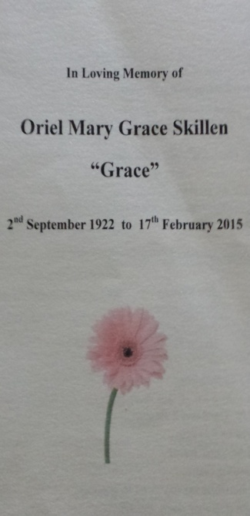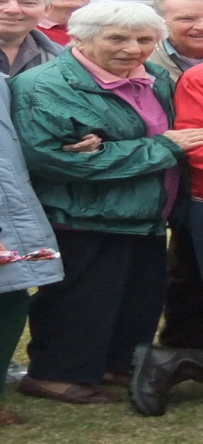
It is with great sadness that E.Z. Squares farewells one of our Dearest friends’ and loyal dancers’ Grace Skillen. She will be greatly missed by all.

Dates to Remember - 2015;

17th March – Special theme St Patrick’s Day

31st March - Party Night theme Italian (Pizza)

2nd /9th June – NO DANCING

4th June - Official Club visit to Glenn’s Northside Promenaders

30th June – Party Night Theme to be advised

21st July – NO DANCING
25th 26th & 27th September – E.Z. Squares Hosting the 35th State Square Dance Convention

29th September- Party Night Theme to be advised

3rd November - Melbourne Cup Theme

24th November – Graduation / Family & Friends

1st December - Christmas Breakup Dance

Thursday 4th June 2015

E.Z Squares Caboolture’s

Official club visit to Northside Promenaders, Zillmere.

The address is:

The Royal Buffalo Hall
30 Seeney Street, Zillmere, 4034

As mentioned last year, there is now an increase in entry fees; this is due to the increase in HALL Hire.

Admission Fees per Dance Night
Child: $2.50
Adult: $6.00
Family: $14.50

Annual Membership Fees Due NOW
Child: $5.00
Adult: $10.00
Family: $25.00

If Annual Membership has NOT been paid, the Fee per Dance Night is:
Child: $3.50
Adult: $7.00
Family: $15.00

Happy Birthday/Anniversary for all those special people that celebrate in the months of
January & February
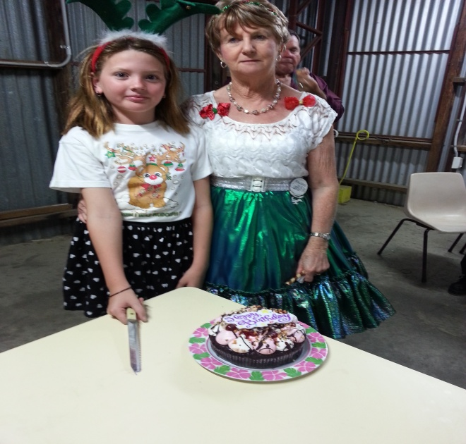
Celebrating Birthdays in the Month November
Val
Celebrating Birthdays in the Month of December
Bethany, Glenn and Arthur
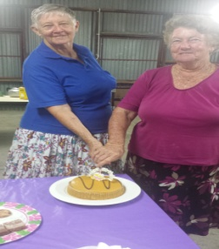
Birthdays in January
Edna, Unice and Irene
Birthdays in February
Maggie

A reminder to all our dancers to please! “Use the sanitizer on hands” between dances, and before supper. The sanitizer bottles are provided at various locations around the hall. “Keep those germs at bay!” NO ONE wants to be sick!!
Kitchen News (Supper)

As your providore, I would like to welcome all new and those not so new to the club.
In the Kitchen you will find Julie and Maggie, (and our UN seen helpers) club members that offer a hand in whatever way they can, I thank these helpers. To make the supper the best it possibly can each and every week, our club members bring along a small offering which is greatly appreciated, this! Along with a cup of coffee or tea goes down well – not forgetting the good friendships which will develop through dance and a friendly chat over supper.

It is great to see so many of us washing our own cup, and helping clean up at the end of the night.

Again this year Birthdays will be celebrated the 4th Tuesday of every month.
I look forward to see you all at Supper.

Providore
Julie

Christmas Break up luncheon at Ken & Julies, Lovely to see so many club members come and take part in the annual break up feast. This as other year’s the committee organised Red Rooster luncheon followed by dessert.
Pic to follow:

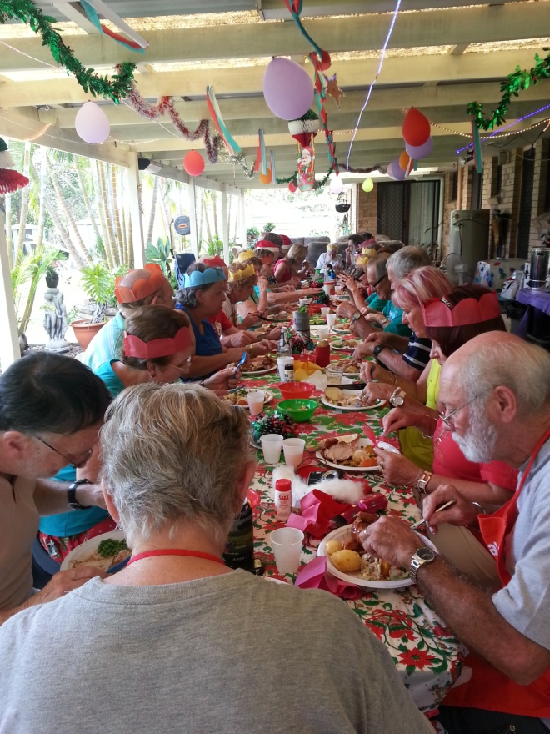

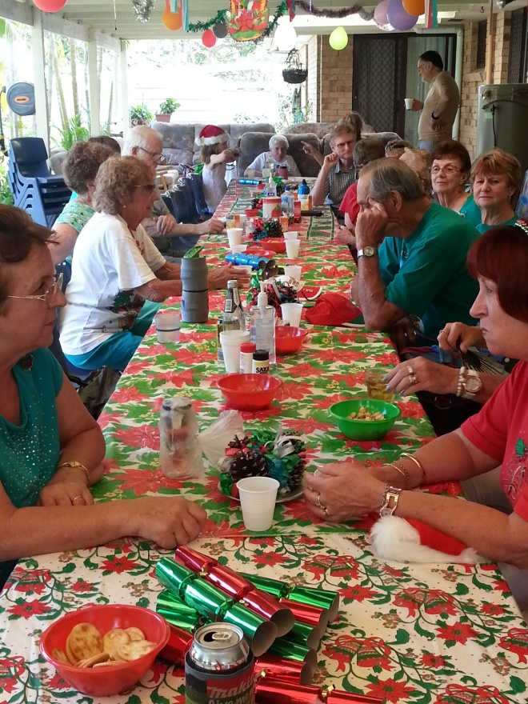

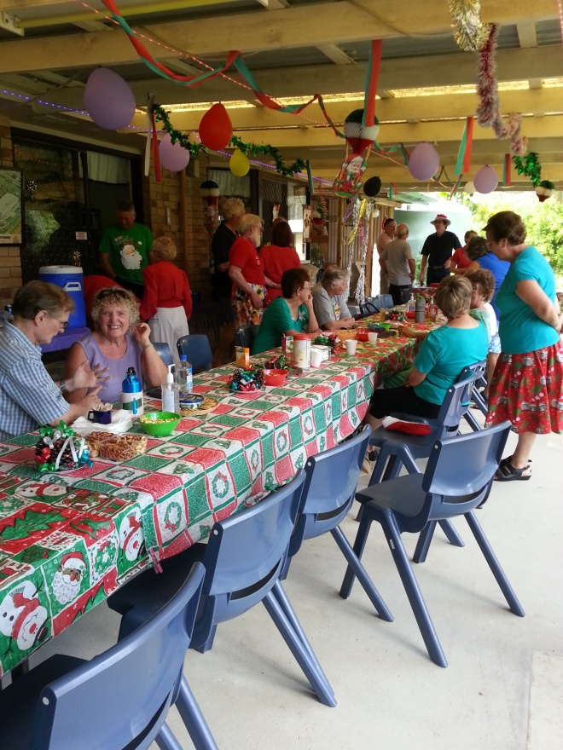

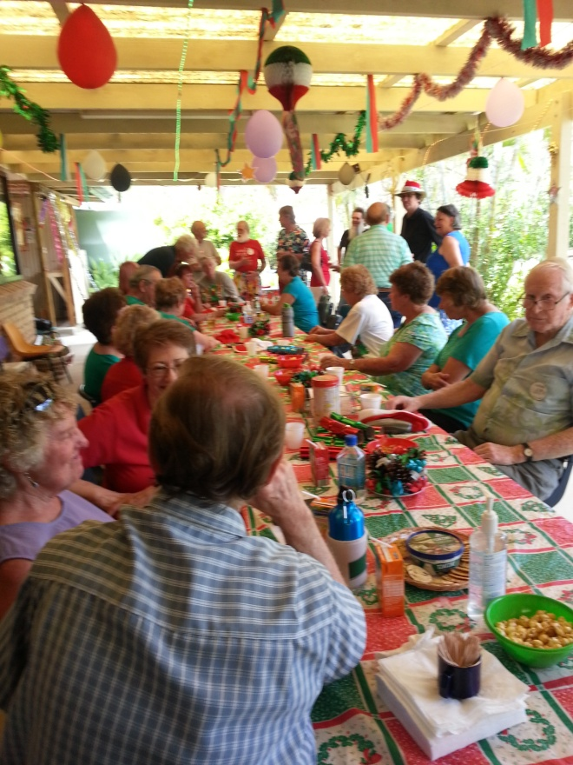

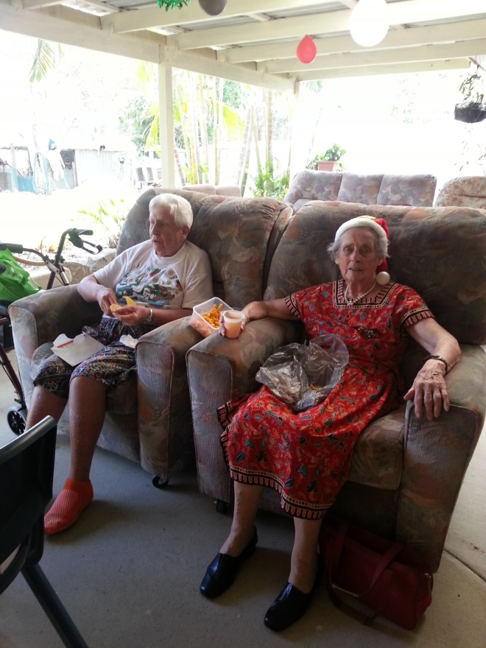

Thank you to all that gave their time!
The Caboolture Twilight Fiesta was a great success.
To all that gave their time to do the demo we thank you.
Pics to follow:
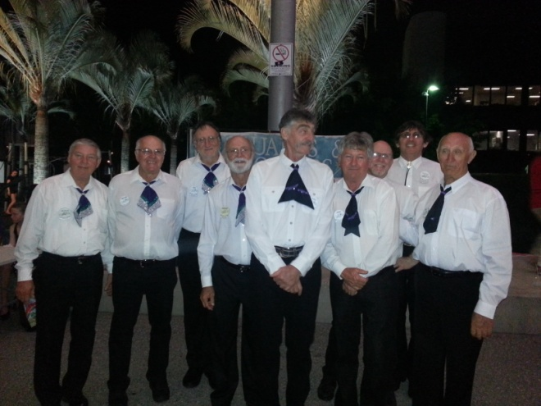

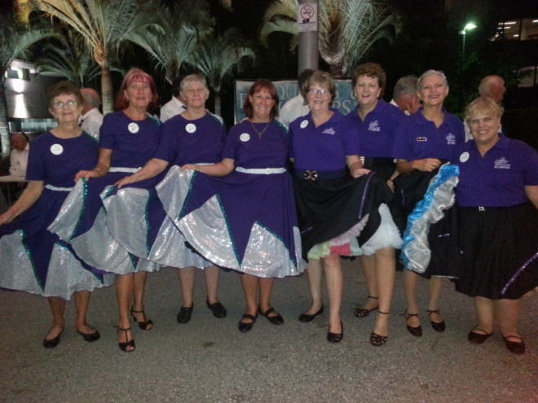

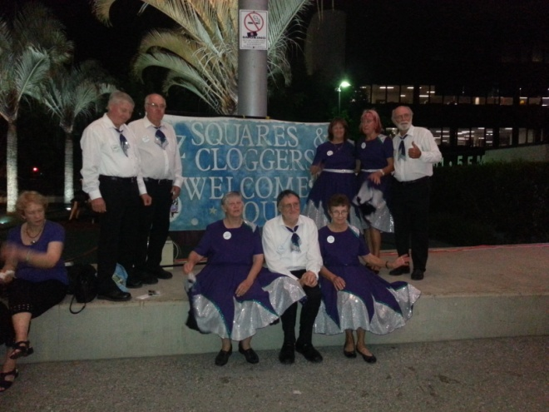
This was the 7.30pm dancers

THE “DANCING” IN SQUARE DANCING
In many of the definitions, the calls are described by stating that the dancers are to “walk” to get to the specified destination. Grand Square and Promenade are two examples, and there are many more. For everyone’s information, the terms “walk” and “dance” are to be considered synonymous or the same.
The dance step should be a smooth, effortless gliding step in which the ball of the foot touches and slides across the surface of the floor before the heel is gently lowered to the floor. The length of stride should be fairly short with the movement coming mostly from the knees down. The dance step must be coordinated with the beat of the music. In general terms, short gliding steps on the balls of the feet make a comfortable dance step.
If done correctly, the dancing will make a shuffling, sandpaper-like sound on the floor. This is music to a caller’s ears.
Square dancers should dance smoothly and considerately, and not do anything that could cause another dancer to feel uncomfortable or confused. The light, sliding step is what should be used. A good square dancer’s feet should never be lifted from the floor. If the dancers “walk” to get from one point to another, it creates a “clomping” sound that is not only annoying, but is certainly not dancing. The heels of the dancer’s shoes or boots will create this sound. However, this same footwear can be used for dancing with great success.
When the music starts, good dancers are in a "ready" position and they are focused on the music and the caller. Let's describe this position.
A. Chin up!
By reminding yourself to keep your chin up every once in a while, you will give the perception that you are confident and happy to be dancing. When dancers learn something new or lack confidence in what they are doing, the chin tends to go straight down subconsciously. An additional benefit is that keeping your chin up enables you to literally "look up" at your fellow dancers as you dance, which will be understood as a sign of respect.
B. Shoulders Back! Dance Tall!
With any of these tips, thinking of the opposite provides an instant reason for why the tip looks good. In this case, the opposite would be hunched shoulders. Since square dancing involves the hands in a lot of movements, the shoulders back in a confident, relaxed position will make it easier to react to calls. Turn at the shoulders as well as the hips to make hands available for calls. Keep your nose over your toes and your body under control and in balance at all times. Good posture is generally a good recipe for success.
C. Arm and Hand Style.
When standing in the squared set, each couple should join hands in what is considered a "Couples Handhold". Normal couples have the man on the left side of the lady. Their adjacent hands (man’s right hand, lady’s left hand) should be joined with the man's hand palm up and the lady’s hand palm down. The elbow should be bent and the hands held just above the height of the elbow. The other hand and arm should be relaxed by their side. When dance action begins, both hands should be in "ready dance position", which means that each dancer is ready to use either hand as required to execute the calls.
An unpleasant feature of bad handholds is roughness, which means that a man (usually the man, but not always) applies awkward or painful forces to a lady. In most cases, he can't do it unless his hold is really a strong grip; and he can't take a strong grip except by clenching something between his fingers and opposed thumb. So, the way to prevent roughness is to teach the dancers, particularly the men, to keep their thumbs out of the action when they take handholds (most of the time).
Touching hands provides instant feedback in formation awareness. Good dancers touch hands as quickly as possible, providing an anchor for themselves and the others in the square. Dancers who simply do their part without touching hands negatively impact the square’s success and detract from the overall social experience. The best dancers are aware that hand-touching is more for the square than for the self.
D. Knees Flexed and on the Balls of Your Feet
Simply keeping your knees flexed and staying on the balls of your feet can completely change how you move and make your steps look smooth. Dancers who are flat footed and have their knees locked will usually move slower and be a step behind as they have to engage muscles to get out of that position before they can dance the next step.
E. Smile!
Remember: Dancing is an artistic expression using the body, including expressions of the face. This may not be a skill that separates dancers of different proficiency levels, but it definitely separates dancers with different attitudes! Whether you messed up, your partner, or if it was someone else, brush it off with a smile. It makes the dancing more fun.
Dance….Dance…..Dance….Dance….Dance ….
E.Z.SQUARES CELEBRATING 25years

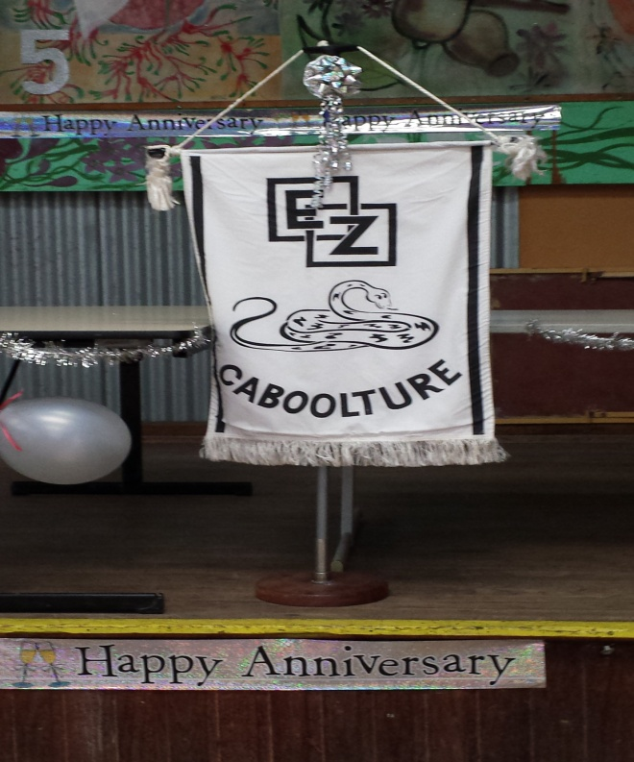

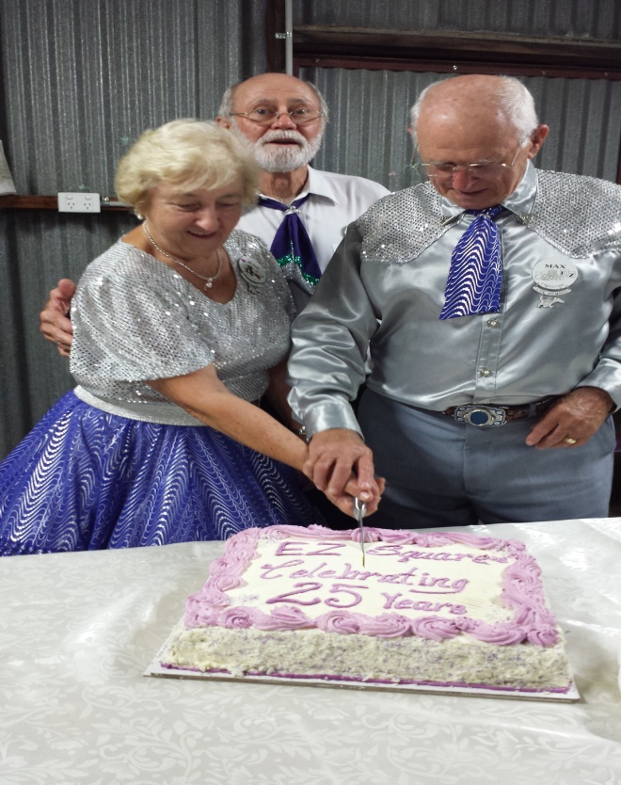
Max, June and Geoff

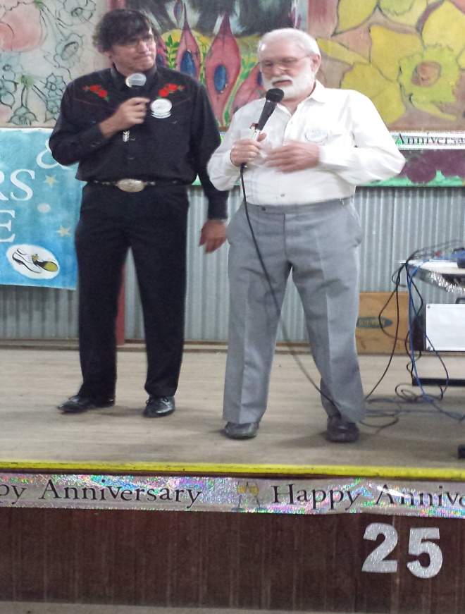
Glenn and Rod

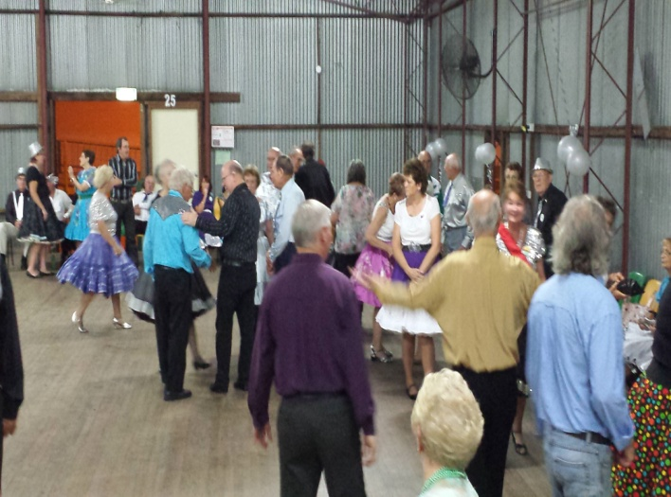

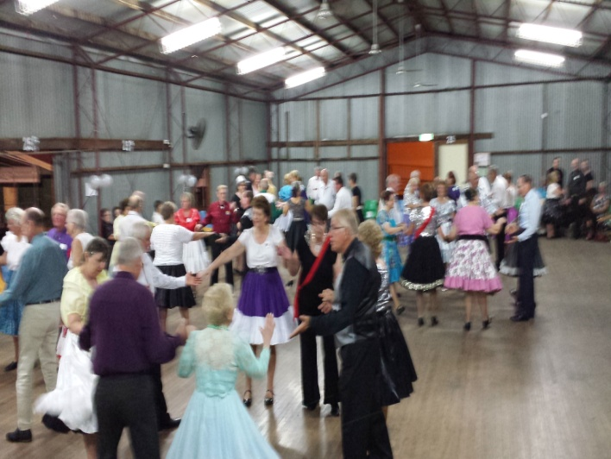

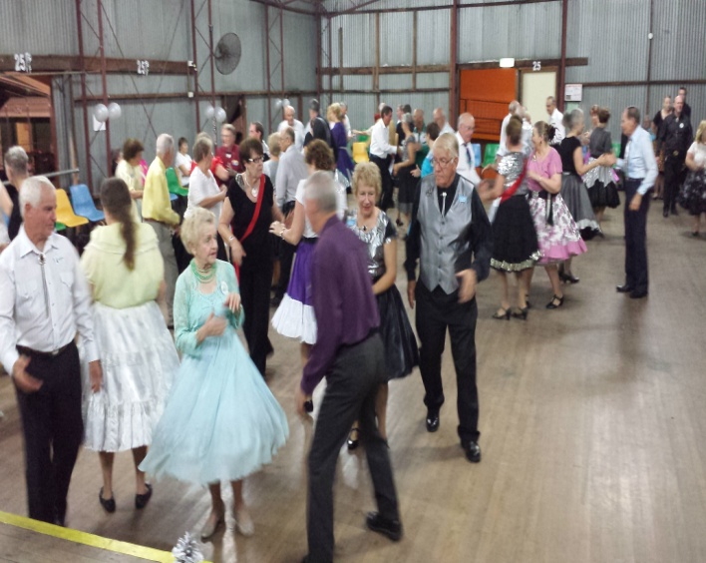

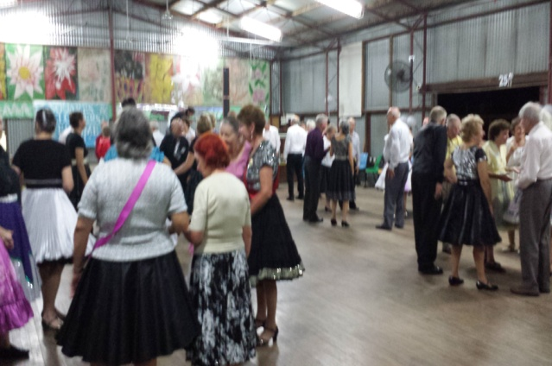

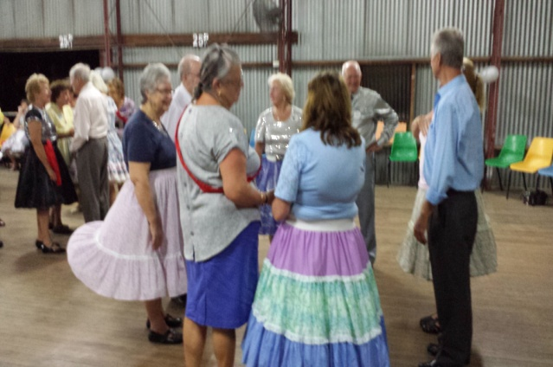

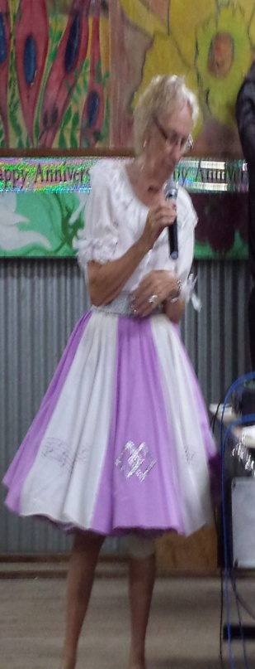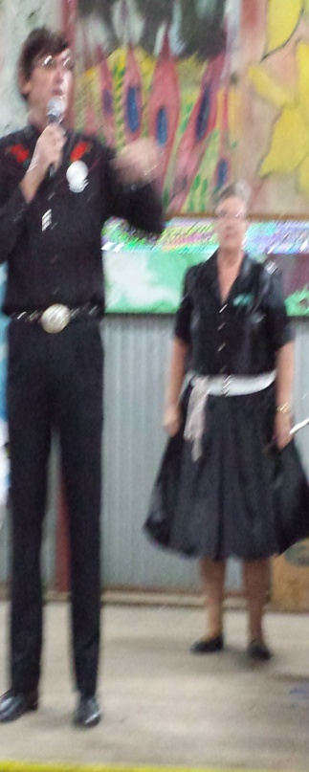
Margaret Jan

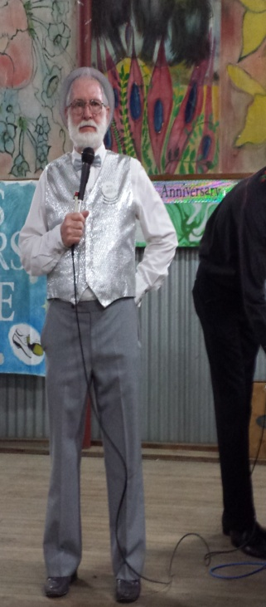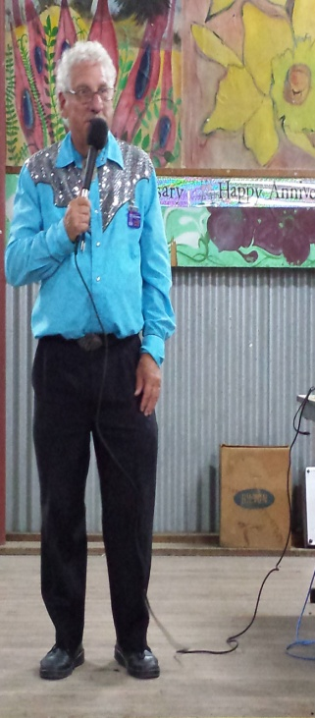
Rod David
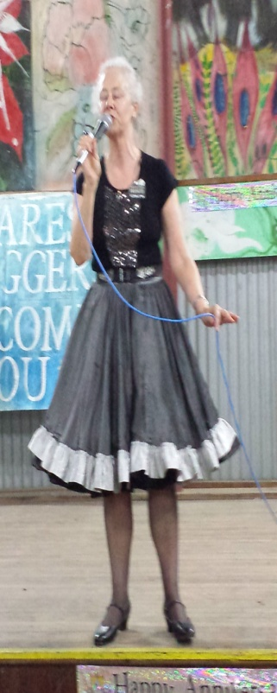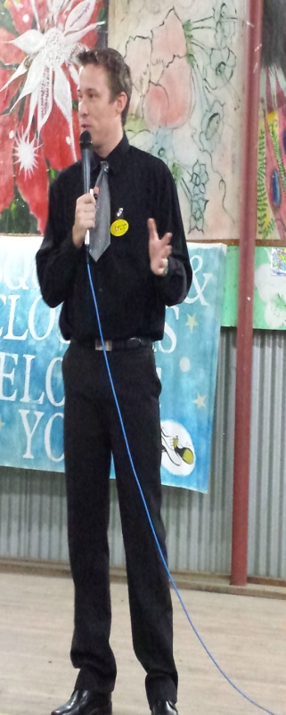
Frances Matthew

Thank you to these talented Callers for
sharing our Clubs’ special milestone 25years of Dancing and still enjoying it.

Newsletter Editor
Julie

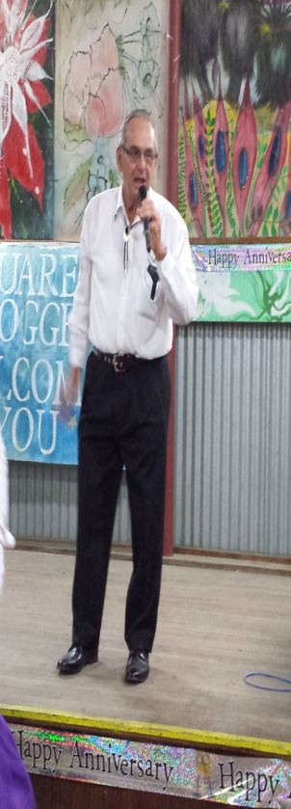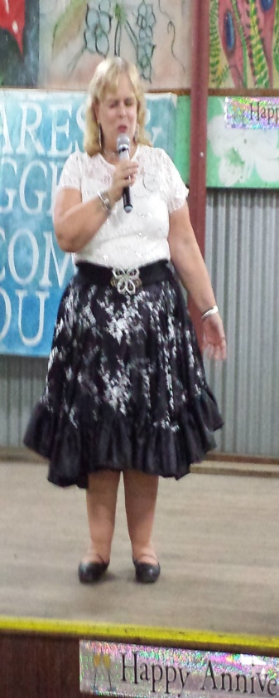
Peter Elaine
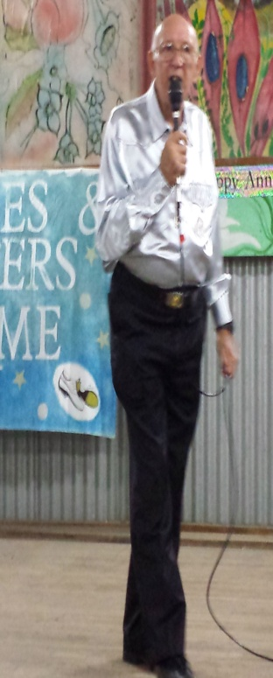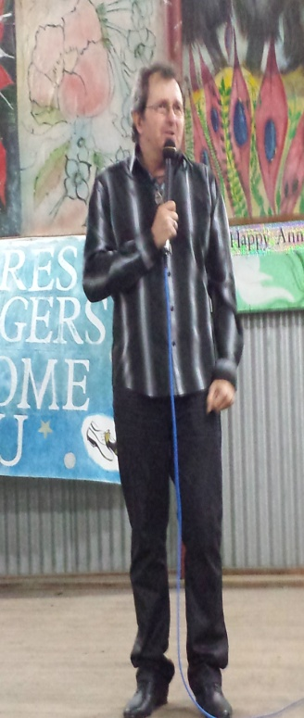
David Gary

E.Z. Squares would like to thank Mark Ryan for the use of his facilities when printing our newsletters

