|  |  |  |
| --- | --- | --- |
| Volume 01 | Edition A01 | February 2014 |

**This is your Committee;**

***Geoff Linck - Parker - President***

***Bert Bowden - V/President***

***Delwyn Linck- Parker – Secretary***

***Ted Newton - Treasurer***

***Gail Staniland – Assistant Treasurer***

***Ken McCulloch – Providore***

***Margie Webber - Co-Providore***

***Julie McCulloch – Newsletter Editor***

***Maureen Miller – Clogging Rep***

***Glenn Wilson - Caller***

***Rod Dinte - Co-Caller***

*The members of this committee, are working hard to make our club the very best it can be, “Your HELP is needed!” - This is YOUR club! How would you like it to be run? Any ideas! Come and talk to a member of the committee.*

***Welcome back to another fun filled year of Square Dancing. This year we hope to welcome many new dancers to our club, good dancing, and good friendship will develop along with some laughter as we are all put through our paces by our incredible callers. Have fun, smile lots as that is what it is all about! ☺***

We have now witnessed a number of very keen dancers that are trying out with the first 3 free nights of February, E.Z Squares welcome’s you.

*The club would like to say once again, WELL DONE! To our 13 graduating students for 2013! We look forward to another great year of dancing with all of our new and experienced dancers.*

***BE KIND TO THE BEGINNERS* *Be kind to the beginners even though they often flub, With courtesy, let's greet'em; they're the new blood of the club, And when we see them struggling, let us lend a willing hand, Guide them o'er the rough spots and to help them understand, Be good to the beginners when they join you in a square, And introduce your partner to the gent and his lady fair, And though they may be strangers when we walk into the set, Remember that a stranger is a friend you haven't met.***

**There will be a slight increase in entry fees as of 2015 due to rise in hall fees.**

Admission for all new learners for the month of February is free, after this time there will be a small fee per week of:

Child: $2.50

Adult: $5.00

Family: $12.50

Annual Membership Fees Due **NOW**

Child: $5.00

Adult: $10.00

Family: $25.00

If annual membership has not been paid, the fee per week is:

Child: $3.50

Adult: $7.00

Family: $15.00

** In case of an accident**

**We don’t ever plan on having an accident,**

**However! In the event of such an incident,**

**Please see a committee member to record this miss fortune so we can document and have on file.**

**Dates to Remember;**

**11th 18th 25th Feb 2014** beginners  **3x free nights dancing**

**30th March 2014 –“Mini Olympics” & Sausage Sizzle fun day**

**11th/12th April 2014 *“SNAKES ALIVE” Roar back to the Twenties***

**29th April 2014 - Party Night “Back to School”**

**29th June 2014 - “Xmas in July” Progressive Luncheon**

**29th** **July 2014 – Party Night “Pyjama Night”**

**4th** **November 2014 - Celebrating Melbourne Cup**

***Happy Birthday/Anniversary for all those special people that celebrate in the months of***

***February / March ☺***

[](http://www.google.com/url?sa=i&source=images&cd=&docid=zaucFnrKx3ztCM&tbnid=ZN-xynv3jtEhMM:&ved=0CAgQjRwwAA&url=http://www.highexpectationsballoons.com/&ei=4roqUrazFsfAkgXq5oCABA&psig=AFQjCNE03Uyo97nxitfU_qfIT3dpbIOXJw&ust=1378618466484098)

Birthdays and Anniversaries are celebrated on the 4th Tuesday of each month.

Keep an EYE open for **ALL - Safety signs!** These are appearing around the E.Z. Squares Hall. Please take notice and obey the distance that is stated. **This is for your own safety.**

[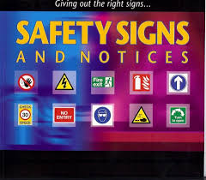](http://www.google.com.au/imgres?start=110&sa=X&biw=1301&bih=612&tbm=isch&tbnid=QyUgRfdMqrA_nM:&imgrefurl=http://www.m-f-p.co.uk/fire-signs-and-equipment/&docid=nFLlQDgqdqM2mM&imgurl=http://www.m-f-p.co.uk/wp-content/uploads/2012/03/Fire-safety-equipment.jpg&w=721&h=633&ei=VMeRUpnCOYumkgXW4IDAAQ&zoom=1&ved=1t:3588,r:19,s:100,i:61&iact=rc&page=6&tbnh=198&tbnw=226&ndsp=24&tx=87.61907958984375&ty=129.61907958984375)[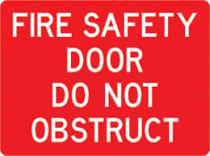](http://www.google.com.au/imgres?start=134&sa=X&biw=1301&bih=612&tbm=isch&tbnid=5kA8GxDUiCJDrM:&imgrefurl=http://www.store-safe.com/store-safe-products/safety-signs/signs/fire-signs?Page=2&Items=24&docid=b_tpfcjbF87YkM&imgurl=http://www.store-safe.com/ProductImages/Safety%20Signs/Fire%20Signs/PF31b.jpg&w=500&h=372&ei=1MiRUtGZBoXDkQW894DYDQ&zoom=1&ved=1t:3588,r:42,s:100,i:130&iact=rc&page=7&tbnh=186&tbnw=249&ndsp=24&tx=171.952392578125&ty=109.90476989746094)

*Check the notice board for: Information on upcoming events for our club and also other clubs’ events.*

*Party Nights are Theme Nights, if you choose not to come in costume, please if possible wear square dance attire as other clubs may join us*

*For these special occasions. : )*

**We need you!**

**Throughout the year, our Club has many invitations to do demonstrations at different venues. Can you help! Requirements are to be supplied with dress set attire “Please” See one of the committee members for further information.**

***THE SQUARE DANCER’S PLEDGE***

**"With all my ability I will do my best to help keep square dancing the enjoyable, wholesome, friendly and inspiring activity I know it to be.**

**This I pledge in the sincere desire that it may grow naturally and unexploited in the coming years and be available to all those who seek the opportunity for friendship, fun and harmony - through square dancing."**

*Mainstreamers! Are you interested in learning Plus?*

*You must be a competent mainstream dancer, who has been dancing mainstream for min 12 months. See a committee member for further information.*

*A reminder to all our dancers to please use the sanitizer on hands between dances, and before supper. The sanitizer bottles are provided at various locations around the hall. “ Keep those germs at bay!” NO ONE wants to be sick!!*

*Please! While our Officials* are talking- show some consideration and listen *to what they are saying.*

Kitchen News

*This is to the kind select few that bring a little something for supper each and every week; I know that we all like to have a cuppa and a little something to nibble on. That goes well with the pleasant company and conversation. I thank you!*

*At the end of each night for which some supper may remain untouched, this is the PROVIDORES job to either distribute perishables out/ or to salvage, for use at a later date.*

**THE SNAKES WILL ROAR IN 2014** “Lets Roar back to the Twenties” with;

**Snakes Alive** on 11th & 12th April 2014

EZ Squares will be heading back to the days of the roaring twenties with a themed version of “Snakes Alive” with **David Cox** as the featured caller:

The venue is Burpengary Hall, Station Road Burpengary.

**FRIDAY - 7:00** – 7:30PM Ezi Rounds

7:30 – 10:30pm Mainstream

**SATURDAY -** 10am -12 Mainstream with a difference

1pm - 3pm Plus with Pleasure

3pm – 5pm Basic/beginners

7:00 – 7:30pm Ezi Rounds

7:30 – 10:00pm Gala Squares

PRICES

Day Sessions $8.00

Basic/Beginner Session free

Evening Sessions $10.00

Weekend Ticket $25.00

For further information

Ph 0428682194 / 38821600

**Five Steps to Better Dancing**

*Helpful hints to make*

*Your Square Dancing*

*More Enjoyable*

**Keep Both Feet On The Floor – Don’t Walk!!!!!!!!**

1. Walking is **not** dancing!

When you walk, one foot is off the floor for a time and you can easily be put off balance. Using the traditional shuffle step, with both feet gliding along the floor, you act perfectly balanced. Remember, the toe should slide on the floor first.

1. **Keep Your Weight Forward**

Stay “on your toes”, don’t jar your heels and body. Smooth movement is a mark of a polished dancer.

1. **Stand Tall, Move Lightly**

Shoulders back, stomach in. Don’t “trudge”, let the music “carry” you along.

1. **Take Smaller Steps**

Men especially! You have a longer stride than the ladies have. Smaller steps make it easier to shuffle and maintain balance, and they look better! Don’t rush, there is plenty of time. Besides, the caller has to be a call ahead of you so you can dance smoothly.

1. **Listen to the Music, and Dance to the Music –**

That’sthe point of dancing. The square is simply the framework in which you move.

Take one gliding step for each downbeat of music.

Learn to pick out and start on the phase whenever possible.

Most comfortable moves are done in 8 steps or multiples or divisions of eight steps.

**☺AND…. DON’T FORGET TO SMILE** **☺**

**The committee is asking for donations of gifts for our annual Snakes Alive Raffle, could you please bring gifts to club nights and give to Delwyn, who will organize these for Snakes Alive.**

**Looking back:**

Last November a set from our E.Z.Squares Club joined in the excitement of the annual “Carols by Candle Light” at Minimbah State School. Four of our youngest graduates along with four adults, provided a small insight into square dancing with a demo, called by none other than Santa “Alias” Rod who arrived via police escort with lights flashing, children’s eyes and laughter said it all! When Santa started to call to the square, the children were amazed! ‘But don’t you know that Santa knows everything!’

Even how to call square dancing : )

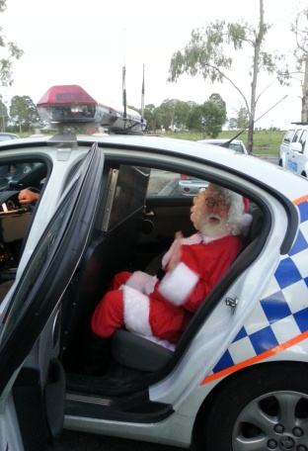

***Santa arriving under police escort.***

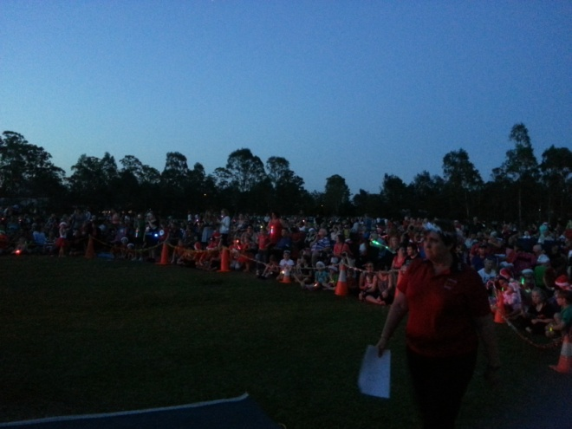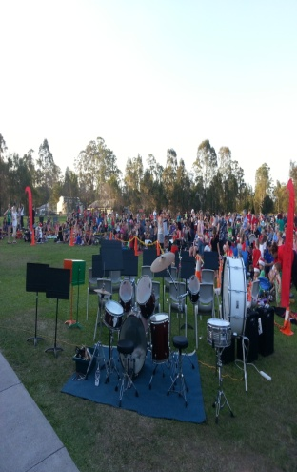

***Minimbah State School’s “carols by candle light” on looking were around 700 mums, dads and children.***

3rd December 2013 also saw, our club’s Christmas break up dance. A lovely atmosphere welcomed the many visitor’s and club dancers on our last break up dance of the year. 6 square’s dancing to our wonderful callers and guest callers- who put the dancers through their paces, so so proud of our newest graduates…. Practice makes perfect! Keep up the good work.

Special mention also goes to the hard workers that decorated the hall on this occasion. Not forgetting the hard working kitchen organizers that prepare supper each and every week.

6th December 2013, Mr. Mac’s Minimbah Mini Square’s annual break up.

This break up is only for a select few, for those that work with Mr. Mac throughout the year learning the very basic moves to square dancing; these children don’t have an allocated time to learn this activity, they come along in their lunch break of 20 minutes once a week.

E.Z Squares sponsors Minimbah Mini Squares- So as a little something extra for these! “ The newest of dances” Some of our own club members come and join with these children to help guide them through the many moves, while having fun learning square dancing. On the floor 5 squares of children and parents guided by Ken & Glenn the look of delight on the faces of all those that mastered the many moves.

Ken “Mr. Mac” would like to Thank Glenn and all club members for their time, those in the kitchen Julie, Sue, Lorre, and Mick, those on the door, Mi-chal and Robyn, and a Special **Thank you** to Rowena McCulloch Manager of Eagle Boy’s Pizza Caboolture for donating pizzas on the night.



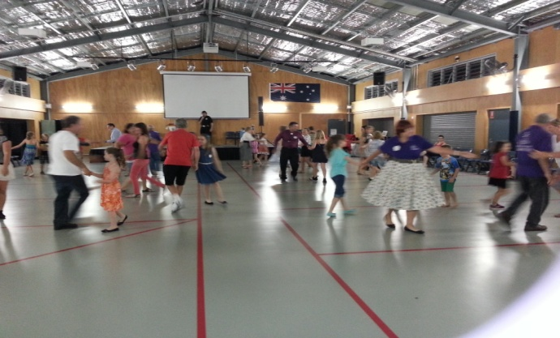

***5 sets on the floor dancing.***

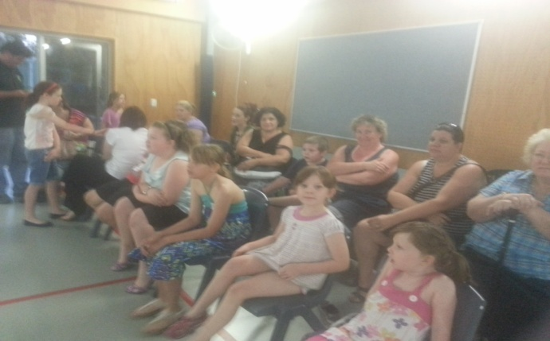

***Eager to learn square dancing.***

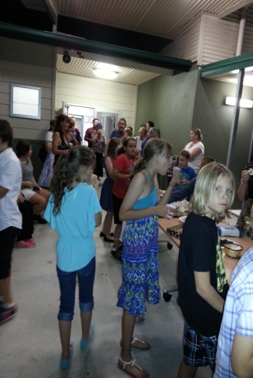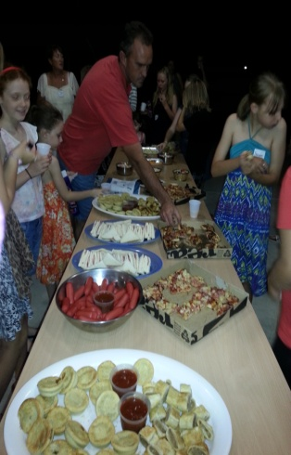

***Supper at the end of the night.***

8th December 2013:- Christmas in the Park. Where did that time go? It seems to come around all too fast these days. As always thanks must go out to the committee members for the organization of this event. Geoff and Delwyn arrived at 7.20 am for the setting up of the day followed closely by Ken the providore with all the necessary’s for the catering for the day. With all set up, some time to chat will awaiting the readiness of our meal from Red Roster, members arrived, children played treasure hunt, Santa arrived, presents were given out, time to sit and chat to Santa. Food was served, what a fantastic day had by all. Thanks again to all concerned in the organization of the food and the day.

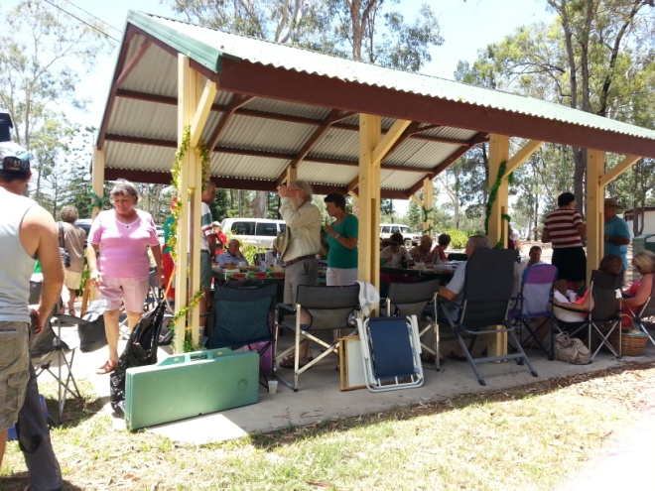

***All set up for the day***

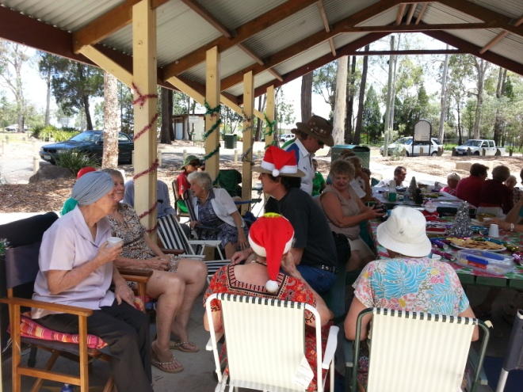

***Chats and laughter with friends***

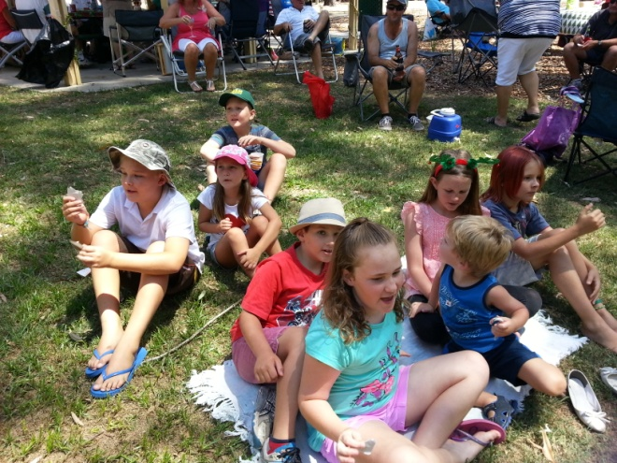

***Children waiting patiently for Santa***



*Rod and Delwyn would like it known, that they are qualified JP’s*

**Joke of the day: ‘Math’s Test’**

***An Irish man wants a job, but the foreman won’t hire him until he passes a little math test, this is the first question the foreman asked.***

**“Without using numbers, represent the number 9”**

*Without numbers? The Irishman says? “Dat is easy” and proceeded to draw three trees.*

***What’s this? The boss asks.***

**“Have you ain’t got no brain?**

*Tree and tree plus tree make’s 9**says the Irishman.*

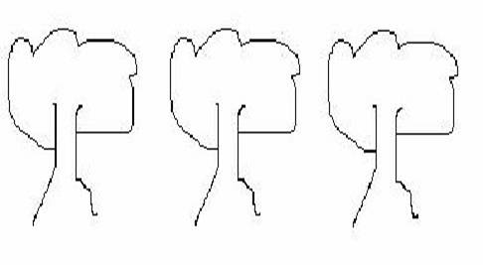

***“Fair enough,” says the boss*. “Here’s your second question. Use the same rules, but this time the number is 99.”**

*The Irishman stared into space for a while then, picks up the picture that he has just drawn and makes a smudge on each tree…..”Ere you go” represents 99?”*

*“Each of da trees is dirty now. So, it’s dirty tree, and dirty tree plus dirty tree. Dat makes 99”*

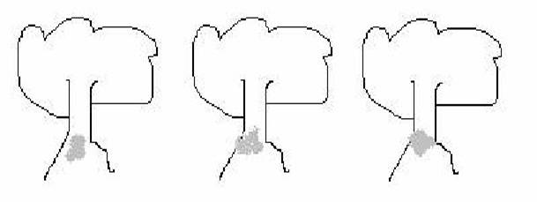

***The boss is getting worried that he’s going to actually have to hire this Irishman, so he says,* “All right, last question. Same rules again, but represent the number 100.”**

*The Irishman stares into space some more, then he picks up the picture again and makes a little mark at the base of each tree**and says “Ere you go” One hundred.”*

***The boss looks at the attempt. “You must be nuts if you think that represents a hundred!”***

*The Irishman leans forward and points to the marks at the base of each tree and whispers, “A little dog came along and poop by each tree, So now you have got dirty tree and a turd, dirty tree and a turd and dirty tree and a turd, which makes* ***ONE HUNDRED***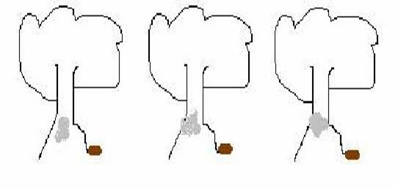

***_____________________________________________________***

**Newsletter Editor**

Julie

***E.Z. Squares would like to thank Darren Grimwade MP for the use of his facilities when printing our newsletters***