Volume 04 | Edition A 04 | December 2016

THE COMMITTEE:
Geoff Linck -Parker –President
Julie McCulloch - Vice President
Yvonne Brittingham– Secretary
Ted Newton - Treasurer
Ken McCulloch– Assist Treasurer
Julie McCulloch –Newsletter Editor
Margaret Webber – Providore
Debbie Webber - Co-Providore

Maureen Miller – Clogging Rep

CALLERS:
Glenn Wilson - Senior Caller
Rod Dinte
Elaine Davis
Ken McCulloch

Message from the President-

First of all! Merry Christmas to all, -and a very Happy, Healthy and safe New Year.

Even though the number of dancer’s on club nights have been small, I still believe that we have had an enjoyable year.

We only had two beginners in Carol and Debbie, who, with Glenn`s expert teaching ability have progressed quite well in their endeavor to square dance

Because of the club`s reunion and promotion day the initiative to begin another learners class in September was taken by Glenn, and we saw some more beginners and a number of past dancers return.

I would like to encourage all dancers to try to recruit new dancers and persuade others to return to our ranks of square dancing, so please don`t just leave it to your committee to swell the numbers.

It is not just now that you need to endeavor to boost the number of square dancers but keep doing it for as long as you have the passion for the fun and exercise that you derive from this wonderful dance genre.

In conclusion I would like to thank my fellow committee members for a job well done particularly for all the hard work that goes on behind the scenes and sometimes at your own expense to keep EZ Squares a viable organisation.

Regards

Geoff Linck-Parker

President
Glenn’s Christmas Message
Thank you! Everyone - for another great year at E Z Squares during 2016.

I started as one of the club callers here back in 1995 and have only had small breaks in all that time. Apart from 6 months off, when I had no drivers license.

Thanks to Ken, Elaine & Rod for their help with the calling this year and I hope that at least Ken & Elaine continue to call for the Club.

Rod is in retirement and is enjoying it, by all accounts.

Thanks to the committee for their continued support. Thanks Margie for always having my supper ready, even when I take “The Mickey”’ and don’t deserve it.

Also thanks to all the dancers for at least attempting to dance everything I call, even when I call stuff that’s a little sus’.

For the first time, I have to miss the Christmas party due to work commitments, that’s not bad over 21 years. Hopefully it will be another 21 years before it happens again.

Congratulations to our 2016 Graduates, Carole & Debbie – keep up the dancing.

Not only will you get better at it, it’s healthy and a lot of fun.

To our 2017 Graduates, you’ve made a really good start – enjoy the Christmas break but please come back in the New Year and we’ll continue the journey.

Everybody, enjoy your Christmas break (I know I will), come back refreshed and rearing to go in the New Year.

If you are travelling, do so safely – If you are drinking, do so moderately.

If you are eating – go nuts with Christmas goodies, we can burn it off dancing.

Have a great Christmas & New Year, see you afterwards.

All the best,
Glenn.

September 2016 – Saw a new intake of beginners / and refresher classers begin
Start time 7pm – 8pm for beginners / refreshers.
Mainstream - follows.
At the end of the evening - all join in the kitchen for some yummy supper, the committee extends their appreciation to all that bring along to share (supper),
If it wasn’t for you kind people it would just be a cuppa!

Birthday’s are celebrated on the 4th Tuesday of every month – Debbie and Margie organise through the Bakery named below, for the Mouthwatering Birthday or Celebration Cake.

“Please Remember”!
Square Dancing is done - all by hand gestures a lot of these are hand touching. Remember to use the HAND SANITISER to stop the spread of germs. Our club is happy to provide this, please use to keep those bad germs away.
Dates to Remember –2017

7th Feb 2017 – Mainstream Dancers Only
14th / 21st & 28th Feb - FREE entry for New Beginners
Party Nights
Special Events
Will be confirmed in the New Year 2017

Annual Membership Fee:
To be paid before the AGM

Admission Fees per Dance Night
Child: $2.50
Adult: $6.00
Family: $14.50

Annual Membership Fees.
Child: $5.00
Adult: $10.00
Family: $25.00

If Annual Membership has NOT been paid, the Fee per Dance Night is:
Child: $3.50
Adult: $7.00
Family: $15.00

AS OF FEBRUARY 2017 – PRICES FOR ENTRY WILL NEED TO BE AJUSTED, DUE TO HALL HIRE INCREASE. THE COMMITTEE WILL KEEP YOU UP DATED IN THE NOT TO DISTANT FUTURE.

Happy Birthday/Anniversary for all those special people that celebrate in the months of
September /October / November and December

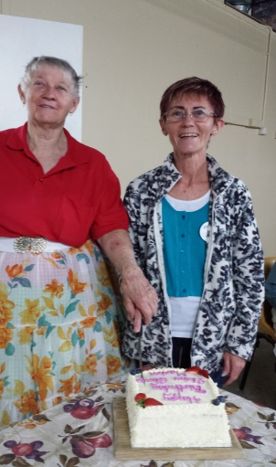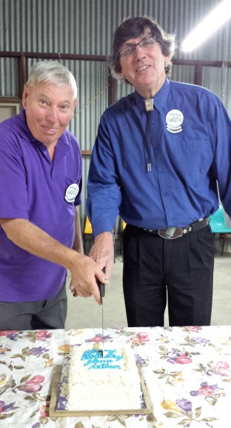
Birthdays in September – Birthdays in November-
Elaine, Kaye & Marion Glenn and Arthur
Thanks Margie and Debbie
for the stand in.

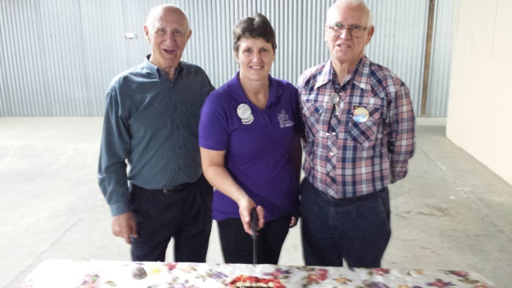
Birthdays in October-
Mac, Julie & Russel

The Club Celebrates Birthdays on the 4th Tuesday of every Month
If you don’t tell us the Month your Birthday is! We may not have a cake to celebrate with.

There are several levels of Square Dance moves.

Basic
You will learn the basic moves. There are approximately
45-50 moves which you learn throughout the year.

Mainstream
The next level! Most square dance nights cater for mainstream dancers. Once you reach this level, you can dance at other clubs, attend festivals and travel the world.

Graduation
To celebrate you becoming a Mainstreamer, the Club holds a special welcoming ceremony called graduation. It symbolizes graduation into the main body of square dancers.

Plus
For many mainstream is enough. You can get all the fun and socializing you want at mainstream level. However some enjoy learning new moves. They go onto learn another set of moves called Plus. It doesn’t make them better dancers, or set them apart. They enjoy learning new moves.
You will enjoy Plus more if you know your mainstream very well. Most clubs like you to dance a year at mainstream level after your graduation before you attempt Plus.

A1 & A2
The “A” level is a further group of moves which a few people enjoy learning. There are also further levels but are rarely danced.

E.Z Squares (pronounced- Easy Squares) is very proud to introduce the 2016 graduate’s
Debbie Webber and Carole Goldsmith
Well done Ladies
DON'T FORGET:
"A SMILE ON YOUR FACE
HELPS YOUR FEET WORK BETTER”
What to do when a square breaks down
Do NOT panic!
Do NOT blame yourself!
Don’t Blame anyone!
It happens frequently!

How to Resume Your Square
•Take your partners hand.
•Head Ladies take your Corner’s hand.
•Form lines at sides of Square.
•Wait for “up to the middle and back” or left Allemande”.

WORLD WIDE DANCE MOVES
Square dance calls are standard around the world. Once learnt, you can dance in any country, all callers call in English, regardless where you might be dancing.

Receive the Bugle on line using this web site:
http://www.squaredancingsocietyofqueensland.org/the-bugle.html

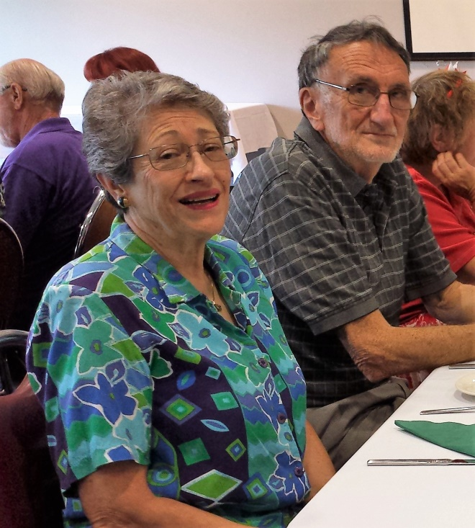
Congratulations Ted and Gail on your recent Marriage, all the very best for the future.

Christmas Luncheon –
Centenary Lakes Bowls Club
Sunday 27th November 2016
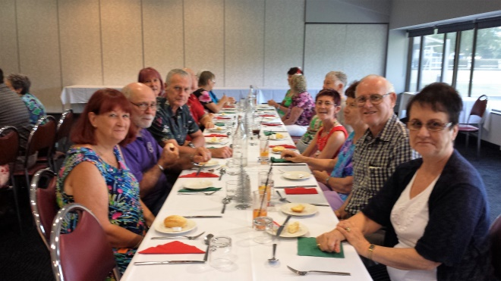

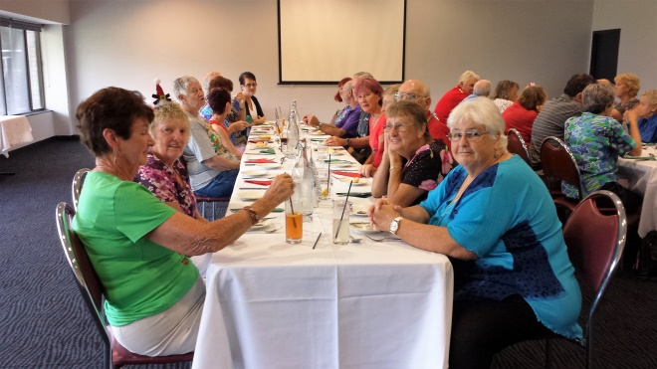

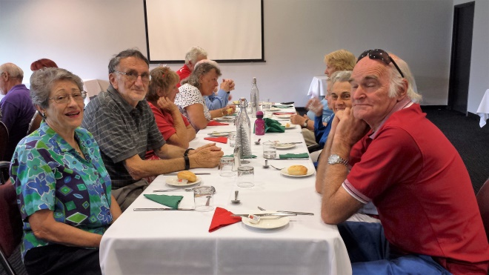

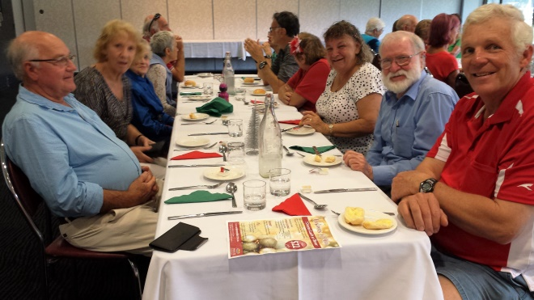

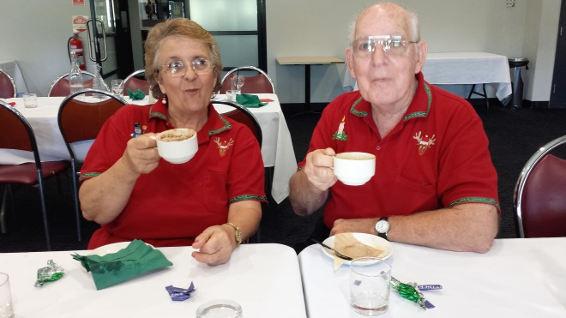

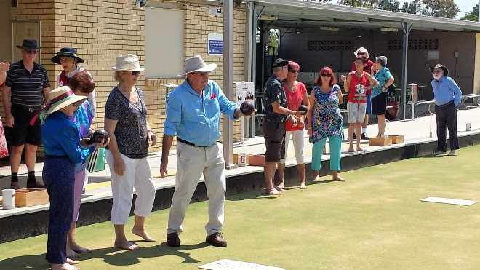

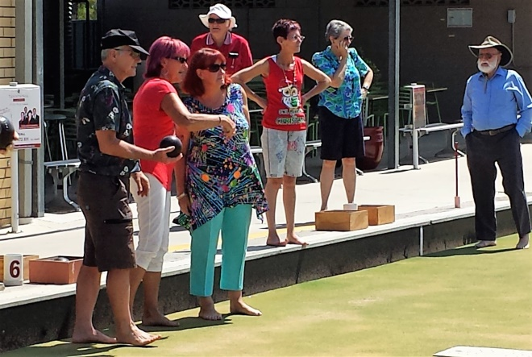

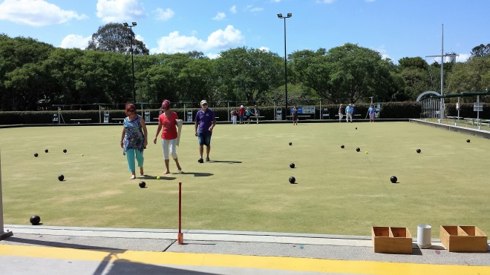

A great day, spent with great company. Thanks to the Square Dance Committee for the organisation of this fine event.

Graduation 2016
Carole and Debbie congratulations and well done on mastering the beginners and mainstream program put before you this year.
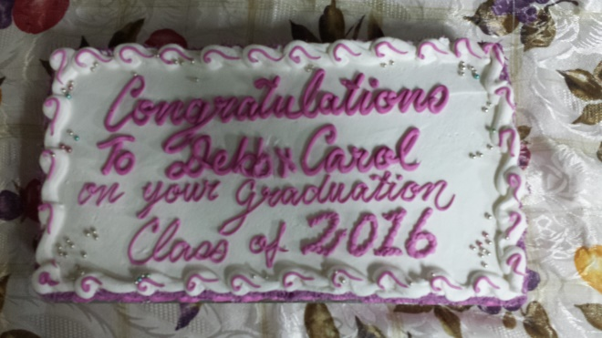

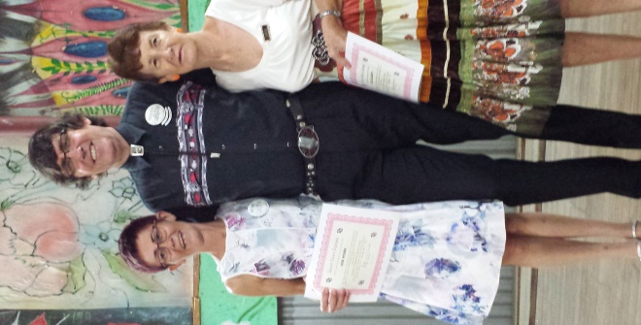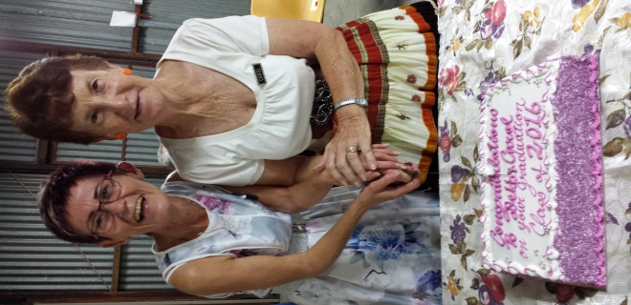

E.Z Squares (pronounced- Easy Squares) is very proud to introduce the 2016 graduate’s
Debbie Webber and Carole Goldsmith
Well done Ladies

DON'T FORGET:
"A SMILE ON YOUR FACE
HELPS YOUR FEET WORK BETTER”

In appreciation to Minimbah State School for allowing us usage of their Hall – Presentation of this beautifully mounted engraved clock to the Principal Sean Bennett with Thanks

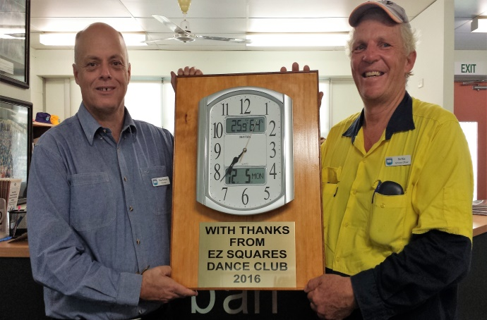

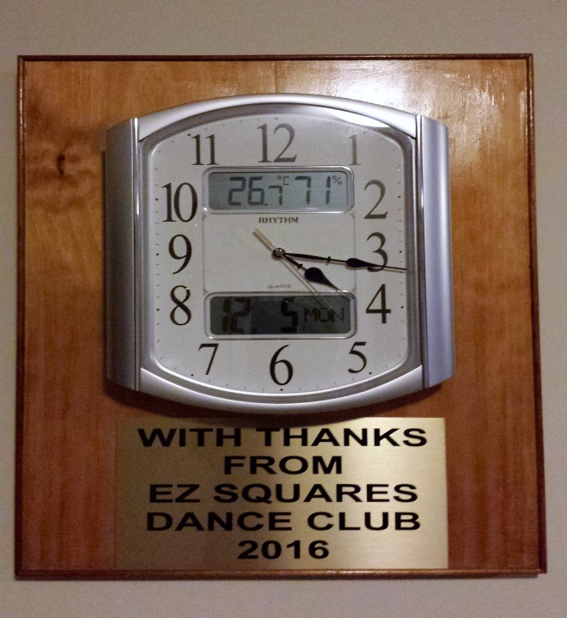

Announcement:
To our Dear and Cherished Square Dance Friends,

Ken and I would like to inform you all, of our “Exciting News”!
We are having a life style change- meaning: our very busy work style will be lightened with the decision we have made:
The end of January 2017 will see the selling of our home and a move out west, to a little place called Hannaford! –
I will be the school cleaner at a school with only 10 students, while running a small country Post Office Agency and Camp Ground along with keeping the Community Club grounds neat and tidy, also reading the rainfall(when it happens).

Ken is also working at the same school, still doing grounds and handyman work, along with helping keep the Community Grounds neat and tidy, also doing various odd jobs around the district.
We will be seeing a lot more of each other! (That’s the plan anyway).
Thank you for all being great
Friend’s.

We will keep in touch
Keep on Dancing and ENJOY!

Julie and Ken

My final Newsletter,

I have enjoyed bringing the EZ Squares Dance Club Newsletter to you all.
It is time now to wish the Committee and Dancers
All the very Best for the future.
As I sign Off on my final Newsletter

Newsletter Editor
Julie

E.Z. Squares would like to thank Mark Ryan for the use of his facilities when printing our newsletters

