|  |  |  |
| --- | --- | --- |
| Volume 03 | Edition D24 | August 2013 |

**This is your committee;**

*Geoff Linck - Parker - President*

*Bert Bowden - V/President*

*Ted Newton - Treasurer*

*Gail Staniland – Assistant Treasurer*

*Delwyn Linck- Parker – Secretary*

*Ken McCulloch – Providore*

*Margie Webber - Co-Providore*

*Julie McCulloch – Newsletter Editor*

*Maureen Miller – Clogging Rep*

*Glenn Wilson - Caller*

*Rod Dinte - Co-Caller*

*The “committee” is working hard to make our club the very best it can be, “Please help us”, - by making suggestions, on how to make it even better! This is your club how would you like it to be run?*

**Something to think about!**

As we are now in the later part of the square dancing year and the time is fast approaching where we will be calling on nominations for the committee for 2014.

 I encourage each and every one of our members to seriously consider nominating for a position on the committee so our club can keep providing the dancing we all enjoy.

Most of the present committee has held office for a number of years and some will not be standing for election for the coming year.

As our club is a committee run club we need a functioning committee to maintain a functioning club.

Geoff Linck-Parker

President

**Barefoot Bowls Day**

What a great morning we had recently at Pine Rivers Bowls Club where 17 of our members and partners enjoyed themselves.

9am saw us sitting on the deck being served a delicious breakfast of pancakes with jam, cream, maple syrup and strawberries.

After our fill, we proceeded to the greens for tips on how to play lawn bowls then off we all went with all this knowledge to start bowling. WELL…………..

Barefoot (or flat shoes) Bowls or Square Dancing?

That is the question we need to answer after considering all the facts:-

(1)  In square dancing we don’t have gutters for the bowls to end up in

(2)  In square dancing we don’t have to worry about which side of the bowl has the small marking

(3)  In square dancing we don’t have to worry about which way the bowl will decide to go

(4)  In square dancing we don’t have to worry about our bowls ending up in the adjoining teams green

(5)  In square dancing we have music to move to

(6)  In square dancing we never make mistakes (only the callers do that!!).

Think maybe most of us should stick to square dancing but we had a lot of fun anyway.

Photos to follow;

Anon.

***Basic Dancers***

Well done to all our newer dancers, you are now ***Basic*** dancers.

Basic is just one of the levels of square dancing and is a milestone in your dancing career.

You have mastered 53 movements in the square dance language and are hopefully

enjoying yourselves still. By the time you are reading this, you will have had 4 weeks

revision at this level. I’m really proud of you all, and you should be proud of yourselves.

Square dancing is not the easiest thing in the world to learn, anything that is worth learning is rarely easy. This activity can give you a lifetime of enjoyment as well as lifelong friends, if you stick with it. It can take you around Australia or the world if that’s what you want. But if you only need the club experience, that’s all it has to be.

Your next step is the ***Mainstream*** program, another 16 or so movements.

Mainstream is the standard level of dance throughout Australia. The beauty of the next 16 moves is, you already know most of them. They are usually combinations and/or

extensions of the 53 Basics that you have already learned. It will take us most of the rest of the year to achieve Mainstream, have fun with it.

There will be a graduation ceremony

in November. But here’s the good news, there is no test and no required pass mark.

The other good news, after that, you don’t have to learn any more new moves unless you want to.

All the best,

Glenn.

**Ten Commandments of Square Dancing**

***I.  Thou shalt honor thy Caller and harken to his voice -- for thy success depends greatly upon his words.***

***II. Thou shalt exchange greetings and be friendly to all in thy group - lest thee be labeled a snob and unworthy of thy title - Square Dancer.***

***III. Thou shalt not ridicule those dancers possessing two left hands -but endeavor to help them distinguish one from the other.***

***IV. Thou shalt strive to dance in different squares -thereby giving to all, the benefits of thy fine personality and great experience.***

***V.  Thou shalt not anticipate nor dance ahead of thy Caller for  he is of fiendish nature and possessed of evil powers to foul  thee up and make thee appear an idiot in the eyes of thy  fellow dancers.***

***VI. Thou shalt not, when thee has goofed -- moan and belittle thy Caller, thy Partner, nor the slippery floor for thine own stupid mistakes.***

***VII. Thou shalt bathe diligently before the dance - thereby creating a pleasant aroma for thy Partner and leaving the more earthly smells to the factory and the barnyard.***

***VIII. Thou shalt remain silent while thy Caller gives advice and instructions lest he go berserk and mumble to himself and offer to break records on thy unworthy head.***

***IX. Thou shalt not partake of strong drink before nor during the dance - lest thy mind become befuddled and thee ends up with thy foot in thine own large mouth.***

***X.  Thou shalt strive to observe these Commandments and thy reward shall be great. Many friends shall thee have and thy name shall be listed among the finest people - The Square Dancer!***

**E.Z. Squares visit to Light House Squares 26th August. If requiring a lift please see a committee member.**

**Dates to Remember;**

**24thAug -** Sunshine State Round Up venue: Bribie Island

**26th Aug -** Visit to Light house Squares

**22nd Sept** -Car Observation Run

**27th-29th Sept-33rd** Qld State Square Dance Convention venue: Ferny Hills

**29th Oct -** Party night theme “Nautical but Nice”

**29th Oct -** Light House Squares visit to our club

**19th Nov -** Graduation and Club Birthday

**26th Nov** - AGM

**3rd Dec -** Xmas Dance break up

**Kitchen News.**

On behalf of the Providore’s, thank you for your contribution to our evening supper without your support there would only be tea and coffee.

***“A special Thank you”***

I would like to extend my sincere appreciation to all that take some time out of their dance routine to help Ken and I (Julie) prepare the evening supper, while Maggie is out of action. Thank you :)

***Here’s hoping for a Speedy recovery “Maggie!”***

***Happy Birthday/Anniversary for all those special people that celebrate in the months of August, Sept& Oct ☺***

***Clogger’s News***

A fun weekend at "Aussie Clog", though it was really disappointing to see so few EZ Cloggers staying for the weekend.  
When we can't go to Aussie Clog because it was cancelled due to lack of support, then we all miss out.   
There were some really great dances and great fun with friends old and new. Nathan did the most amazing dance; check it out on the ACA Face book page. Thanks to all of you who rolled up your sleeves and helped out with the evening meal. EZ club has always been good at getting in and helping, and the tradition continues.  
We always get rostered on for the evening meal because they know that we are happy to help and we can cope with those mountains of dishes. Obviously Stephen is kitchen trained too; he was in there helping out.  
What an amazing job Olive and Sunstate Cloggers do.  
The National ACA Convention is next on our calendar. You should have your registration in by now.  
September 13, 14, 15 in Queanbeyan  
Are you a member of the Australian Clogging Association? Cost of $20 a year.   
Your membership entitles you to:​​​​  
¬​Receive the quarterly newsletter  
¬​Discount on ACA merchandise  
¬​Discounted rate for the National Convention   
¬​Borrow items from the Resources Library  
¬​Vote on State Showcase routines at the National Convention   
¬​Participate and vote on motions at the Annual General meeting, and  
¬​Dancer insurance cover (see further information on their website)  
  
Website: www.cloggingaustralia.com. Phone: 1300 780 017  
 E-mail: secretary@cloggingaustralia.com  
  
 I have added this to our Clogging News, as I would like you all to be aware that the ACA has dancer insurance cover. We would hate you to have a fall on the dance floor, but wouldn't it be nice to know you do have insurance cover when on the dance floor.  
Always take care when clogging, have fun but be careful.  
Thank goodness we don't yet have cloggers texting on the dance floor.  
Our new polo shirts look good in a bunch, and if you're a bit cold, have a look at my new jacket.  
A huge Thank you to Stephen for his continued patience while teaching us EZ Cloggers.

Maureen  
Clogging Representative.

*A reminder to all our dancers to please use the sanitizer on hands between dances, and before supper. The sanitizer bottles are provided at various locations around the hall. “ Keep those germs at bay!” NO ONE wants to be sick!!*

*Please! While our Officials* are talking- show some consideration and listen *to what they are saying.*

*Check the notice board for: Information on upcoming events for our club and also other clubs’ events.*

*Party Nights are Theme Nights, if you choose not to come in costume, please if possible wear square dance attire as other clubs may join us*

*For these special occasions. : )*

Weekly Admission once annual membership is paid:

Child: $2.50

Adult: $5.00

Family: $12.50

Annual Membership Fees Due NOW for 2013

Child: $5.00

Adult: $10.00

Family: $25.00

If annual membership has not been paid:

Child: $3.50

Adult: $7.00

Family: $15.00

**BE KIND TO THE BEGINNERS**

*Be kind to the beginners even though they often flub,*

*With courtesy, let's greet'em; they're the new blood of the club,*

*And when we see them struggling, let us lend a willing hand,*

*Guide them o'er the rough spots and to help them understand,*

*Be good to the beginners when they join you in a square,*

*And introduce your partner to the gent and his lady fair,*

*And though they may be strangers when we walk into the set,*

*Remember that a stranger is a friend you haven't met.*

***Sunshine State Round up***

Come and join a great day of dancing on 24th August at the *Sunshine State Round up.* See notice board for details

**Car Observation Run**

22nd September will be E.Z. Squares next social event. Come and join in the fun as all will follow instructions and cryptic clues – to find our way to our destination. byo own food and drink, join us for lunch and a chat.

See notice board for more details

**Looking Back**

Recently, our club had its party night; theme held was Sports. It was wonderful to see so many of our dancers taking pride in dressing for the occasion. Photos to follow

**33rd Queensland State Square Dance Convention 27th – 29th September 2013**

**Venue:**  *Ferny Hills State School*

*Illuta Avenue, Ferny Hills Qld 4055*

**Extra Venue:** *Hills District Community Centre*

*291 Dawson Parade, Arana Hills 4054*

*Squares – Rounds – Clogging – Contras*

*Spectators are welcome at all sessions – free of charge*

See Notice board for more details

**Minimbah Mini Squares Update:**

Third term has commenced, and the grade 3 students are starting to learn square dancing. These children are 8 years old, this takes place on a Monday, during their lunch break of about 20 minutes. So far between 20 – 30 eager 8 year olds, have come along and started to learn the ***very basic*** moves to square dancing. My intentions for these children are for them to enjoy themselves and have fun whilst learning square dancing: *after all* *that is what Square Dancing is all about.* Having fun and enjoying yourself.

Ken (Mr. Mac)

Newsletter Editor

Julie

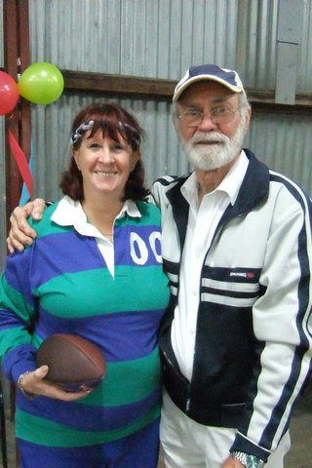

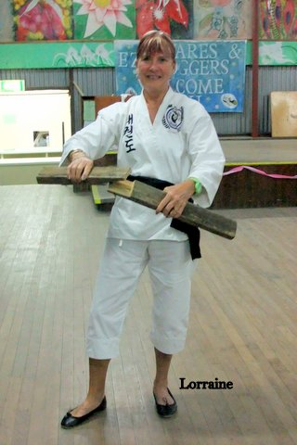

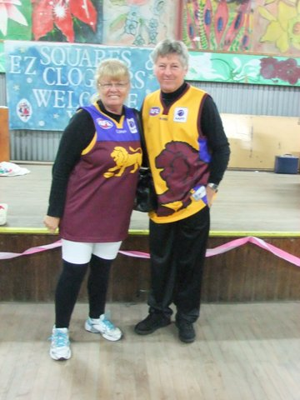

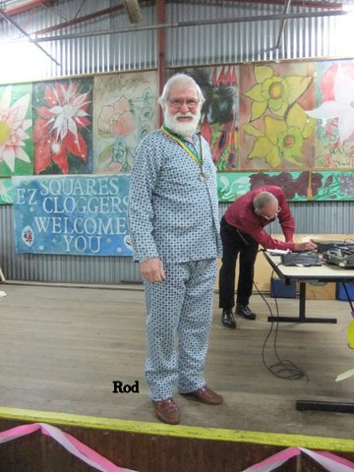

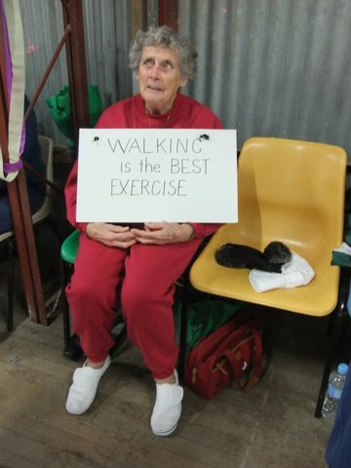

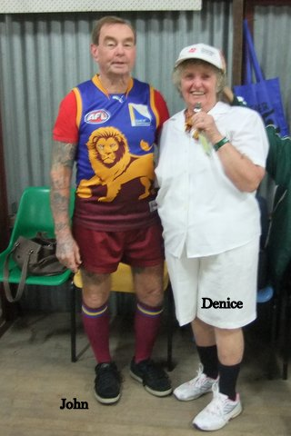



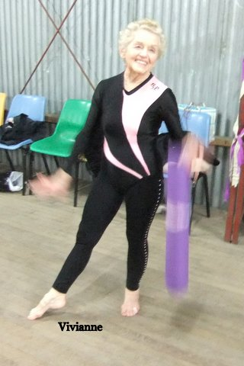

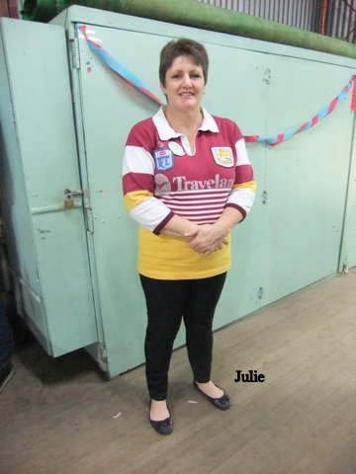

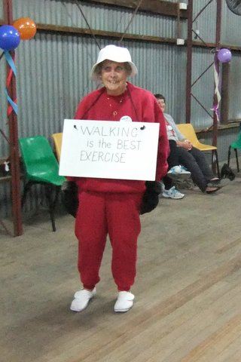

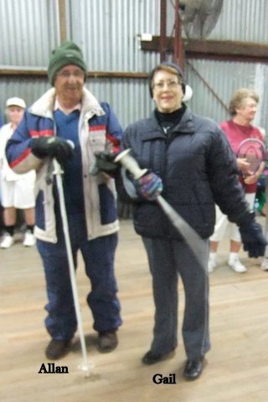

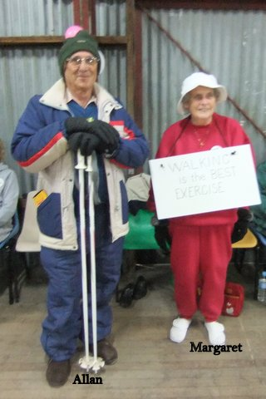

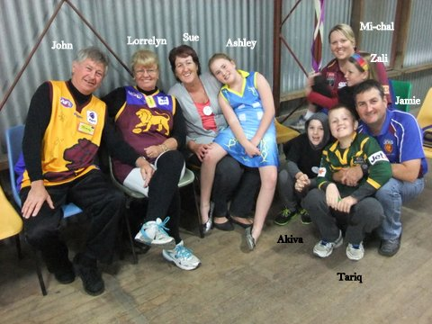

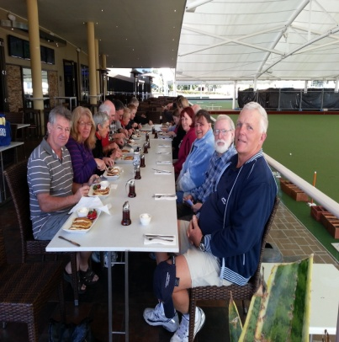

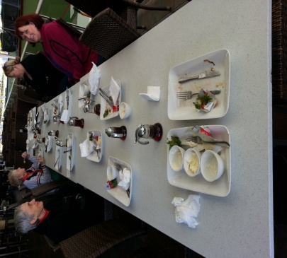

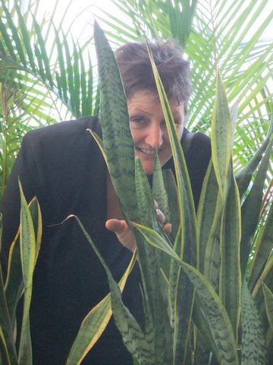

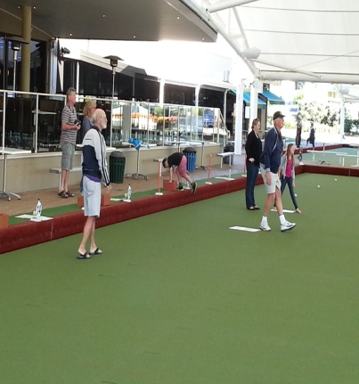

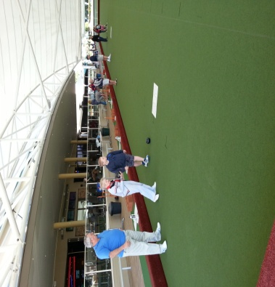

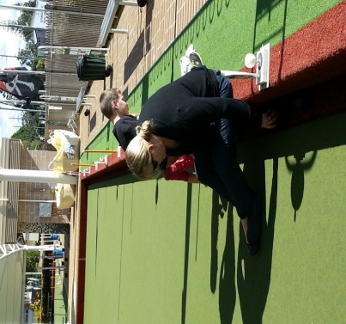

*E.Z. Squares would like to thank* ***Darren Grimwade MP*** *for the use of his facilities when printing our newsletters ☺*