Volume 03 | Edition A 03 | August 2016

THE COMMITTEE:
Geoff Linck -Parker –President
Julie McCulloch - Vice President
Yvonne Brittingham– Secretary
Ted Newton - Treasurer
Ken McCulloch– Assist Treasurer
Julie McCulloch –Newsletter Editor
Margaret Webber – Providore
Debbie Webber - Co-Providore

Maureen Miller – Clogging Rep

CALLERS:
Glenn Wilson - Senior Caller
Rod Dinte
Elaine Davis
Ken McCulloch

Condolences – Go out to Geoff and Delwyn, on their recent loss. Our thoughts are with you at this difficult time
All your friends/colleagues at E.Z. Squares extend their sincere sympathy.

Recently- due to the Caboolture Show and Farm Fantastic:
5 Nights were arranged in May/ June for dancing at the Minimbah State School. Most nights there were 2 sets which was wonderful to see.

I would like to give Minimbah State School an enormous Big Thank you for allowing us the use of their Hall, I might add, at NO cost to the club (Thanks Ken and Julie for the organization that went into this)
28th June the National Square Dance Convention took place, our “Glenn” attended! According to all reports, it was a great success.

Here at our Dance venue, Rod and Ken shared the evening, some great laughs and dancing was had, right to the end of the evening - a lovely supper was had.

Thanks - Rod and Ken

New Beginner classes
6th September 2016
Start time 7pm – 8pm
Mainstream to follow as per normal

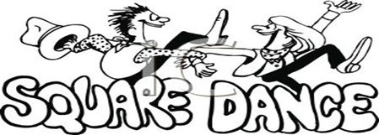
EZ Squares Social Day was held on Sunday 21st August 2016
Car Observation Drive.
Started at Burpengary Community Hall 10am sharp. - After our instructions were given away we went - all 5 vehicles, Navigators and Drivers. No cheating, we were staggered. The drive took us all the way through back streets, eye’s peeled for the clues (I might say a great way to see what is taken for granted on just a normal drive) After almost an hour arrived at the destination- Sandstone Point, Arthur was waiting to check all the answers/ mileage, as a few of us traveled a little further than supposed to.
Lunch was had, presentation was done:
Ken and Julie 1st
Geoff Maggie and Lorraine 2nd
Brenda and Helen 3rd
Thanks Arthur! When can we do it again?

Arthur – Checking all paper work

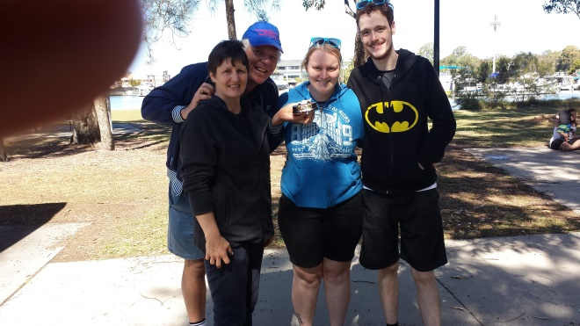
1st Place
2nd Place
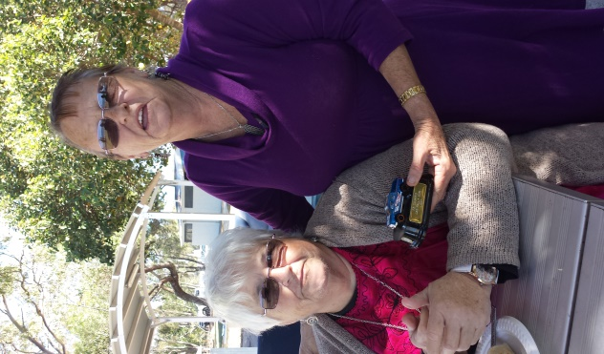
Last place
A reminder to all our dancers to please! “Use the sanitizer on hands” between dances, and before supper. The sanitizer bottles are provided at various locations around the hall. “Keep those germs at bay!” NO ONE wants to be sick!!
Dates to Remember –2016

6th Sept 2016 – Beginner Classes Start
1st Nov 2016 – Melbourne Cup Night
29th Nov 2016 – Party Night Cryptic
(Who am I) Night
29th Nov 2016 –Graduation / Family& Friends
6th Dec 2016 – Christmas Break up Dance

Annual Membership Fee:
To be paid before the AGM

Admission Fees per Dance Night
Child: $2.50
Adult: $6.00
Family: $14.50

Annual Membership Fees.
Child: $5.00
Adult: $10.00
Family: $25.00

If Annual Membership has NOT been paid, the Fee per Dance Night is:
Child: $3.50
Adult: $7.00
Family: $15.00

Happy Birthday/Anniversary for all those special people that celebrate in the months of
June, July and August
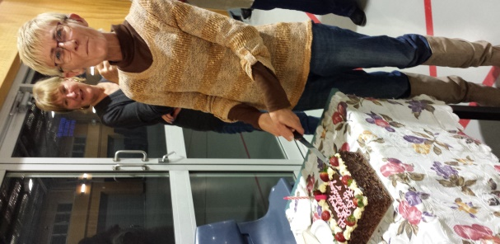
Birthdays in June -Lorraine, Birthdays in July – Debbie
Colin and Ken and Kaye

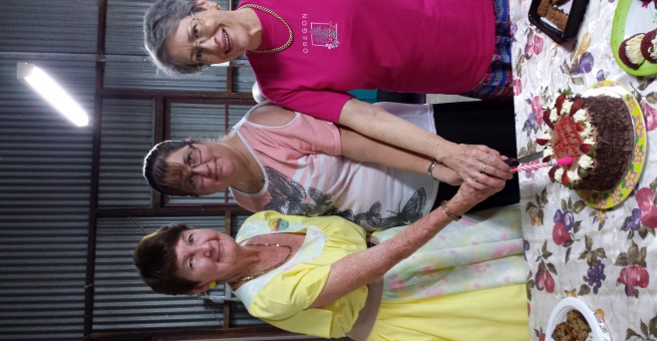
Birthdays in August – Gail, Freda, Linda and Tracy

The Club Celebrates Birthdays on the 4th Tuesday of every Month
If you don’t tell us the Month your Birthday is! We may not have a cake to celebrate with.

Mango Hill Bakery Café – Prepare the Birthday Cake each Month

Kitchen News: -
Thank you to all club members for assisting in supper each and every week.

Maggie and Debbie

Receive the Bugle on line using this web site:
http://www.squaredancingsocietyofqueensland.org/the-bugle.html

27th August - The 3 R’s - Reunion, Revision and Recruitment:
A day of the 3 R’s, - who would have thought! When initially mentioning a reunion, to bring back those that have been active in the running of this club and participating in dancing - a decision was made! why not do a revision and a recruitment day as well.
What a great Day had by all! Reunion – good to welcome back many familiar club members, Revision - Many that had graduated and came back to participate, -and lastly:
Recruitment - I do believe we have cast our magic spell, at least 3 maybe 4 newbie’s in the not too distant future.
Many thanks to all the committee members for assisting in this great day.
Special mention to Glenn for the running of the event.

Group Photo - The 3 R’s

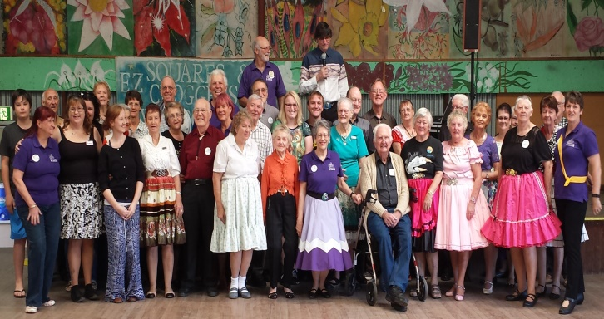

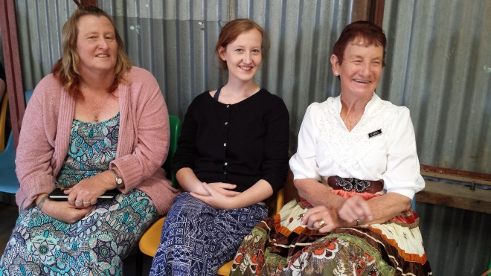

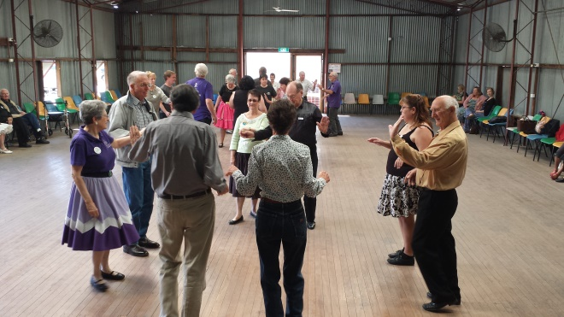

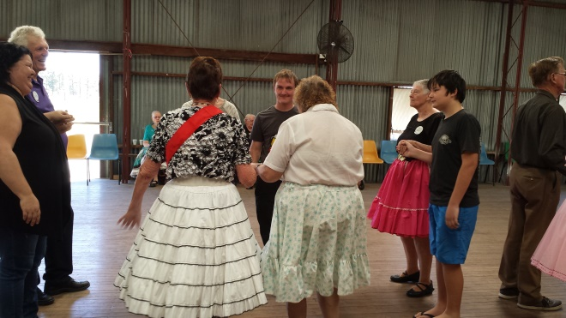

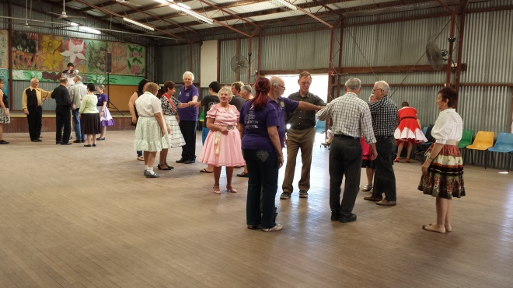

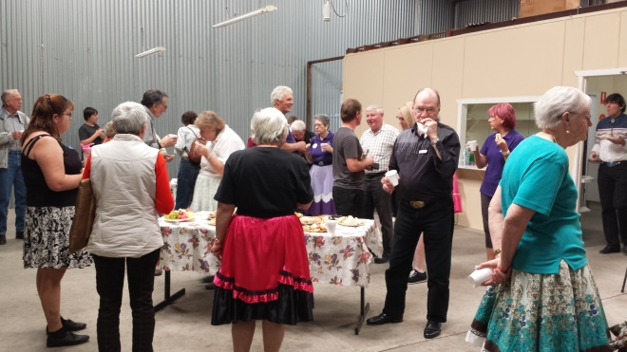
DON'T FORGET:
"A SMILE ON YOUR FACE
HELPS YOUR FEET WORK BETTER
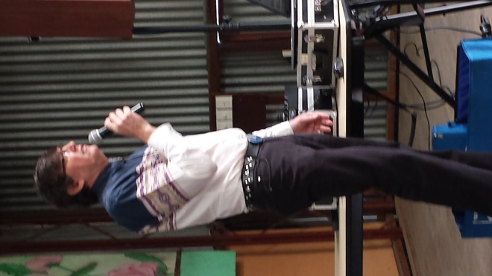
Caller - Glenn

Carol and Debbie are very close to completing their basic level, only a couple more moves to go. Keep up the good work girls; you are dancing well! Graduations just around the corner

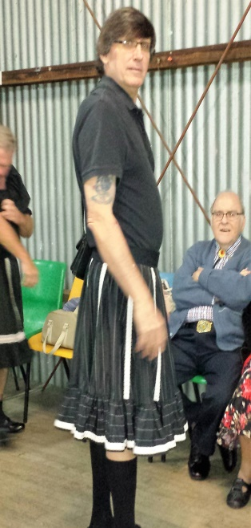
Cross Dressing – Nice Glenn
E.Z Squares recent Party Night in August:
2 Squares enjoyed the night of Cross Dressing, lovely to have a couple from Lighthouse Squares, Northside Promenader’s and Gumdale.

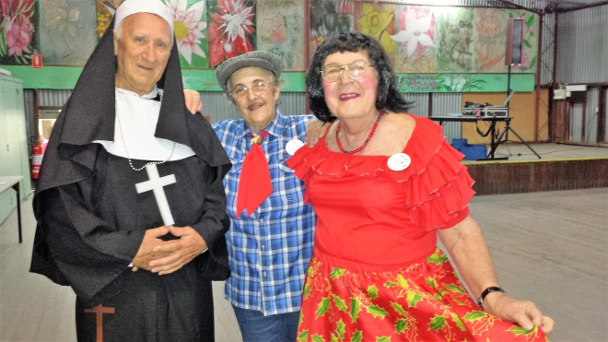

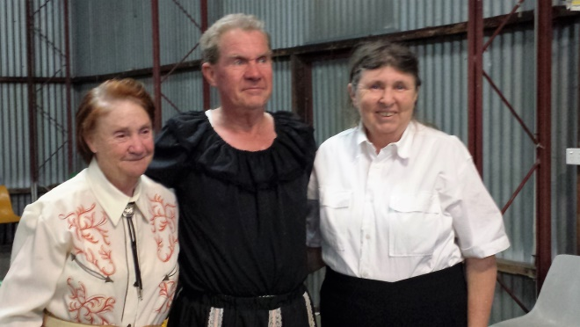

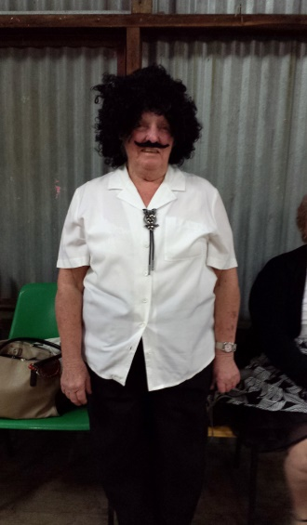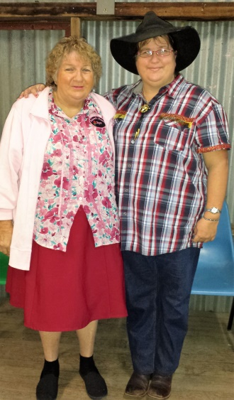

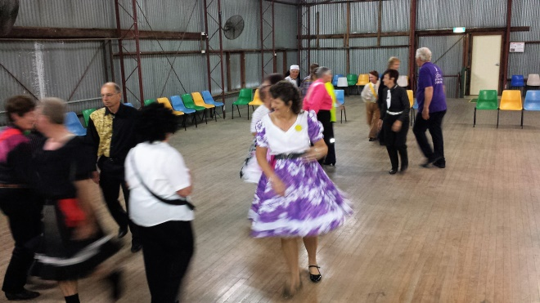
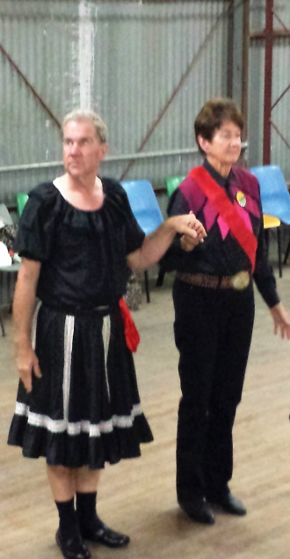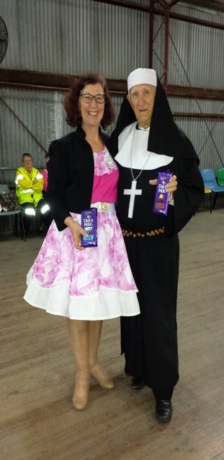
Are you confused!? We certainly were

The mission of “Square Dancing” is
“Friendship set to Music”

Important Facts

Square Dancing is meant to be FUN. Don’t worry if you can’t pick up a move instantly. No-one expects you to!
Being human, means sometimes you will have “two left feet”. Even experienced Dancers make mistakes! It just adds to the fun.

We are all Different

So don’t feel you must be perfect. Just enjoy it. We all find some moves easy and some hard, and it’s different for everyone. So if everyone seems to know a move except you, don’t worry. Especially don’t go home and worry. Just enjoy the fun, laugh at your mistakes. Go home relaxed and looking forward to your next session.

ETIQUETTE

When Square Dancing you never dance alone. We need and help each other throughout the dance.

Do Do’s
Here are a number of unwritten rules we practice:

Always say “Hi” to all in the square.
When Squares form, please join the nearest square.
Thank all in the Square after each bracket.
Be nice to be near - wear deodorant.

No No’s
Never argue with other dancers or the Caller.
Never push, pull or shove a dancer into place, if help is needed a simple hand gesture is usually enough.
Don’t walk through a formed Square, always go around.
Never walk out of a Square.

Fancy Moves
Dancers often add extra swings or turns to enhance their dancing fun. These are optional and will come with experience.

WHAT TO WEAR
Beginners need to wear comfortable clothes and shoes. (No thongs please). Ladies may prefer to wear skirts to help learn skirt work. It is preferred that men wear long sleeves.

Mainstream Dancing Dress Codes:
MEN: long sleeved shirts – open or buttoned neck worn with Bolo, Western Ties or Cravats, long trousers or shorts and long socks.
LADIES: Full skirts and petticoats, tops and blouses, no bare midriffs or backs, closed in comfy shoes.

We are flexible with our dress code on Club nights, open neck club Tee-shirts are available to purchase.
However, should we be hosting a special dance or visiting another club full square dance attire is to be worn.. Club skirts are available on loan.

WORLD WIDE DANCE MOVES
Square dance calls are standard around the world. Once learnt, you can dance in any country, all callers call in English, regardless of where you might be dancing.

There are several levels of Square Dance moves.
Basic
You will learn the basic moves. There are approximately
50 – 60 moves which you learn throughout the year.

Mainstream
The next level! Most square dance nights cater for mainstream dancers. Once you reach this level, you can dance at other clubs, attend festivals and travel the world.

Graduation
To celebrate you becoming a mainstreamer, the Club holds a special welcoming ceremony called graduation. It symbolizes graduation into the main body of square dancers.

Tips for Smooth Dancing

How to Move
Keep the beat with your feet – all moves have set numbers of steps designed to fit the beat. Take small steps especially inside the circle, so the outside dancers who have further to go can keep up.

Your Body
Keep your elbows bent and your back straight. Keep squares small and moves compact to prevent rushing. Keep your touch and hand holds light and gentle.

Don’t be a Bully
In swings, move together. Swing to your partner’s physical capabilities. Take special care not to drag the lady’s arm backwards when her arm is over her head. In waves stand back from facing dancers so you can drop your hands easily. In arm turns don’t push opposite dancer’s hand back as you move forward.

Be a Smoothie
Dance smoothly, gently and on the beat, it makes it much easier. You can do fun moves and fancy twirls without hurting anyone.

Hi All!
Welcome to another newsletter - bringing all the news and events happening at Our Club “E.Z Squares” If you would like something printed in the newsletter, drop me a line or see me.

Newsletter Editor
Julie
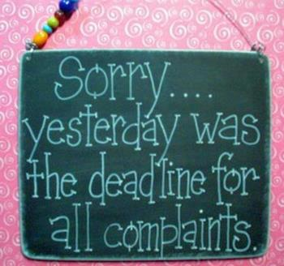

E.Z. Squares would like to thank Mark Ryan for the use of his facilities when printing our newsletters

