Volume 04 | Edition A04 | September 2014
This is your Elected Committee;
Geoff Linck-Parker - President
Ken McCulloch - V/President
John Twining – Secretary
Ted Newton - Treasurer
Gail Staniland – Assistant Treasurer
Julie McCulloch – Providore
Margaret Webber - Co-Providore
Julie McCulloch – Newsletter Editor
Maureen Miller – Clogging Rep
Glenn Wilson - Caller
Rod Dinte - Co-Caller

The members of this committee, are working hard to make our club the very best it can be, “Your HELP is needed!” - This is YOUR club! How would you like it to be run? Any ideas! Come and talk to a member of the committee.

Hello and welcome to the September Newsletter!
I’d like to acknowledge and congratulate all our new dancers on their journey through what must have seemed like a very strange form of dance. But Hey! Guess what? You are all mastering it and I’m sure that you are enjoying it too! Graduation is all but around the corner so hang in there and keep up the good work!

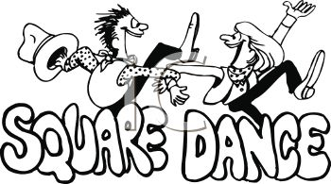

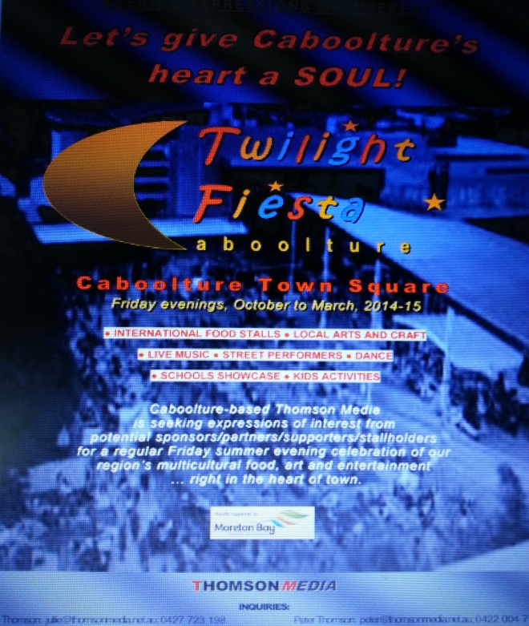

E. Z. Squares have been approached to take part in the Caboolture Twilight Fiesta over the coming Months. This great event will take place on two Friday evenings. Anyone interested in Helping Out Please come and see a committee member for more information. (We would ideally love to have two complete sets of dancers). The dates are as follows:

Friday 21st November 2014 for a 5.30pm & 7.30pm demonstration for 20 minutes each.

Friday 23rd January 2015 for a 5.30pm & 7.30pm demonstration for 20 minutes each.

This great event is one way of advertising Square Dancing and there will be a stand for handing out Information about our Club, and an invitation to the Graduation/Family and Friends on 25th of November.

We need you!
Throughout the year, our Club has many invitations to do demonstrations at different venues. Can you help! Requirements are: To be supplied with dress set attire. “Please” See one of the committee members for further information.

PARTY NIGHT
September 30th - is Party Night
Theme – “Silver & Gold”
Gold coin donation for entrance.
Light House Squares annual visit.
If you can spare a little time to help decorate the hall please see one of the committee members, More hands get the job done quicker.
Thanks in advance

2014 - Dates to Remember;
30th Sept 2014 - Party Night “Silver and Gold”
30th Sept 2014 Visit from Lighthouse Squares
4th November 2014 - Celebrating Melbourne Cup
21st November2014 – Twilight Fiesta Caboolture
25th November 2014 – Graduation
25th November 2014- Family and Friends
2nd Dec 2014 – Last Dance
7th Dec 2014 – Club break up Christmas Luncheon Venue: Ken and Julies home.

2015 - Dates to Remember;

23rd January 2015 - Twilight Fiesta Caboolture
3rd Feb 2015 - first night back main stream only
10th 17th & 24th Feb - Beginners: Free entry for new dancers during the Month of February
28th Feb E.Z Squares 25th Anniversary

Increase in entry fees: Due to an increase in the HALL rental, there will be a small increase in the entry fee for dancers. These fees will take affect as of February 2015.

Admission Fees per Dance Night
Child: $2.50
Adult: $5.00
Family: $12.50

Annual Membership Fees Due NOW
Child: $5.00
Adult: $10.00
Family: $25.00

If Annual Membership has NOT been paid, the Fee per Dance Night is:
Child: $3.50
Adult: $7.00
Family: $15.00

E.Z. Squares Caboolture on the Internet.
Did you know E.Z. Squares Caboolture has their own Facebook page?
https://www.facebook.com/pages/EZ-Squares-Dance-Club-Inc/236526663045546
If you “do” face book, get on there, make something happen.
If you think of something that you think should be on this page, let a committee member know.
We also have our own website:
http://ezsquarescaboolture.weebly.com
If you think of something that you think should be on the website, let a committee member know.
We are also hosting the 35th Queensland State Square Dance Convention in 2015. And yes, there’s a website for that:
http://35thqldstatesdconvention2015.weebly.com
If you think of something that you think should be on this website, let a committee member know.
This is our page on the National Square Dance website
: http://squaredance.org.au/Associations/State-Societies/Queensland/Clubs/E.Z.-Squares-Caboolture-QLD
It has general information about our Club and our Callers.
We have to let the State manager of this website know if we want or need any changes.
Club Members: Get on the web sites; let your friends know about us and our club.
All the best Glenn.
P.S. I also have my own websites:
(square dance) http://glennwilsonsquaredance.weebly.com
(personal) http://glennwilsonsdcaller61.weebly.com

THE SQUARE DANCER’S PLEDGE
"With all my ability I will do my best to help keep square dancing the enjoyable, wholesome, friendly and inspiring activity I know it to be.
This I pledge in the sincere desire that it may grow naturally and unexploited in the coming years and be available to all those who seek the opportunity for friendship, fun and harmony - through square dancing."
Happy Birthday/Anniversary for all those special people that celebrate in the Months of
July & August

Celebrating Birthdays in the Month of July
Lorre, John, Marlin and Nola
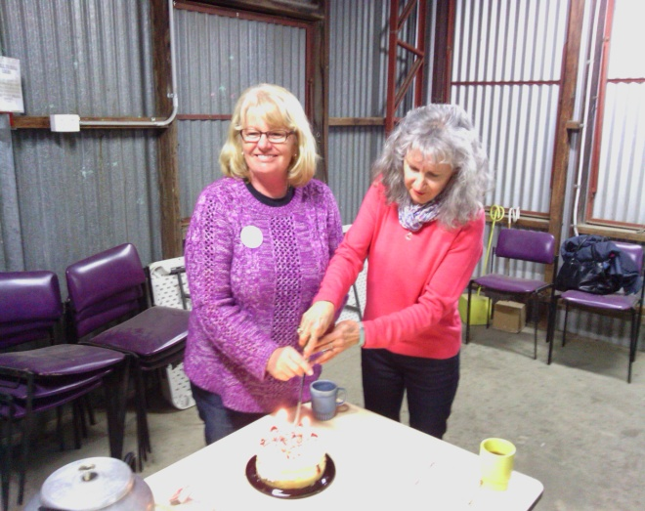

Celebrating Birthdays in the Month of August
Gail, Vicki, Zali, Margot, Linda, and Julie-Anne

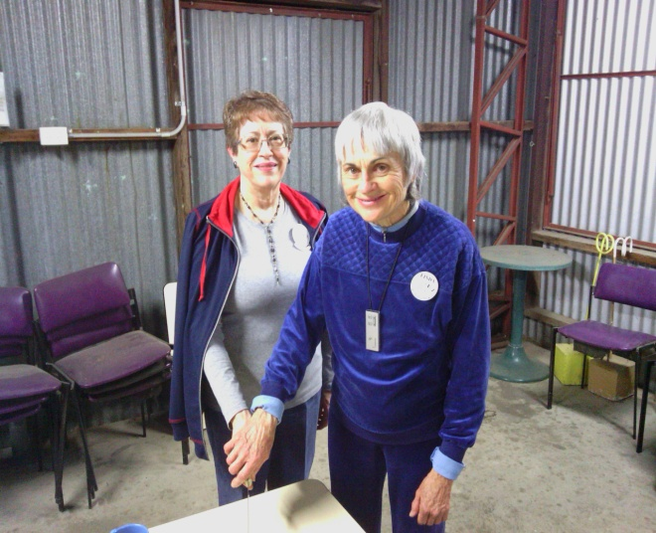

I ask myself! “Where have you been?” Then I tell myself! - The colder nights have made for fewer dancers participating; I’m sure we all find it harder to come out on such nights. Many of our dancers coming down with the dreaded lurgy, many finding it just too cold to venture out. For those that have symptoms of a cold or flu please consider the health of others and maybe give the night a miss, so - one doesn’t pass it around. Take care, keep warm and stay healthy. See you at dancing!
HAND SANITIZER
A reminder to all our dancers to please use the sanitizer on hands between dances, and before supper. The sanitizer bottles are provided at various locations around the hall. “ Keep those germs at bay!” NO ONE wants to be sick!!

Clogging News.
We all complain when it is too hot to dance, but it must be harder to leave our warm homes when it is cold. Numbers have been very low lately, so hopefully it is just the cold weather and we will start to see you all on the dance floor again soon.
After returning from our great weekend in Darwin, we have been busy going through the dances that were taught at the convention. Victoria won the showcase, so we have already added that dance to our list, Stuck, choreographed by Josh King.
There are always so many great new dances to put on the list for the next year.
A big Get Well Soon to Donna Cartwright, we hope you are back on the floor again soon.
Thank you Stephen for always being there to teach us. Thank you for being able to teach us all the new clogging routines.
See you all at Aussie Clog, only 2 weeks away. Come along and support this wonderful weekend of clogging.
Maureen
Clogging Representative.

Kitchen News (Supper)
You may have noticed my absence in previous weeks! I have been feeling under the weather but am finally making a comeback after some much needed rest.

I would like to Thank Maggie, Ken & Lorre. I also know that there are others that were willing to help and to those I thank as well. It’s great to know that all will rally together to help in whichever way they can. We have a very special club that looks after their own in times of need.

We have a party night coming up on the 30 Sept,
We are expecting a visit from the Light House Squares. On these nights (Party Nights) it would be very much appreciated if a plate of supper was supplied by our dancers to share.
I believe this to be a very important part of the evening, where the meeting and greeting of fellow dancers take place over a cuppa and a small offering.

Don’t forget Birthdays will be celebrated on the 4th Tuesday of every month.

I look forward to seeing you all at Supper.

Providore
Julie

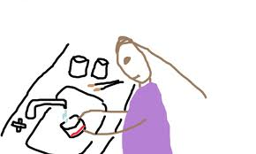
Please bring a plate to share! Don’t forget to wash your cup

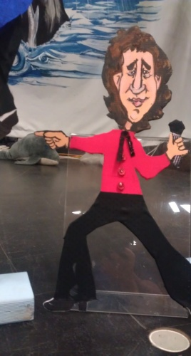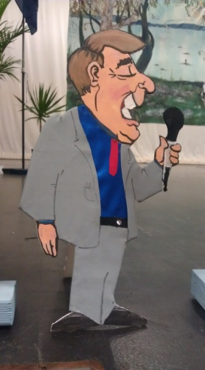
_{Do WE REALLY KNOW OUR CALLERS?}
_{Glenn, Rod & Peter}
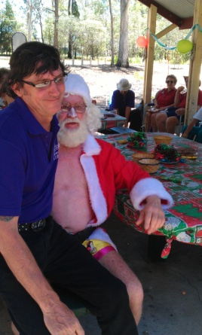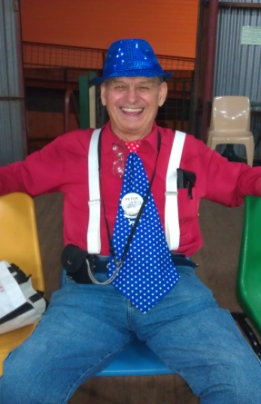
What to know about Glenn?

Profile: - Glenn Wilson - Square Dance Caller
Born in Hull England 8th November 1961. Moved to Australia 25th May 1965.
While I was at Zillmere State School in the late 60’s, I was first introduced to Square Dancing as a compulsory part of the curriculum.
It was while at Pine Rivers High School in 1976, I went to my first real Square Dance with a live caller. It was here I became hooked.
The club was “Pine Rangers” run by Alan Leighton and his wife Jenny. Alan’s brother Sid is still calling at “Wavell Whirlaways”.
I entered and won the club’s Amateur Callers contest in 1976, this contest was judged by legendary Queensland caller Eric Wendell.
In 1978, I joined the Royal Australian Navy and was immediately sent to junior recruit training in
Western Australia. I danced most Saturday nights that year at a club called “White Gum Valley” in Fremantle. After this I had a long break from square dancing.
After my naval career was over, in 1993, I started square dancing again at “Caboolture E.Z. Squares”.
By the end of that year, I did my first (very bad) singing call.
During 1994, I called anywhere that anyone would let me, still not sure whether I wanted to be a “proper” caller.
I started my first teaching class for “Caboolture E.Z. Squares” in early 1995. I’m still calling there now.
In 2001, “Rock ‘n’ Roll Squares” at Bald Hills came into being, this club continued for 4 years on the 2nd Friday of every Month.
During 2003 I was asked to be the club caller for a new club at Geebung.
“Northside Promenaders” started in early 2004 and is still going strong today. This club moved to Zillmere in 2013 and kept the same name.
I have called At 9 Australian National Conventions - 1999, 2001, 2003, 2005, 2006, 2008, 2009, 2012 & 2013.
I was the Assistant Venue Manager at the ANSDC Caloundra 2003, I was also the Program Manager at the ANSDC Brisbane 2008. I’ve called at most Queensland State Conventions since 1995. I was Sound Manager at 2 of them.
I’ve been a member of the Queensland Callers Association since 1994; I was Vice President in 1999 thru 2000 and again from 2002 thru 2003 and again from 2012 to present. I was also President of the Association in 2009 and 2010. I have been a QCA Assistant Caller Training Officer since 2009. I’ve been a Member of The Australian Callers Federation since 1994 and I’ve been an ACF board member since 2011.
I’ve been a Callerlab Member since 2007. I am also a member of the Callerlab Mainstream Committee.
I have attended numerous Caller Training sessions. I have attended most QCA training sessions since 1994 and have been involved in presenting QCA caller training sessions since 2004.
I have also presented 3 caller training sessions in Cardwell, North Queensland
I have attended 5 Brian Hotchkies 5-day callers schools (2003, 2006, 2009, 2010 & 2013) and helped with a Sight Resolution presentation at the latest.
I have been privileged to be invited to call for the following clubs:-
Summerland Larrikins - Lismore Logan City Square Dancers Inc. - Logan City
Hervey Bay Dancers - Hervey Bay Heritage City Hoedowners - Maryborough
Happy Hoedowners - Gladstone Rocky Twirlers - Rockhampton
Salad Bowl Squares – Brisbane Gumdale Grand Sliders - Brisbane
Uniting Squares - Brisbane Upbeat Chaos - Deception Bay
I was the first caller in Queensland to use CD’s as my principal music player and in June 2004, I was the first Queensland caller (as far as I am aware) to switch completely digital and use a laptop computer as my music player.
What to know about - Peter Clarke
Pete was born at Woodford (the old place is still there on the road to Kilcoy ) in 1937.
His Dad was a motor mechanic who moved to Kilcoy in 1939. Pete went to school at Kilcoy State School until high school when he moved to Brisbane to live with an aunt to do Junior High as it was in those days. He continued living with his aunt to do his 5 year apprenticeship as a fitter and turner. While employed by Rapson Engineering he met Val who was an office girl/ typist. She had gone to do that after her eyes started to give her problems as a photographic colourist. After their marriage in 1958, Pete left the engineering and went to be an Oil Company Representative with Shell oil, whom he worked with for 4 years, stationed in Ayr and base office in Townsville. Gave that away in 1964 and went back to Kilcoy to work as a motor mechanic with Hobarts Garage, which is still there. After a couple of years, he looked after the spare parts there, for another 8 years. He decided this wasn't for him and he went into teaching at Kilcoy High School in 1977 starting as a manual arts teacher, after doing 2 years of college in Brisbane, and then later, after about 8 years, into Special education, which involved another year of college in, Brisbane starting with 4 years teaching in deaf education at Cornwell Street, and then onto Bundaberg as a special needs support teacher at Kepnock High in 1989.. He Transferred to the Bundaberg Special School in 1991 and worked with special needs students there and at Bundaberg TAFE College until early retirement in 1999. Over the period of those years at Kilcoy, he did part time fire officer and part time theatre projectionist. During the years of their union, he and Val ran a cub scout group as well as Pete doing scouts and senior scouts at different intervals over the years.
His square dance career started in Bundaberg with Cane Country Squares in 1992, learning basic and main stream dancing and starting calling in 1993 after the club caller, Shirley Kelly, heard him calling along with her singing calls He called at Cane Country Squares and Bundaberg Promenaders. He did a few guest caller weekends at Gladstone and Rockhampton while living in Bundy. Attended a few caller schools with David Smythe and the QCA and then in 1999, decided to move down to Sandstone Point to be nearer family when he and Val joined Bribie Island Squares and Caboolture EZ Squares, calling at both these clubs. He attended more caller schools with the QCA and one at Casino with Brian Hotchkies. He did a bit of calling at Various clubs including Glenn's Rock and Roll Squares at Bald Hills, a Police Club square dance at Deception Bay, and a retirement village at Deception Bay.and of course, Caboolture EZ Squares. He and Val were granted club Life membership after doing stints in various positions on committee. A few club dancers still recall learning with Pete's teaching in the little supper hall at the showgrounds
He resigned as a club caller in 2010 after having leg and back operations and not being able to be actively involved in the club. Returned to club in 2013 and now does a guest call when able to do so at the invitation of the different club callers? He is still a member of the QCA and ACF having retained membership during the off years and has retained his club membership, hopefully for some years to come.
Cheers Peter
What to know about Rod Dinte;
G’day Everyone,
I’ve been asked by Julie to write a profile on yours truly! When I first put “pen to paper, it started to grow into a Book size. I therefore decided to put it into a “Time Line” leaving out all the juicy bits.

Born in Mackay, North Queensland in 1943 and spent the first 15 years if my life there reaching sub-junior level in education.

Moved with the family to Toowoomba in 1959 and started part time work in the Hotel that my parents managed. Did junior level at Toowoomba High.

After 12 months we moved to Brisbane where the parents bought a Corner Store on corner of Gympie Rd. & Stafford Rd. Attended Kedron High School for sub – Senior and worked in the shop after school & on weekends.

At this time decided, I had had enough of schooling and decided to find a job. Tried to join the Airforce to study Electronics, but they didn’t want me. During the August holidays, managed to obtain an apprenticeship with a local firm called Radio Corporation that most people know as “ASTOR”. While an apprentice, joined the CMF for 6 years rising to the rank of Sergeant.

After completing my apprenticeship, staying with the company as their Marine service person, servicing & installing Radars, Gyro Compasses & automatic Pilots in local & overseas ships. Was involved in the installation of the new Radar Station in Caloundra. After rising to workshop manager, decided to move to Philips ( who had bought out Astor) as a design and salesperson in commercial electronics. This included Fire Evacuation Systems, Emergency Nurse Call System in Hospitals & Nursing Homes and P.A Systems.

Met Noeleen at Beatnik Dance at Ashgrove in 1961 and after chasing her for 4 years she finally caught me and we were married in 1965. Bought a house in Bango, which in those days, was in the sticks.

Twin girls were born in 1966 and five years later we had a son.

In 1978, after the company I was working for closed down, bought a 4 wheel drive, built a tray on the back, and went on a 6 month trip around Australia living under a tarp.

I could write a story on that trip alone but as a quick resume’, from Brisbane to Birdsville, down the Birdsville Track to Adelaide, up to Alice Springs, out to Ayers Rock & the Olgas, across the Great Victoria Desert through the Aborigine Missions to Kalgoolie, down to Esperance ,round the bottom of Western Australia, up the west coast to Broome, across to Katherine, up to Darwin to Tennant Creek, Townsville, Fraser Island & home.

Arrived home with no money, no job but lots of memories. Decided to start our own Electronics business which we ran until 2000 when we sold it, retired and went to live on the Sunshine Coast at Diamond Head in a house we bought in 1996.

My Square dancing career began in 1993, learning to dance with Graham Rigby at S-Bar-B at Red Hill. During that year, visited E.Z. Squares where we liked the Club, the Caller and the people. Joined EZ Squares in 1994 and become President in 1995. Held that position for 2 years and then become Vice – President, in those days our by-law stated that you could only hold a committee position for 2 years and then had to step down. This was changed in 1998 and so was Vice – President for quite a few more years spending 12 years on the committee.

As a member of the Queensland Callers Assoc. & the Australian Callers Federation, spent about 6 years as treasurer of the QCA and was a Board member of the ACF for 4 years.

Also was a member of Logan City Square Dance (Inc.) where I helped in the building of the Square Dance Centre and was Treasurer for 8 years.

In1996 entered the Amateur Callers contest against 10 competitors and was fortunate to win it. Deciding I liked calling, became a co- caller to Brian Horsey, our resident caller and eventually started my own Club at Palm Lakes and ran it for 4 years doing both morning and afternoon dances. Gave this Club away when we decided we wanted to do more travelling and didn’t want the commitment of running a Club. Believe me, there is a lot of commitment needed from callers and I know all of you appreciate the commitment of Glenn to our Club. Still enjoying being co – caller with Glenn at EZ Squares. Have to retire one day.
Beside Square Dancing, my other interests include Wood Turning and general Wood Work, Travelling, Fishing and more recently, breeding Finches

Well I hope that gives you a small insight into myself. For any further information you will have to wait until the book & mini – series comes out.

In conclusion, I would like to state that one of my ambitions in life is to be a country music singer when I grew up. Unfortunately I will never grow up!!!

Rod

Looking back at our last Party Night

29th July - Pyjama Party Night
Great night had with many friendly visitors from other clubs, Pine Rivers, Gum Dale, North Side Promenaders, Bribie Island and Light House Squares just to name a few. With four squares up dancing the night away.
I’m sure it didn’t take long for all to get ready for bed when arriving home.

Photo’s to follow:

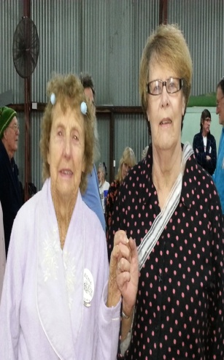
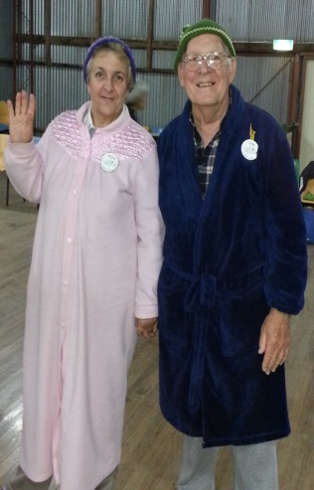

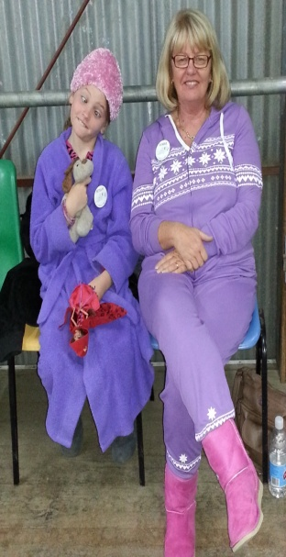

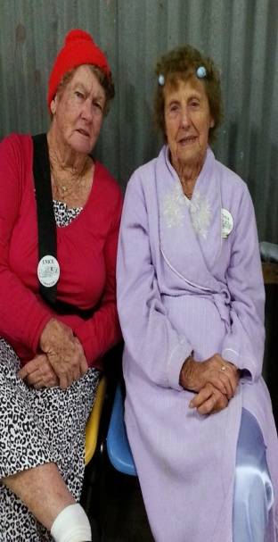
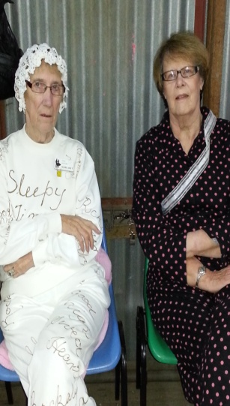

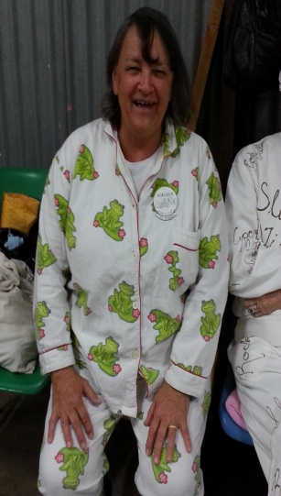

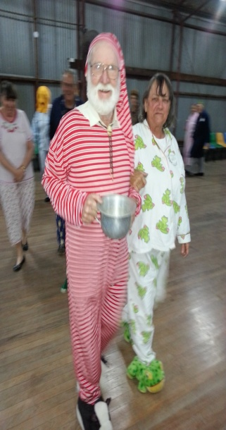

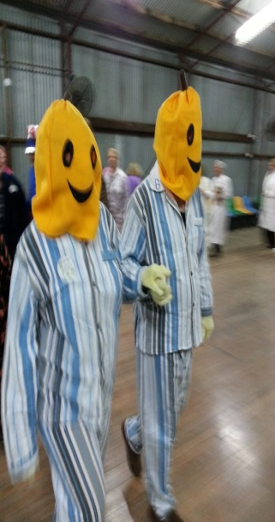

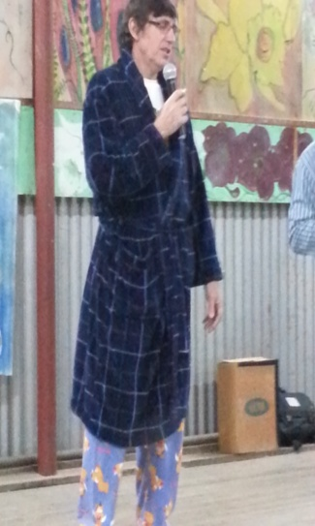
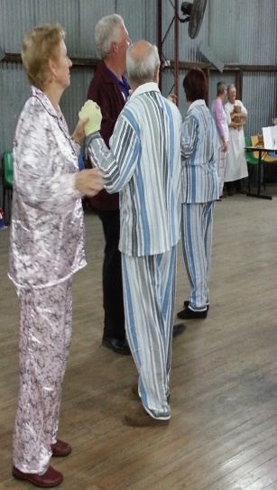

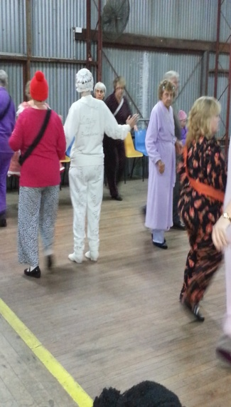

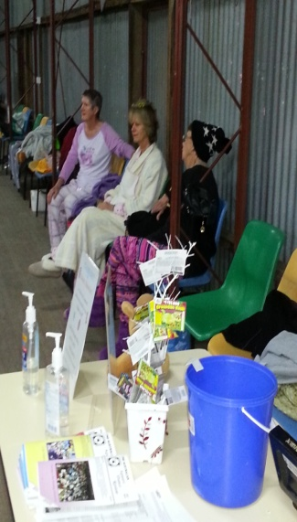
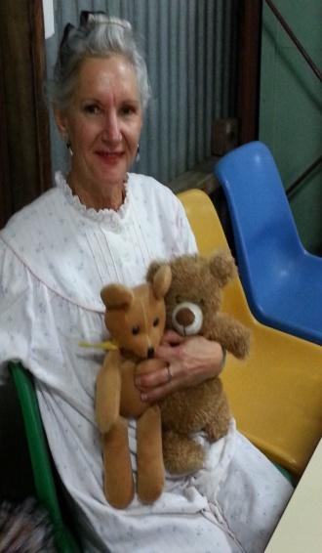

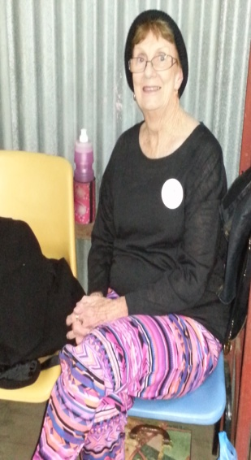

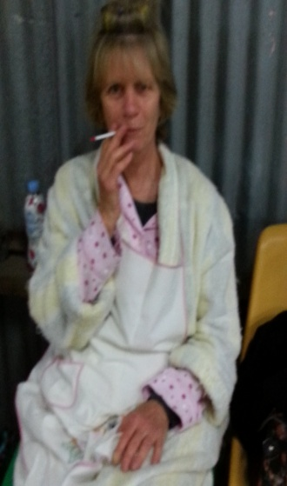
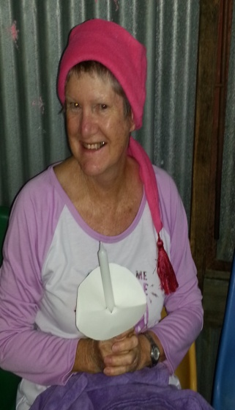

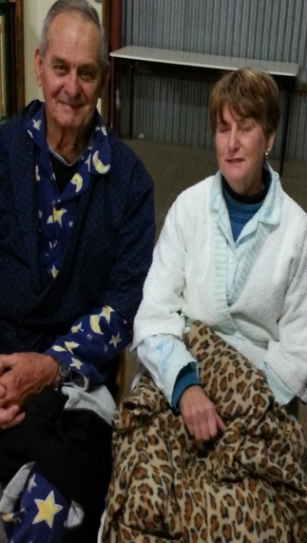

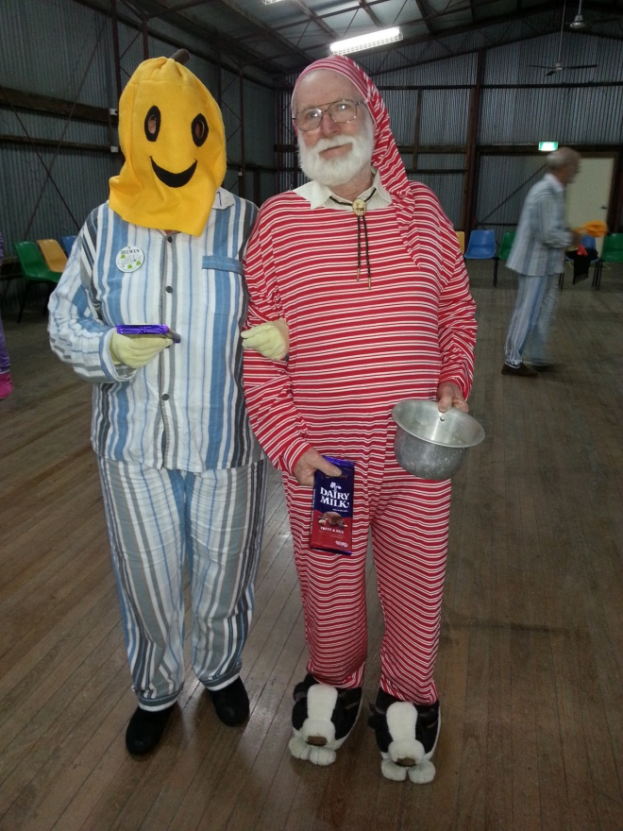
The winners; Delwyn and Rod

Rod and Delwyn would like it known, that they are qualified JP’s

Newsletter Editor
Julie

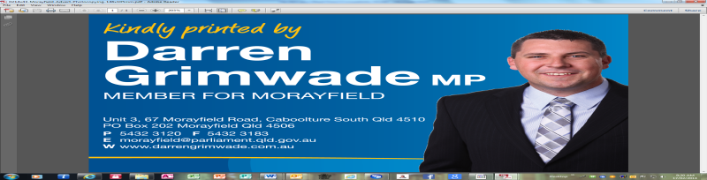E.Z. Squares would like to thank Darren Grimwade MP for the use of his facilities when printing our newsletters

