Volume 05 | Edition A05 | November 2014
Meet your Committee;

Geoff Linck-Parker - President
Ken McCulloch - V/President
John Twining – Secretary
Ted Newton - Treasurer
Gail Staniland – Assistant Treasurer
Julie McCulloch – Providore
Margaret Webber - Co-Providore
Julie McCulloch – Newsletter Editor
Maureen Miller – Clogging Rep

Glenn Wilson - Caller
Rod Dinte - Co-Caller

Welcome all, to the final newsletter for 2014- this means that the year has come to an end for our clubs weekly dances. The committee would like to wish all a Merry Christmas and a Happy New Year. Have a great break and if travelling please do so safely. See you all in 2015

The Presidents Report –

The square dance year for 2014 with only a few weeks of dancing left has been nothing short of encouraging after knowing that on the 25th November we will see our new dancers graduate. As well as this being graduation night it is also Friends and Family night so please encourage others to come and enjoy our favourite pastime.
With our graduates swelling our dancing ranks it has been pleasing to see up to four squares dancing on our club nights and having fun while enjoying square dancing.
The year has also been an eventful one where we had our party nights. On these nights we hosted visitors from other clubs most of whom also joined in the fun by dressing for the themes, namely a Pyjama Night, Back to School Night and Silver & Gold Night.
Again In 2015 there will be two party nights, the first being an Italian Night on 31st March and the other on 30th June (yet to be named).Our club is also celebrating our 25th Anniversary with a celebration dance on Saturday 28th February.2015. This dance will be held in our usual venue at the showground so please mark this important date in your diary as there will be a lot of different callers as well as our own.
On the social side we had our Mini Olympics Day which tested our skills and patience ,our Christmas in July Progressive Lunch which was, as always ,popular and intriguing with playing games as well as the mystery destinations and to partake of the fine food on offer, and still to come is our Christmas Break Up
As yet our club has not been involved in any demonstrations this year, but, as I am sure you are all aware we will be dancing at the Twilight Fiesta in the Caboolture Square on 21st November 2014 and again on 23rd January 2015. These demonstrations are not only beneficial for the promotion of our club to try to gain new dancers but also for the promotion of square dancing in general. If and when these occasions arise in the coming year dancers will be required, so, if you are able please come forward to make up the numbers.
While "Snakes Alive" was not the raging success we would have liked it to be I believe it was still a very enjoyable occasion dancing to the superb calling of David Cox who was ably assisted by our own club callers.
I urge all dancers to please read the notice board each week for upcoming events not only for your club but for others as well and if the opportunity arises please visit them and hopefully they will reciprocate and enjoy the fun and exercise we have at our dances which I am sure you all agree we do.” Snakes Alive” is unfortunately on hold for 2015, but, our club has been given the honour to host the 2015 State Square Dancing Convention Your committee will need the support of all members to help make this event a great success.
In closing I would like to thank my fellow committee members for all their hard work and time and for that matter all club members who have contributed to make EZ Squares the great dance and fun club it has grown into and on that note I am sure we all wish each other a very Merry Christmas and a Prosperous Happy New Year.

Geoff Linck-Parker

President.
E .Z Squares Caboolture Dance Club.

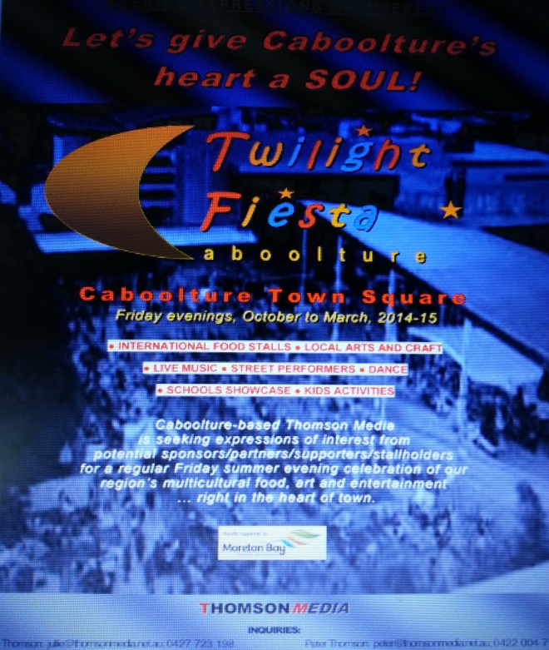

E. Z. Squares have been approached to take part in the Caboolture Twilight Fiesta over the coming Months. This great event will take place on two Friday evenings. Anyone interested in Helping Out Please come and see a committee member for more information. (We would ideally love to have two complete sets of dancers). The dates are as follows:

Friday 21st November 2014 for a 5.30pm & 7.30pm demonstration for 20 minutes each.

Friday 23rd January 2015 for a 5.30pm & 7.30pm demonstration for 20 minutes each.

This event is one way of advertising Square Dancing, there will be a stand for handing out Information about our Club, and an invitation to the Graduation/Family and Friends on 25th of November.

Don’t forget those who have volunteered for this above demo to please be there in plenty of time – before each dance. “Thank you in advance”

THE SQUARE DANCER’S PLEDGE
"With all my ability I will do my best to help keep square dancing the enjoyable, wholesome, friendly and inspiring activity I know it to be.
This I pledge in the sincere desire that it may grow naturally and unexploited in the coming years and be available to all those who seek the opportunity for friendship, fun and harmony - through square dancing."

Graduates of 2014
Congratulation to the following:-
Julie-Anne Weimers
Noela-Parsons
Vicki- Bouna
Bethany- Slanyer
Irene-Locke

2014 - Dates to Remember;
21st November2014 – Twilight Fiesta Caboolture
25th November 2014 – Graduation
25th November 2014- Family and Friends
2nd Dec 2014 – Last Dance
7th Dec 2014 – Club break up Christmas Luncheon Venue: Ken and Julies home.

2015 - Dates to Remember;

23rd January 2015 - Twilight Fiesta Caboolture
3rd Feb 2015 - first night back MAIN STREAM only
10th 17th & 24th Feb - Beginners: Free entry for new dancers during the Month of February
28th Feb E.Z Squares 25th Anniversary
31st March- Party Night Italian Night (Pizza Party)
30th June – Party Night Theme to be advised

Clogging News
We are fast approaching the end of our Clogging year 2014. We are always very thankful that we have Stephen Hope to help us along the way. Not an easy job to be committed to teaching every Sunday night, and reading the cue sheets of the new Advanced Challenge dances. What a brilliant effort Stephen. Thank-you so much.
We are presently looking at the dances nominated to go on the list for 2015. Not an easy job!
None of us really enjoy these nights, but if we don't vote, we don't have a say. Again we will be relying on Stephen to teach us the new dances that do get chosen for the ACA list.
There are lots of Christmas parties being held around the Brisbane area over the next few weeks. Everybody is welcome at all XMAS parties.
27th. Nov. Sunstate Cloggers
30th Nov. Christmas Party & Rise'N'Shine 21st Birthday. Mothar Mountain Hall. Gympie. 10am-3.pm.
2nd Dec. Hooked on Clogging (Bribie Island)
5th Dec. Gold Coast Cloggers ( morning)
9th Dec. Double Up Warner ( morning)
9th Dec Chug-A-Lug ( Coorparoo)
11th Dec. Double Jingle (Lutwyche) morning
14th.Dec. EZ Cloggers Caboolture. Dancing starting at 5pm, followed by supper. Please bring a plate. Everybody Welcome.
What a wonderful year it has been. Keep on Clogging and tell all your friends what great fun we have. It's not just about the Clogging, it is the fun and friendship that goes with it.

Maureen

Clogging Rep

E. Z. Squares Caboolture on the Internet.
Did you know E.Z. Squares Caboolture has their own Facebook page?
https://www.facebook.com/pages/EZ-Squares-Dance-Club-Inc/236526663045546
If you “do” face book, get on there, make something happen. If you think of something that you think should be on this page, let a committee member know. We also have our own website
http://ezsquarescaboolture.weebly.com
If you think of something that you think should be on the website, let a committee member know. We are also hosting the 35th Queensland State Square Dance Convention in 2015. And yes, there’s a website for that:
http://35thqldstatesdconvention2015.weebly.com
If you think of something that you think should be on this website, let a committee member know. This is our page on the National Square Dance website
: http://squaredance.org.au/Associations/State-Societies/Queensland/Clubs/E.Z.-Squares-Caboolture-QLD
It has general information about our Club and our Callers. We have to let the State manager of this website know if we want or need any changes. Club Members: Get on the web sites; let your friends know about us and our club.
All the best Glenn.
P.S. I also have my own websites:
(Square dance)http://glennwilsonsquaredance.weebly.com
(Personal) http://glennwilsonsdcaller61.weebly.com

Sadly - There has been much illness this year, as well as the passing of our Kathy and many hospitalisation’s, our thoughts go out to those in need, please know that we as a square dance club are thinking of you all. Wishing a Speedy recovery for those that are under the weather.

A reminder to all our dancers! Please use the sanitizer on hands between dances, and before supper. The sanitizer bottles are provided at various locations around the hall. “Keep those germs at bay!” NO ONE wants to be sick!!

There will be a slight increase in entry fees as of 2015 due to rise in hall fees.

Admission Fees per Dance Night
Child: $2.50
Adult: $5.00
Family: $12.50

Annual Membership Fees
Child: $5.00
Adult: $10.00
Family: $25.00

If Annual Membership has NOT been paid, the Fee per Dance Night is:
Child: $3.50
Adult: $7.00
Family: $15.00

Kitchen News (Supper)
Thank you to all our kind dancers that have brought along a small offering for our evening suppers. This is very much appreciated, also for those early helpers that set up at the start of the evening and to those that help at the other end of the evening packing up and putting away. This has not gone unnoticed. I must say have a wonderful break and see you back dancing in the New Year.

Julie
Providore
This year the venue has changed
Christmas break up at Ken and Julie’s

Christmas luncheon is:-
Red Rooster (Roast Chicken)
Roast Potato
Roast Pumpkin
Vegetables
Gravy

Dessert:-
Christmas pudding
Fruit salad
Custard
Cream
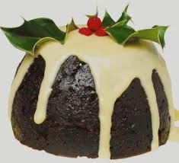

Tea and Coffee

The Christmas break up on the 7th December 2014 at Ken and Julie’s home. Number’s for catering purposes, please see Ted, put your name down, come along and enjoy the friendly atmosphere.

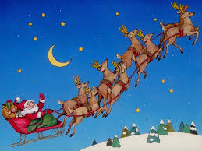

Happy Birthday/Anniversary for all those special people that celebrate in the months of
September & October

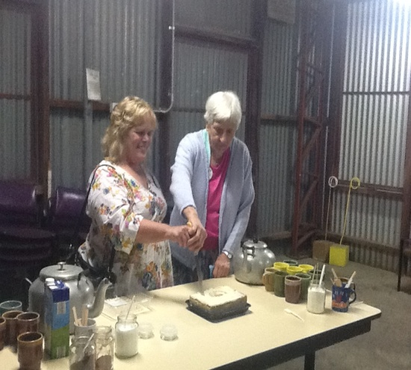

Celebrating birthdays in the month of September -
Grace and Elaine

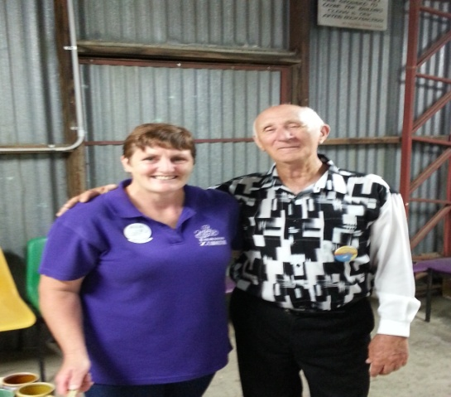

Celebrating birthdays in the month of October –
Julie and Mac

Celebrating birthdays in November
Val

Celebrating birthdays in the month of December
Bethany

E.Z. Squares - has recently had 2 club party nights.
20th September saw our Gold and Silver theme,
Also the official visit from Light House Squares, with many of our dancing companions from other clubs joining the fun.

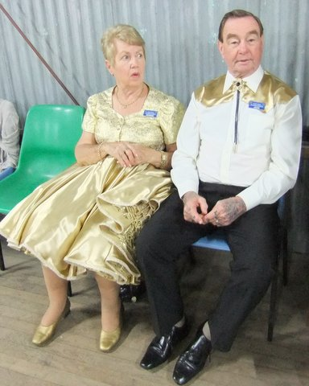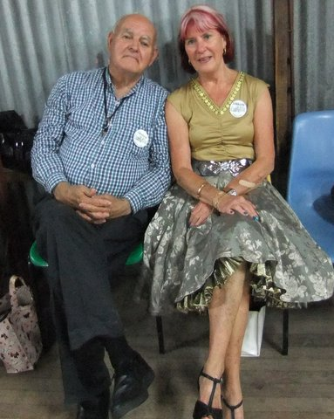

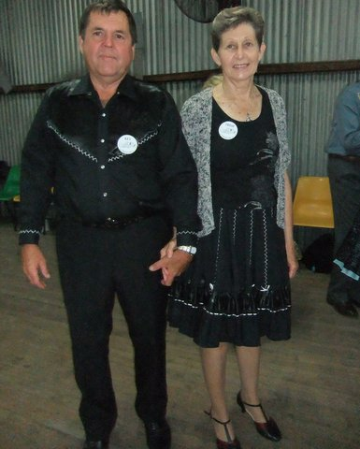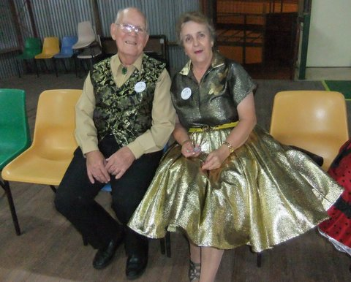

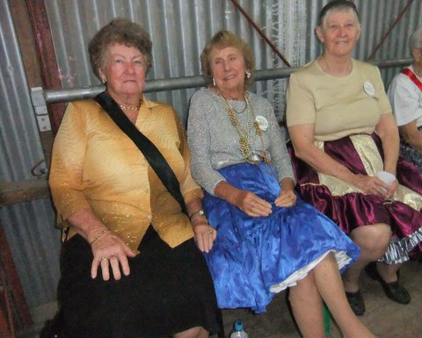
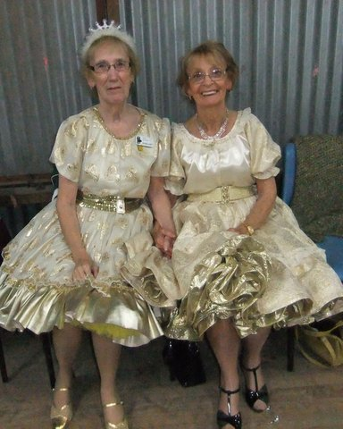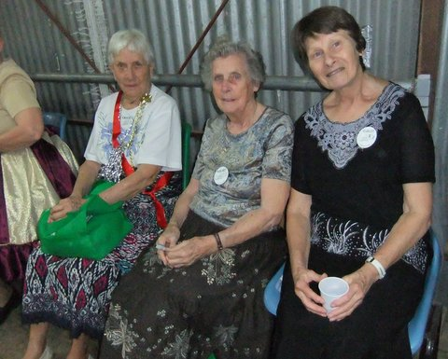
Melbourne Cup night – 2014
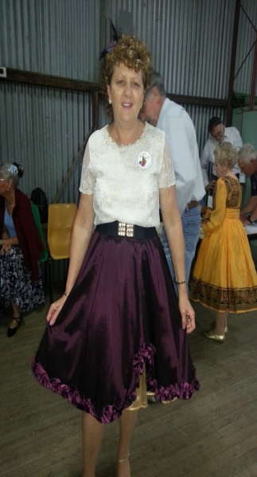

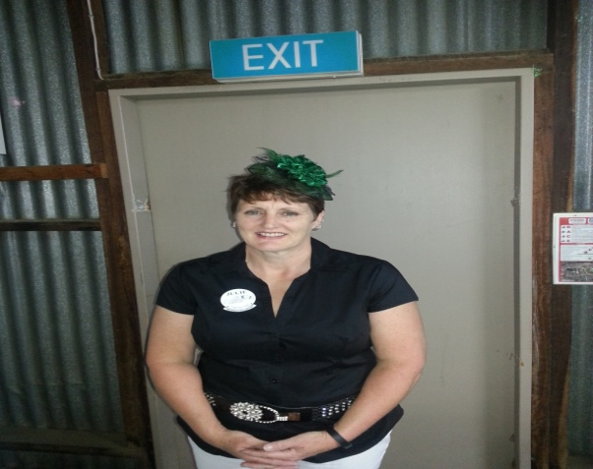

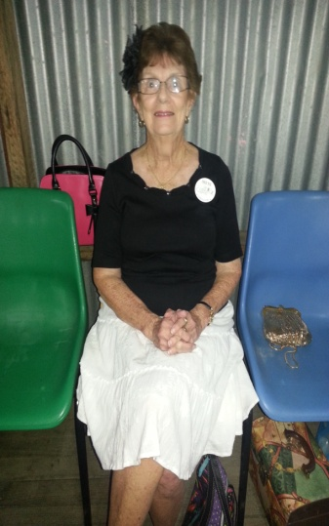

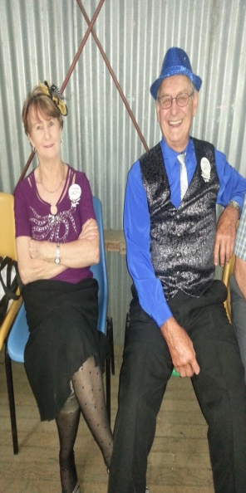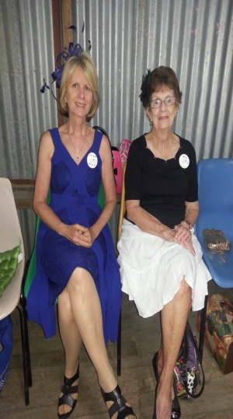

Rod and Delwyn would like it known, that they are qualified JP’s

Newsletter Editor
Julie
E.Z. Squares would like to thank Darren Grimwade MP for the use of his facilities when printing our newsletter

