|  |  |  |
| --- | --- | --- |
| Volume 05 | Edition D21 | November 2012 |

**This is your committee;**

Geoff Link - Parker - *President*

Maureen Miller - *V/President/Clogging Rep*

Bert Bowden - *Treasurer*

Arthur Trumper – *Assistant Treasurer*

Delwyn Link- Parker – *Secretary*

Ken McCulloch – *Providore*

Margie Webber - *Co-Providore*

Kaye Clouston - *Publicity/Liaison Officer*

Julie McCulloch *– Newsletter Editor*

Glenn Wilson - *Caller*

Rod Dinte - *Co-Caller*

The committee are working hard to make our club the very best it can be, please help us, by making suggestions, on any matter.

The year is almost over and sadly that means our square dance year is also coming to an end. What a wonderful year we have had! A big congratulations to our graduating dancers this year, well done for coming so far in such a short time!

Well done to the beginners that started with the club in February. You have now graduated Square Dancing 2012:

Denice Crump

Margaret Gannining

Ted Newton

Kerry and John Wills

Trevor Shervey

Gail Staniland

**XMAS MESSAGE FROM YOUR PRESIDENT.**

*As we near the end of our square dance year it is good to reflect on what has been an eventful and very enjoyable period of time. Our club started the year with a number of people eager to learn square dancing and have fun. As time progressed , unfortunately , some of our learners have for one reason or another fallen by the wayside, but, I am told that some may return in the new year so let`s hope so. During the year we had three very well attended party nights with a big number of dancers showing their enthusiasm by dressing up according to the theme for each night. These nights turned out to be a lot of fun because not only did we square dance but also had a Monte carlo and a parade of people in costume where the best dressed male and female were rewarded with a small prize.*

*Snakes Alive was once again a big hit even though the inclement weather wasn`t kind and also the political scene didn`t help much by commandeering our regular hall at Burpengary, where Snakes Alive will return to on the 17th and 18th May in 2013. Clearly one of the highlights of Snakes Alive was the participation of the children from Minimbah Primary School, who are sponsored by EZ Squares and known as Minimbah Mini Squares .They really attracted the attention and praise of the accomplished dancers. The young dancers were later joined by their parents and the rest of the square dancers in a bracket of square dancing.*

*During the year a number of our dancers have visited various clubs, taken part in demos, participated in dress set parades and attended the Sunshine State Roundup, where Ken did us proud by winning the Amateur Callers title. Our club has now won the title three out the last four years, what a great accomplishment for our club. Also a most enjoyable weekend was had by all who travelled to the State Convention at Hervey Bay. Our club should be proud of the fact that we usually represent well at most events during any given year for the betterment and promotion of Square Dancing as a fun, exercise based, activity.*

*I am sure our year will finish as well as it has been all through, by welcoming many people to our Family & Friends night on the 20th November , Graduation Night on the 27th November and our Christmas dance on the 4th December. Last but not least don`t forget to join your fellow club members, their guests and any visitors for Christmas lunch at Buchanan Park Burpengary on Sunday December 2nd.*

*As the square dancing year draws to a close I know you will all join with me in congratulating this year’s graduates and thanking your hard working committee and helpers for their commitment and hard work during the year. Without the support of members like these the club would not function and I encourage anyone to raise their hand and volunteer for any one of these positions in the New Year as members of the committee do get tired and welcome a rest.*

*In closing on behalf of Delwyn & myself and all the committee I wish you all a Merry Christmas and a Safe and Happy New Year and look forward to seeing you all again in 2013.*

*Geoff Linck-Parker*

**Christmas is almost upon us.**

**The year has come to an end once again, what fun it has been dancing the year away, having all of our beginners now graduating, and they too in return will buddy up with beginners next year and show a helping hand to guide through some of those tricky moves. Thank you to all our dancers for their hard work and dedication throughout the year.**

GREAT TRUTHS THAT LITTLE CHILDREN HAVE LEARNED:   
1) No matter how hard you try, you can't baptize cats.   
2) When your Mum is mad at your Dad, don't let her brush your hair.  
3) If your sister hits you, don't hit her back. They always catch the second person.   
4) Never ask your 3-year old brother to hold a tomato.  
5) You can't trust dogs to watch your food..  
6) Don't sneeze when someone is cutting your hair.  
7) Never hold a Dust-Buster and a cat at the same time.   
8) You can't hide a piece of broccoli in a glass of milk.   
9) Don't wear polka-dot underwear under white shorts.  
10) The best place to be when you're sad is Grandpa's lap.

GREAT TRUTHS THAT ADULTS HAVE LEARNED:   
1) Raising teenagers is like nailing jelly to a tree..  
2) Wrinkles don't hurt.  
3) Families are like fudge...mostly sweet, with a few nuts   
4) Today's mighty oak is just yesterday's nut that held its ground..   
5) Laughing is good exercise. It's like jogging on the inside.  
6) Middle age is when you choose your cereal for the fiber, not the toy.

GREAT TRUTHS ABOUT GROWING OLD   
1) Growing old is mandatory; growing up is optional.   
2) Forget the health food. I need all the preservatives I can get.   
3) When you fall down, you wonder what else you can do while you're down there.  
4) You're getting old when you get the same sensation from a rocking chair that you once got from a roller coaster.   
5) Its frustrating when you know all the answers but nobody bothers to ask you the questions.   
6) Time may be a great healer, but it's a lousy beautician.  
7) Wisdom comes with age, but sometimes age comes alone.

THE FOUR STAGES OF LIFE:   
1) You believe in Santa Claus.   
2) You don't believe in Santa Claus.  
3) You are Santa Claus.  
4) You look like Santa Claus.

***Dates to remember***

**20th November -** Family and Friends Night

**24th November -** Society Xmas Dance

**27th November -** Graduation and Club Birthday

**2nd December -** Christmas Break up Party, Buchanan Park Burpengary

**4th December -** Last Dance for 2012

**5th February 2013 -** First dance back

**23rd April 2013 -** Nasser Shukayr

**17th/18th May 2013 -** Snakes alive

**Square dance Break up!**

*What*: Christmas in the Park

*When*: 2nd December 2012

*Where*: Buchanan’s Park Burpengary

*Time*: 11am for presents with Santa (unisex present to the value of $5 for secret Santa)

*Lunch*: 12.30pm

-Red Rooster

-chicken, roast potato, pumpkin, peas

-and gravy

*Dessert*:

-plum pudding

-fruit salad

-custard

-cream

Tea and Coffee

*Members*; **NO CHARGE**

*Non members*; $5.00each

R.S.V.P by the 20th November for catering purposes

***Christmas Wishes***

Hi Folks,

Another year is quickly

Drawing to a close. Has the club been successful this year? I think so. We’ve danced 4 squares most of the year. We’ve had a couple of successful demonstrations. We’ve been on a couple of club visits and had a couple of clubs visit us. We’ve got a good group of learner dancers ready to graduate. And it’s a fun club to be part of. Is it time to rest on our laurels? Not a chance.

Do you know someone that might enjoy square dancing? Maybe a friend who is on their own a lot. Possibly a family looking for an activity they can do together. Try to encourage them to come along and give it a try. A club that is not expanding is shrinking.

On another subject - Do you think the squares breakdown too often? Most of the time, it’s not that the call can’t be done. I admit sometimes I make mistakes (I’m human). Quite often it is lack of concentration, but sometimes it’s because someone is not sure how to do a movement. I’m very willing to workshop any movement, anytime. I think sometimes, we would all benefit from a workshop on a particular move. And I don’t just mean the beginners, I mean all of us. Enough said, let me know what you think.

Christmas and New Year are coming up fast and it is always a hectic time of year.

Square Dance parties, Family functions, holiday driving, etc. etc. Please have a happy and safe Christmas and New Year and join us again next year to do it all over again.

I’m really looking forward to the Christmas break, but usually, by early January I’m ready to go again. It also been great this year to see our Trainee callers coming on, in leaps and bounds. Well done to Elaine and Ken, keep working hard, it’s not easy, but oh so rewarding.

That’s all folks,

Glenn

*With Summer almost upon us , we would like to remind our dancers to please use the sanitizer on hands between dances, and before supper. The sanitizer bottles are provided at various locations around the hall. “Keep those germs at bay!” NO ONE wants to be sick during the holiday season!*

***Looking Back***

Hervey Bay Queensland Callers Association

32nd Qld State Square Dance Convention

Hervey Bay September 28th, 29th & 30th

Hervey Bay knows how to turn on a great long weekend of Square Dancing, Clogging, Rounds and Plus Dancing.

The weekend comprised of entertainment with more than 20 callers, guest callers and cuers from near and far.

***Friday 28th***

13 squares

Official opening

Banner parade (24 banners)

***Saturday Afternoon***

8 squares

***Saturday Night***

17 squares

***Sunday Morning***

8 squares

***Sunday Night***

15 squares

Closing ceremony

Well done! Elaine and Ken for their contribution.

**Demo at Elimbah Family Day Out**

20th October, E.Z. Squares performed a demo. Thank you to the set that gave their time to show others how easy it is to square dance, evidence of this occurred when our square broke to make 3 other squares. One well known face amongst us was none other than Wyatt Roy, who found square dancing a breeze thanks to the excellent calling skills of both Glenn and Elaine.

**Recent Party Night:**

30th October

Theme: Birth of Origin

Wow what a great night had by all that attended:

Light House Squares

North side Promanaders

Wavell Whirl Aways

Pine Rivers Senior Citizens

Logan City

Gumdale Grand Sliders

Minimbah Mini Squares

5 Squares dancing the night away, fancy dress won by: Di – Light House Squares

Col- E.Z. Squares

Callers: Glenn, Rod, Peter, David, Margaret, Elaine & Ken.

***Clogging News:***  
*Walk around the shops and you quickly realise that Christmas is just around the corner and then the end of the year.  
2012 has been another great year of Clogging.  
 Storm King, Aussie Clog, then the Convention in Adelaide. Those who attended from EZ, had a great time with all the other Queensland Cloggers and of course the Cloggers from all over Australia.  
We should take this opportunity to thank Stephen for his patience and skill in teaching us this year. Thankyou Stephen we are so lucky to have you.  
As this is the final newsletter for 2012, we wish you all a Very Merry Christmas and please all come back next year and bring a friend.  
Sunday 9th December EZ Cloggers (Caboolture) Christmas break up. Dancing from 5-7.30pm Social night. Followed by supper, please bring a plate. No charge.   
Club Recommences 3rd February 2013  
Maureen Miller  
Clogging Representative/Vice President.*

**Minimbah State School proud of “our Mr Mac”**

The staff and students of Minimbah State School always know they can speak to Mr. Mac, whether it is because of a problem with a friend, work with the Eco Warriors or general lost shoes and missing hats. But they also know about Mr. Macs other side that is as Ken McCulloch Square Dance Caller.

We all know Ken as a hard worker and all round great bloke, but it becomes so easy to see when Ken’s two loves Square Dancing and school kids, combine. Ken takes lunchtime groups for Square Dancing and the students love it and to see Ken’s enthusiasm, you can see why. Ken gives his time freely to the students and they respond with open arms and hearts, the smiles on the student’s faces say it all. They love Ken, they love the time he spends with them, teaching them Square Dancing and they love to tell the rest of the school how much fun Square Dancing is.

It is great to see so many young students Square Dancing and they really appreciate the efforts Ken puts in to the next generation of Square dancers. So from all the staff, parents and most importantly, the students of Minimbah State School, we say thanks to “Mr. Mac” and look forward to many more lunchtime Square Dancing lessons.

Sean Bennett,

Acting Principal

Minimbah State School

***Mr. Mac’s Minimbah Mini Square Dancers***

This year the students of Minimbah State School have introduced the wonderful world of ‘Square Dancing’ into their lives. Students between eight and ten years of age, come along on their lunch break to bust out their moves. Twice a week these eager young dancers swing and promenade around their squares. The lessons are only very short, that there of only twenty minutes per session.

The girls outnumber the boys, so many of the girls are learning the boys part and becoming quite good at it.

There are two different groups. On the Wednesday, the more experienced students dance, these are the students that have been dancing with Minimbah Mini Squares the longest, and also the ones that danced a demo set in the 2012 Snakes Alive.

Thursday’s are just for beginners with many of these being grade three students, there are three sets. These students will continue on for the start of next year.

The aim is to teach these students three things:

Basic Square Dance

To enjoy it

To have fun

I would like to acknowledge the work Linda puts in with the students, thank you for volunteering your time each week.

Also thanks to E.Z. Squares and the committee, Glenn and Rod for your help with Minimbah Mini Squares.

Thank you

Ken McCulloch (Mr Mac)

Minimbah State School

*Message from the Kitchen:*

*Maggie and Ken have extended their appreciation to all that have supplied supper throughout the year. Without your support there would be tea and coffee only.*

*Thank you.*

**HAPPY BIRTHDAY/ ANNIVERSARY TO ALL THAT HAVE CELEBRATED IN THE MONTHS OF OCTOBER & NOVEMBER, AND WHO WILL BE CELEBRATING IN DECEMBER AND JANUARY ☺**

***Up an Coming in 2013;***

***-Nasser Shukayr’s Visit-***

Come along and Celebrate the

Red, White and Blue Theme;

E.Z. Squares Caboolture Presents;-

(In his only Qld Appearance)

Internationally Acclaimed

Caller Accredit

From San Antonia, Texas, U.S.A

* NASSER SHUKAYR -

Tuesday 23rd April 2013

7 .00 pm plus

7.30 pm main stream

10.00 pm supper

C.T Williams Pavillion, Caboolture

Show grounds.

Gate 2, Beerburrum Road Caboolture.

You could come as an Aussie, A Brit or an American, maybe you’re Dutch or a Frenchman too! Come along wearing your Red, White and Blue.

**Adult $6.00!!**

**Child and Family concessions available**



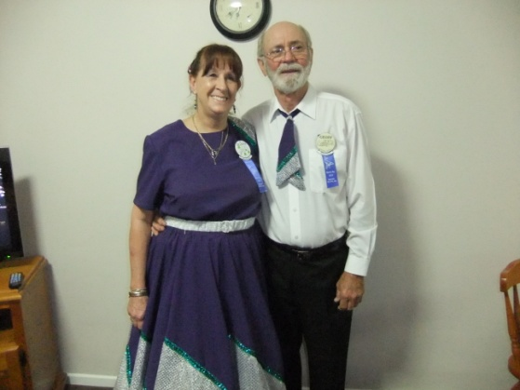

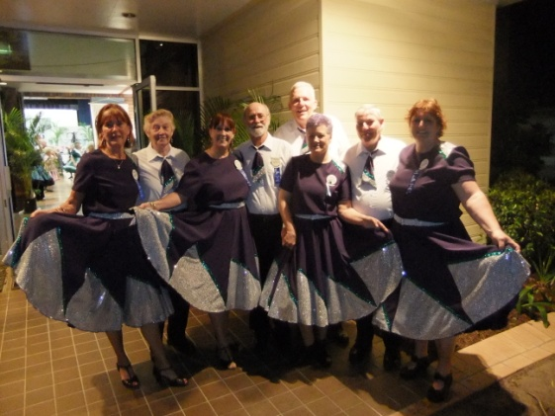

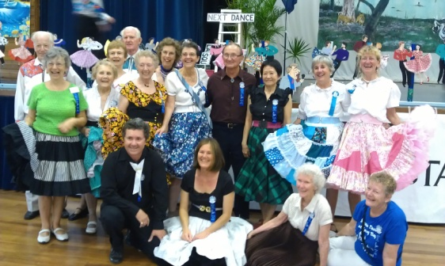

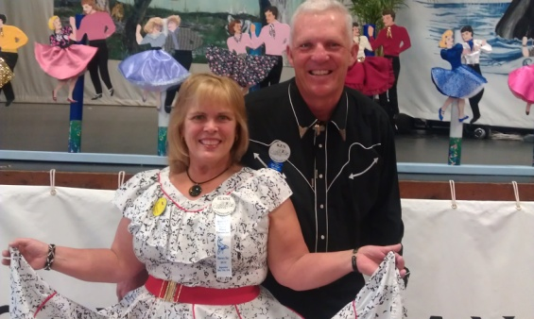





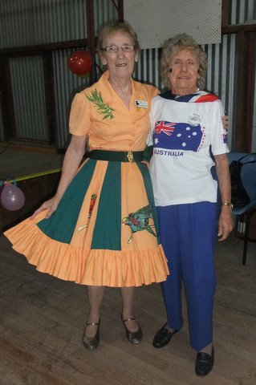

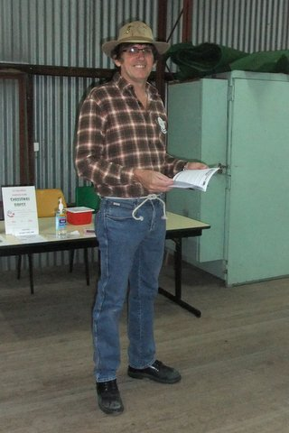

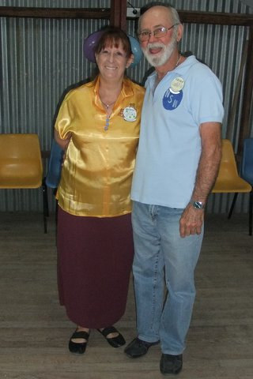

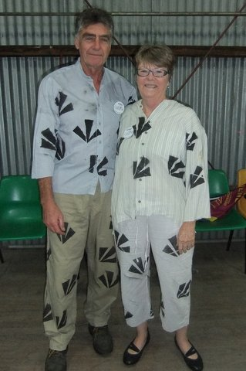

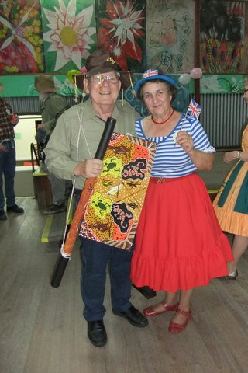

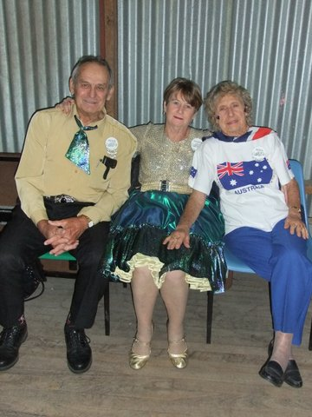

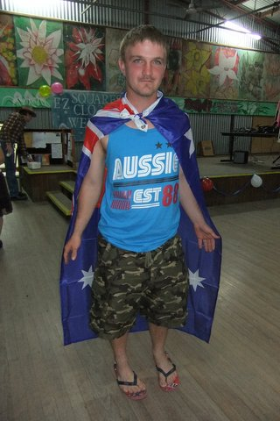

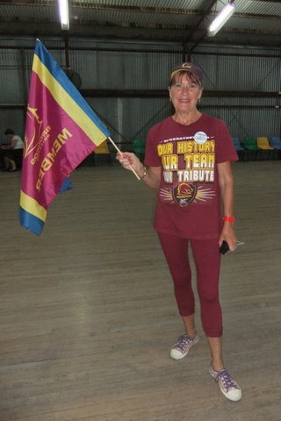

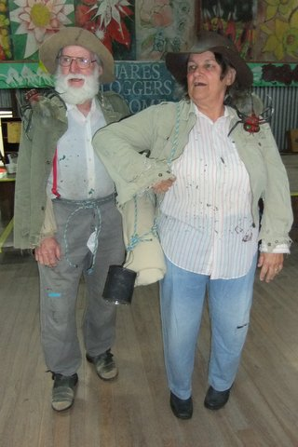

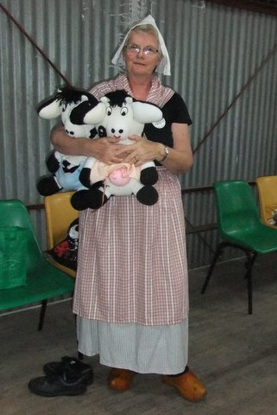

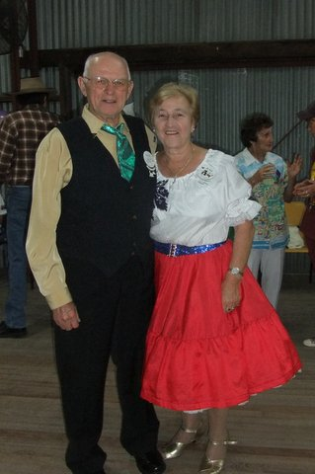



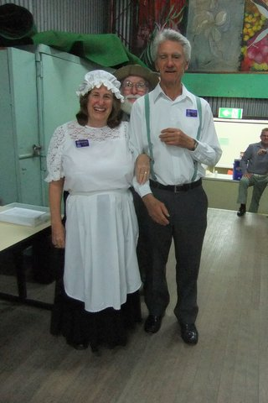



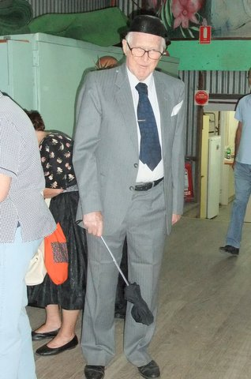



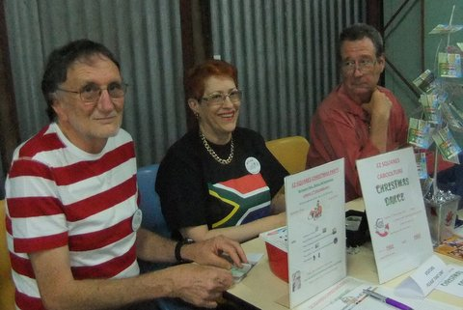

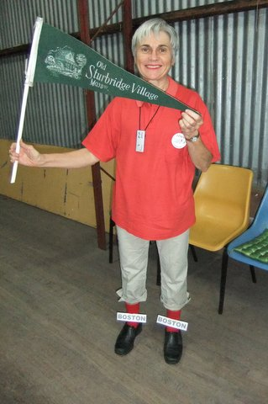

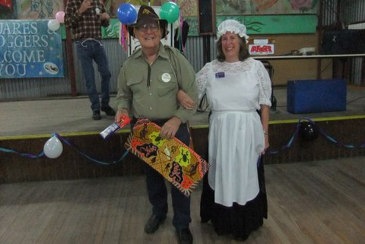

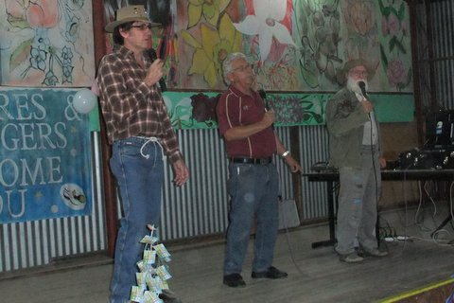

**What’s for Dinner Peg?**

**Bert feared his wife Peg wasn't hearing as well as she used to and he thought she might need a hearing aid.  
  
Not quite sure how to approach her, he called the family Doctor to discuss the problem.**  
**The Doctor told him there is a simple informal test the husband could perform to give the Doctor a better idea about her hearing loss.   
'Here's what you do,' said the Doctor, 'stand about 40 feet away from her, and in a normal conversational speaking tone see if she hears you. If not, go to 30 feet, then 20 feet, and so on until you get a response.'   
  
That evening, the wife is in the kitchen cooking dinner, and he was in the den. He says to himself, 'I'm about 40 feet away, let's see what happens.' Then in a normal tone he asks, 'Honey, what's for dinner?'   
  
No response.   
  
So the husband moves closer to the kitchen, about 30 feet from his wife and repeats, 'Peg, what's for dinner?'   
  
Still no response.   
  
Next he moves into the dining room where he is about 20 feet from his Wife and asks, 'Honey, what's for dinner?'   
  
Again he gets no response.   
  
So, he walks up to the kitchen door, about 10 feet away. 'Honey, what's for dinner?'**  
**Again there is no response.**  
**So he walks right up behind her. 'Peg, what's for dinner?'   
  
'For crying out loud, Bert, for the FIFTH time, CHICKEN!'**

Well Folks! This has brought our final newsletter to a close. It has been a pleasure compiling the newsletter for you throughout this past year, and I certainly look forward to what awaits us in the coming year.

I have one more person to thank before signing off, that is Rowena McCulloch, for her assistance, dedication and perseverance in fine tuning the newsletter that comes to you. Thank you Rowena!

Have a safe and enjoyable holiday break. Look forward to seeing you back dancing in the New Year.

Julie McCulloch

Newsletter Editor 2012

*E.Z. Squares would like to thank* ***Darren Grimwade MP*** *for the use of his facilities when printing our newsletters ☺*

