Volume 03 | Edition A03 | July 2014
This is your Elected Committee;
Geoff Linck-Parker - President
Ken McCulloch - V/President
John Twining – Secretary
Ted Newton - Treasurer
Gail Staniland – Assistant Treasurer
Julie McCulloch – Providore
Margaret Webber - Co-Providore
Julie McCulloch – Newsletter Editor
Maureen Miller – Clogging Rep
Glenn Wilson - Caller
Rod Dinte - Co-Caller

The members of this committee, are working hard to make our club the very best it can be, “Your HELP is needed!” - This is YOUR club! How would you like it to be run? Any ideas! Come and talk to a member of the committee.

PRESIDENT’S REPORT 2014
Welcome Ladies & Gentlemen to the Annual General Meeting of your club.
I believe that as a club we have functioned well over the past year and have been successful, in fact, by having an enthusiastic functioning committee. I thank each and every one of them for their efforts and it has been a pleasure to have a top team to work with for the benefit of this club.
The Square Dance callers and Clogging Cuers are to be commended for their efforts in keeping us all informed with the right movements to fulfill our respective dance routines. The variety and energy that they provide in their calls and genres of music really seems to lift the enthusiasm of those dancing.
During the year we visited Northside Promenaders and Lighthouse Squares, a great night was boosted by the large number of EZ Squares who travelled to Caloundra for the evening.
It was great to see most dancers dressing up for the theme of our party nights. These were again well attended and enjoyed by all who joined in the variety of different dances. We try to make these party nights free or low fee nights to encourage more dancers to visit us, and I feel that this is a successful move and also helps with fuel costs the way they are these days.
Thank you to all who donated items for the raffles for “Snakes Alive”.
Unfortunately the committee has, after considering all aspects of the viability of snakes alive not only the recent one but last years as well, decided to cancel snakes alive for 2015 but not entirely rule anything out for 2016 and beyond.
Our social functions during the year included an observation car rally in which we had many willing participants and a barefoot bowls morning preceded by pancakes on the deck at Pine Rivers Bowls Club and then later in the year went on to enjoy our Christmas dinner at Buchanan Park Burpengary with Santa AKA Rod, and followed this year by a mini Olympics day. These functions are a great way to socialise and get to know other club members. I really must thank all members who have placed their confidence in this committee and have rallied when help has been required.
As this committee vacates it’s office I must say it is very encouraging to see many new dancers/prospective members in attendance and hope that they can join present members to not only enjoy our regular Tuesday dance nights and Party nights but also any other social events that may come to pass this year as I am sure we have all enjoyed this past year.
In conclusion, I would like to say please remember that a functioning committee leads to a functioning successful club and I encourage you all to come forward with ways to aid your committee for the future success of the club for the enjoyment of all. I also would like all members to consider that when the next election of your committee comes around to nominate for a position because it is not good for the club for the same people to be there too long and new committee members can bring fresh ideas to allow the club to flourish even more.
Once again your committee thanks you for your support and we are sure you will support your new one with the same vigour and enthusiasm.
Geoff Linck-Parker
President.
E.Z. Squares Caboolture Dance Club.

THE SQUARE DANCER’S PLEDGE
"With all my ability I will do my best to help keep square dancing the enjoyable, wholesome, friendly and inspiring activity I know it to be.
This I pledge in the sincere desire that it may grow naturally and unexploited in the coming years and be available to all those who seek the opportunity for friendship, fun and harmony - through square dancing."

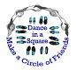
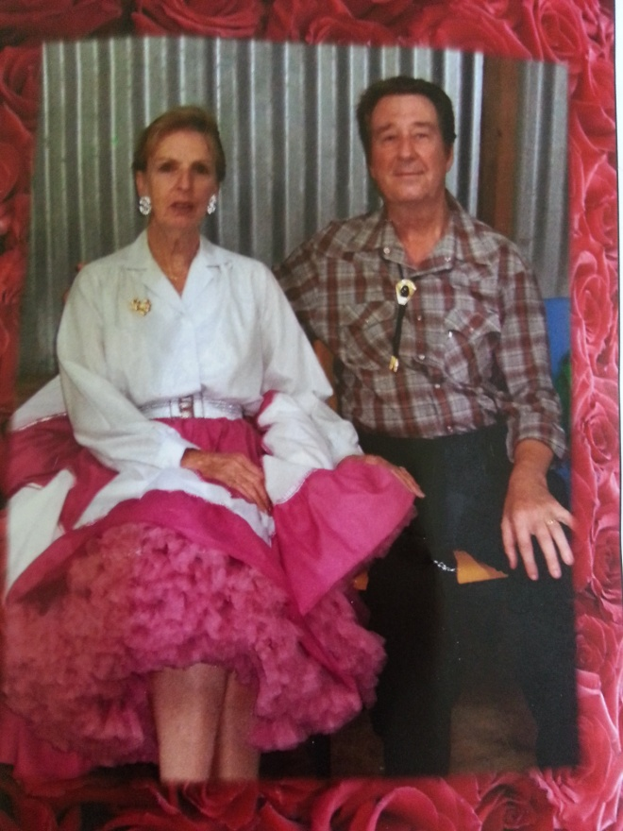
Kath
Kathleen Heather Bowden
16th June 1947 - 31st May 2014

It is with extreme sadness that we, the members of EZ Squares, acknowledge the passing of Kathy Bowden on the 31st May.
Kathy has been a member of EZ Squares for a number of years and took pride in always dressing in lovely square dancing outfits.
Kathy's funeral service was attended by many of her square dance friends some of which paid tribute by dancing to her favourite song "Grandfather's Clock"
On behalf of all members I would like to express our deepest sympathies and condolences to Bert and Family.
Kathy will be forever in our hearts and memories.

Geoff Linck-Parker
President EZ Squares
In case of an accident
We don’t ever plan on having an accident,
However! In the event of such an incident,
Please see a committee member to record this miss fortune so we can document and have on file.

Dates to Remember;
14th July - Club visit to Lighthouse Squares
29th July 2014 – Party Night “Pyjama Night”
30th Sept 2014 - Party Night “Silver and Gold”
30th Sept 2014 Visit from Lighthouse Squares
4th November 2014 - Celebrating Melbourne Cup
27th November 2014 – Graduation
2nd Dec 2014 – Last Dance
7th Dec 2014 – Club break up Christmas Luncheon Venue: Ken and Julies home.
3rd Feb 2015 - first night back main stream only
10th Feb - Beginners welcome
28th Feb E.Z Squares 25th Anniversary

Admission Fees per Dance Night
Child: $2.50
Adult: $5.00
Family: $12.50

Annual Membership Fees Due NOW
Child: $5.00
Adult: $10.00
Family: $25.00

If Annual Membership has NOT been paid, the Fee per Dance Night is:
Child: $3.50
Adult: $7.00
Family: $15.00

There will be a slight increase in entry fees as of 2015 due to rise in hall fees.

We need you!
Throughout the year, our Club has many invitations to do demonstrations at different venues. Can you help! Requirements are to be supplied with dress set attire “Please” See one of the committee members for further information.

Happy Birthday/Anniversary for all those special people that celebrate in the months of
April, May & June

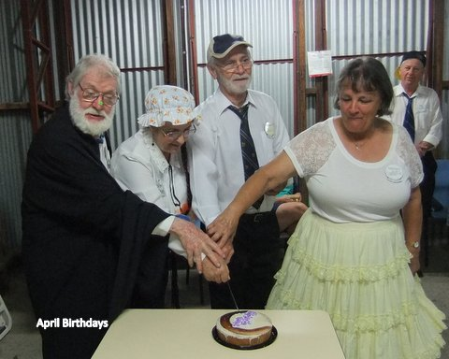
Celebrating Birthdays in the Month of April
Geoff, Mavis, Kerry, Rod and Noeleen

Celebrating Birthdays in the month of May
Laurie B, Ted, Trevor, Denice, Margaret B, Yvonne and Ivana

Celebrating Birthdays in the month of June
Sylvia, John T, Ken, Colin, Lorraine (Rusty) and Peter
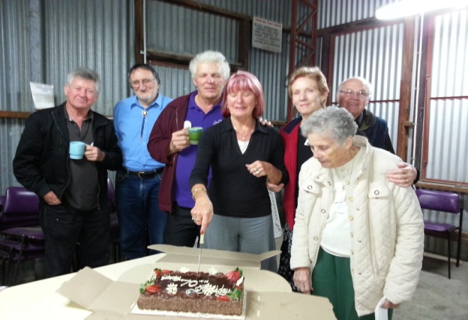
Happy 70th Birthday to Lorraine and Sylvia

Keep an EYE open for ALL - Safety signs! These are appearing around the E.Z. Squares Hall. Please take notice and obey the distance that is stated. This is for your own safety.
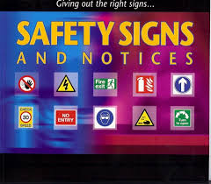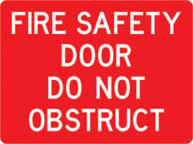
A reminder to all our dancers to please use the sanitizer on hands between dances, and before supper. The sanitizer bottles are provided at various locations around the hall. “ Keep those germs at bay!” NO ONE wants to be sick!!
Kitchen News (Supper)
I would like to take some time to extend my THANKS to Ken! For those that don’t know, Ken has been providore for the past 3.5 years. We all tend to take for granted that all the kitchen supplies just mysteriously appear, but behind the scenes, Ken worked very hard keeping supplies up. Thanks again Ken.

As your new providore, I would like to welcome all new and those not so new to the club.
In the Kitchen you will find Julie and Maggie, (and our un seen helpers) club member’s that offer a hand in whatever way they can, I thank these helpers. To make the supper the best it possibly can each and every week, our club members bring along a small offering which is greatly appreciated, this! Along with a cup of coffee or tea goes down well – not forgetting the good friendships which will develop through dance and a friendly chat over supper.

It is great to see so many of us washing our own cup, and helping clean up at the end of the night.

Again this year Birthdays will be celebrated the 4th Tuesday of every month.
I look forward to see you all at Supper.

Providore
Julie

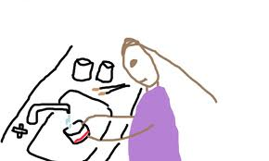
Please bring a plate to share! Don’t forget to wash your cup
Clogging News
During the month of May, we celebrated Stephen Hope's 50th Birthday with a social dance and party afterwards. Dancers from other clubs around Brisbane joined us to help celebrate this wonderful occasion. When it was mentioned that he would now be able to dance with the Seniors Dance Group he did not seem to be very happy with this comment!

Last month we also had a wonderful social day over with “Chugs” now located at their new address at Cooparoo. It is a great time to catch up with friends that share our passion for dancing.
A Big thanks to Frances Look for all her hard work to organize and plan the program for the day and also for Stephen and the other Cuer’s for their help. It was a great day.

June is a very quiet month for us. No clogging because the Caboolture Show is on, then this year the Clogging Convention is being held in Darwin in June. A lot of the cloggers have gone up early to do some sightseeing. No clogging for 4 weeks is a bit hard to take, but I'm sure that most of the EZ Cloggers have found their way to other clubs to keep those toes a- tapping.

Donna
(EZ Cloggers)

For Sale
2 ladies club shirt for sale (size 14 & 16)
$ 25.00 each
See Delwyn

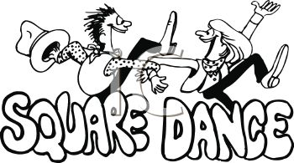
Back to School Party Night Recently
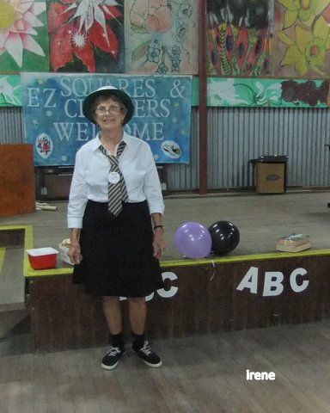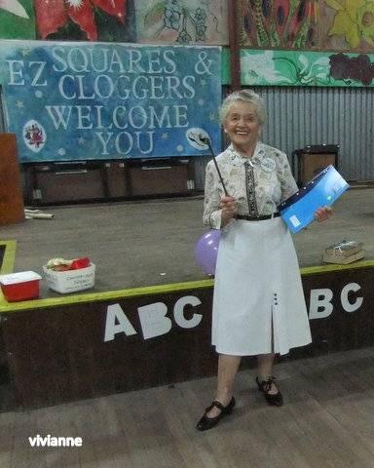

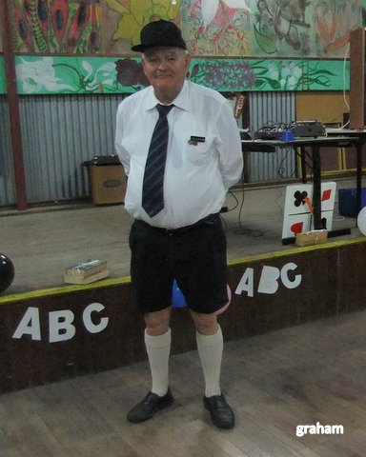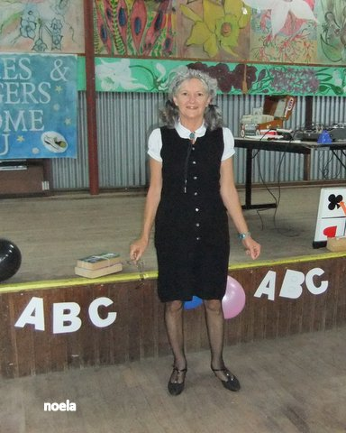

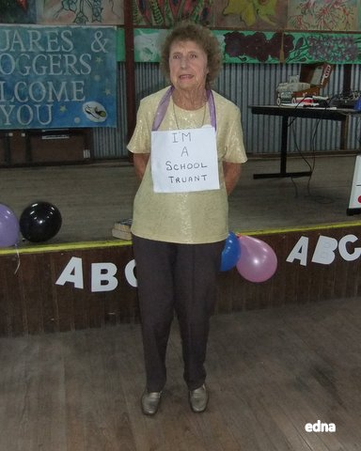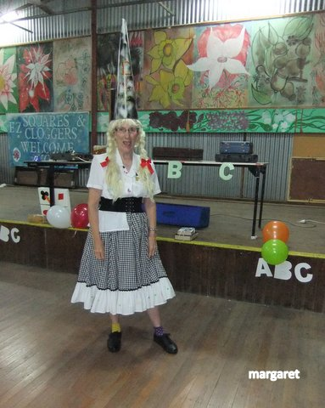

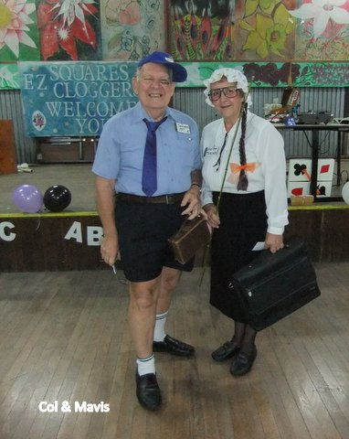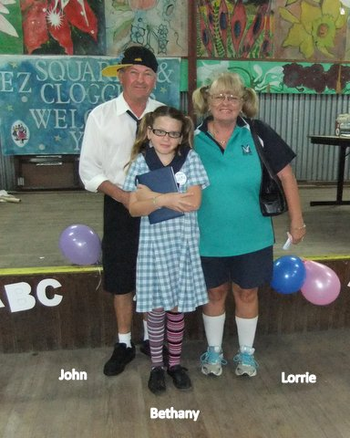

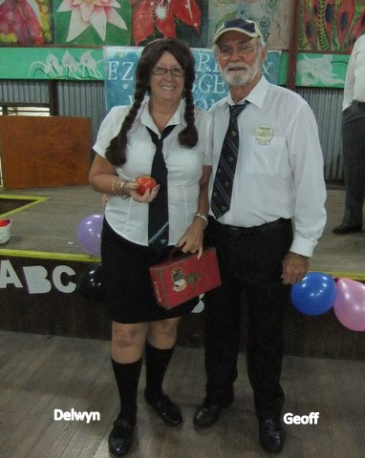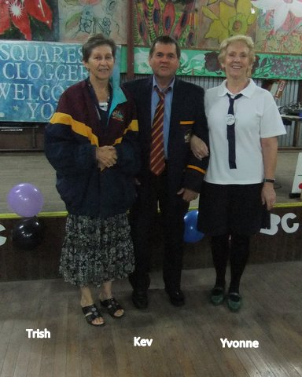

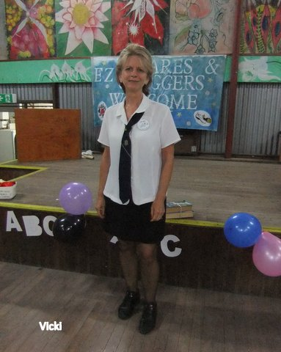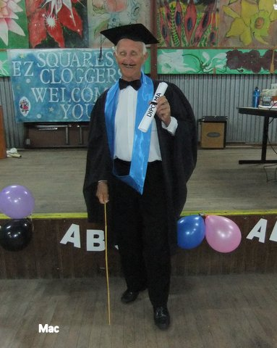
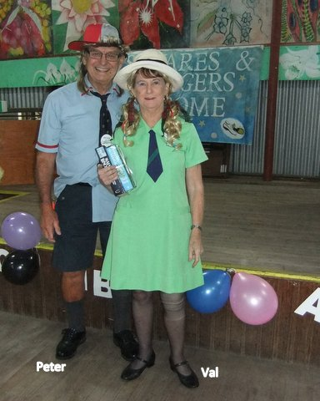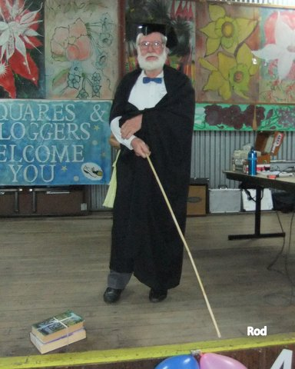

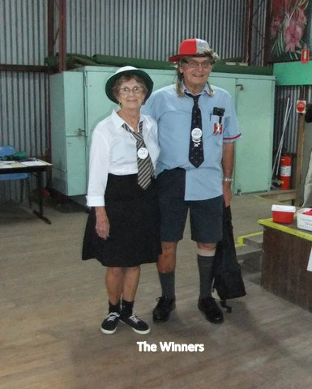

Progressive Luncheon
The weather was kind to us on the 14th of June 2014 as Christmas in July - come early in June
Starting point was Buchanan’s Park Burpangary. 1st course was served here! Choice of 3 soups-
Pea and Ham, Minestrone and Pumpkin served with French stick- yum.
From here directions where given with clues to the next destination were lunch was served, many thanks to Lorraine for hosting our clubs luncheon. Red Rooster was enjoyed by all.
Fun was had with the many games played.
Final destination –
Following the clues, a beautiful drive to Ken and Julie’s to finish the progressive luncheon with dessert.
Plum Pudding, Custard, Fruit Salad, Cream Tea and Coffee
Thank you to the committee for organizing this great day.

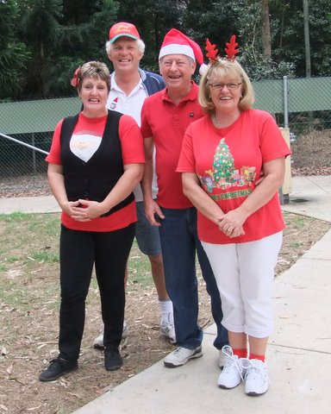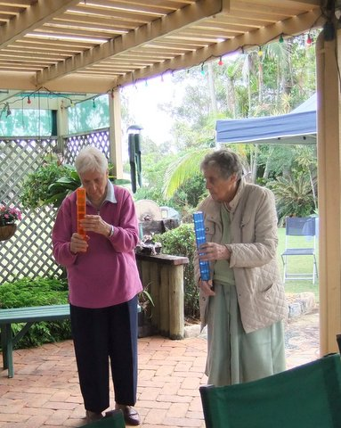

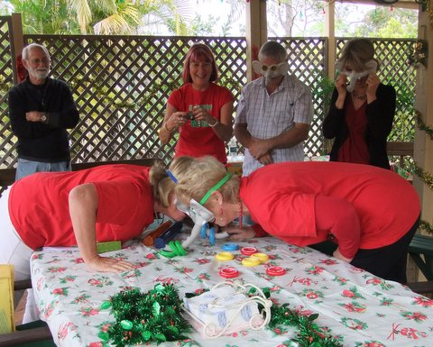

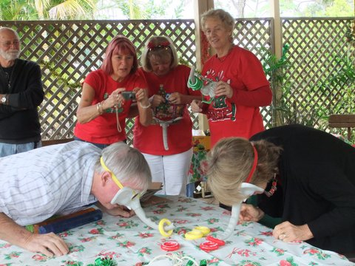
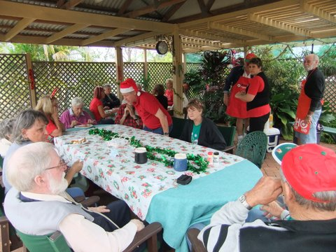

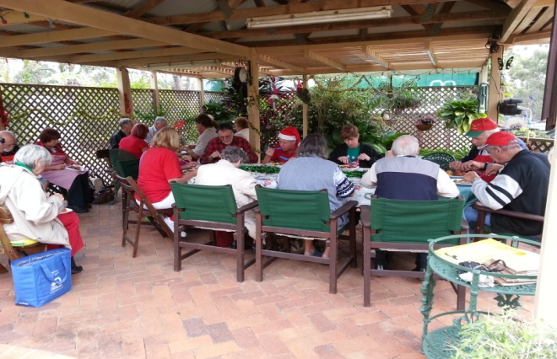

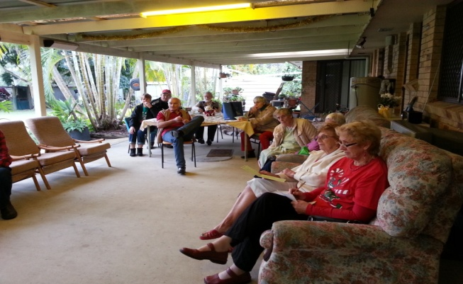

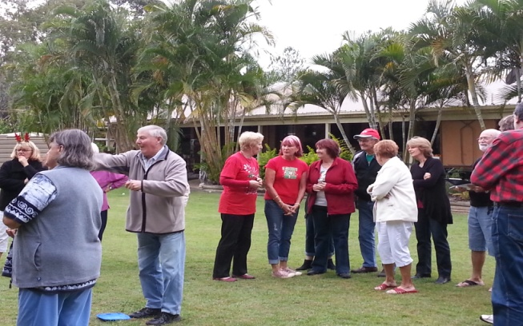

15th July please come in square dance attire. We will be doing demo for the organizers of the Twilight Fiesta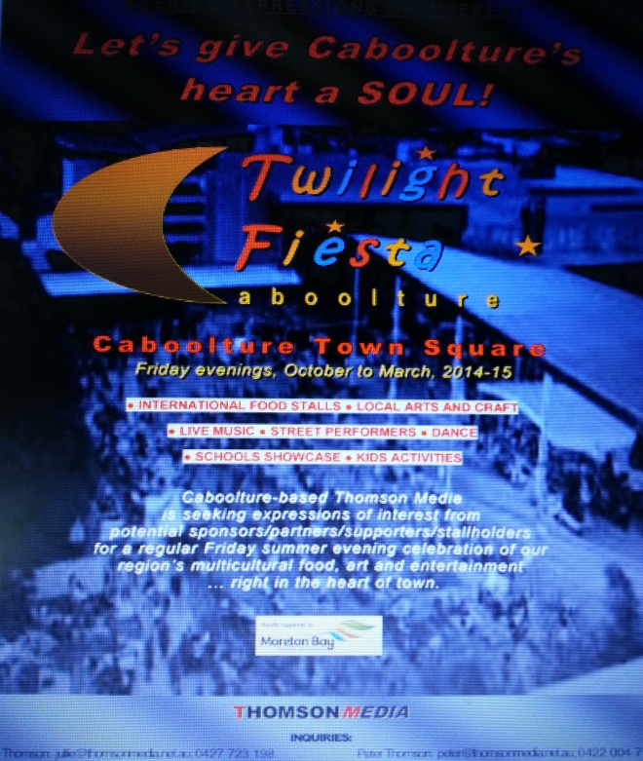

What’s for Dinner Peg?
Bert feared his wife Peg wasn't hearing as well as she used to and he thought she might need a hearing aid.
Not quite sure how to approach her, he called the family Doctor to discuss the problem.
The Doctor told him there is a simple informal test the husband could perform to give the Doctor a better idea about her hearing loss.
'Here's what you do,' said the Doctor, 'stand about 40 feet away from her, and in a normal conversational speaking tone see if she hears you. If not, go to 30 feet, then 20 feet, and so on until you get a response.'
That evening, the wife is in the kitchen cooking dinner, and he was in the den. He says to himself, 'I'm about 40 feet away, let's see what happens.' Then in a normal tone he asks, 'Honey, what's for dinner?'
No response.
So the husband moves closer to the kitchen, about 30 feet from his wife and repeats, 'Peg, what's for dinner?'
Still no response.
Next he moves into the dining room where he is about 20 feet from his Wife and asks, 'Honey, what's for dinner?'
Again he gets no response.
So, he walks up to the kitchen door, about 10 feet away. 'Honey, what's for dinner?'
Again there is no response.
So he walks right up behind her. 'Peg, what's for dinner?'
'For crying out loud, Bert, for the FIFTH time, CHICKEN!'
THE “DANCING” IN SQUARE DANCING
In many of the definitions, the calls are described by stating that the dancers are to “walk” to get to the specified destination. Grand Square and Promenade are two examples, and there are many more. For everyone’s information, the terms “walk” and “dance” are to be considered synonymous or the same.
The dance step should be a smooth, effortless gliding step in which the ball of the foot touches and slides across the surface of the floor before the heel is gently lowered to the floor. The length of stride should be fairly short with the movement coming mostly from the knees down. The dance step must be coordinated with the beat of the music. In general terms, short gliding steps on the balls of the feet make a comfortable dance step.
If done correctly, the dancing will make a shuffling, sandpaper-like sound on the floor. This is music to a caller’s ears.
Square dancers should dance smoothly and considerately, and not do anything that could cause another dancer to feel uncomfortable or confused. The light, sliding step is what should be used. A good square dancer’s feet should never be lifted from the floor. If the dancers “walk” to get from one point to another, it creates a “clomping” sound that is not only annoying, but is certainly not dancing. The heels of the dancer’s shoes or boots will create this sound. However, this same footwear can be used for dancing with great success.
When the music starts, good dancers are in a "ready" position and they are focused on the music and the caller. Let's describe this position.
A. Chin up!
By reminding yourself to keep your chin up every once in a while, you will give the perception that you are confident and happy to be dancing. When dancers learn something new or lack confidence in what they are doing, the chin tends to go straight down subconsciously. An additional benefit is that keeping your chin up enables you to literally "look up" at your fellow dancers as you dance, which will be understood as a sign of respect.
B. Shoulders Back! Dance Tall!
With any of these tips, thinking of the opposite provides an instant reason for why the tip looks good. In this case, the opposite would be hunched shoulders. Since square dancing involves the hands in a lot of movements, the shoulders back in a confident, relaxed position will make it easier to react to calls. Turn at the shoulders as well as the hips to make hands available for calls. Keep your nose over your toes and your body under control and in balance at all times. Good posture is generally a good recipe for success.
C. Arm and Hand Style.
When standing in the squared set, each couple should join hands in what is considered a "Couples Handhold". Normal couples have the man on the left side of the lady. Their adjacent hands (man’s right hand, lady’s left hand) should be joined with the man's hand palm up and the lady’s hand palm down. The elbow should be bent and the hands held just above the height of the elbow. The other hand and arm should be relaxed by their side. When dance action begins, both hands should be in "ready dance position", which means that each dancer is ready to use either hand as required to execute the calls.
An unpleasant feature of bad handholds is roughness, which means that a man (usually the man, but not always) applies awkward or painful forces to a lady. In most cases, he can't do it unless his hold is really a strong grip; and he can't take a strong grip except by clenching something between his fingers and opposed thumb. So, the way to prevent roughness is to teach the dancers, particularly the men, to keep their thumbs out of the action when they take handholds (most of the time).
Touching hands provides instant feedback in formation awareness. Good dancers touch hands as quickly as possible, providing an anchor for themselves and the others in the square. Dancers who simply do their part without touching hands negatively impact the square’s success and detract from the overall social experience. The best dancers are aware that hand-touching is more for the square than for the self.
D. Knees Flexed and on the Balls of Your Feet
Simply keeping your knees flexed and staying on the balls of your feet can completely change how you move and make your steps look smooth. Dancers who are flat footed and have their knees locked will usually move slower and be a step behind as they have to engage muscles to get out of that position before they can dance the next step.
E. Smile!
Remember: Dancing is an artistic expression using the body, including expressions of the face. This may not be a skill that separates dancers of different proficiency levels, but it definitely separates dancers with different attitudes! Whether you messed up, your partner, or if it was someone else, brush it off with a smile. It makes the dancing more fun.
Dance….Dance…..Dance….Dance….Dance ….
This goes without say; I’m sure by now, that our dances have noticed the dedication of many of our experienced ladies, stepping up to take on the roll of the Left hand dancer. With the passion of seeing the newer dances up and enjoying square dancing. The committee extends their gratitude and appreciation…..
We thank you for putting in the time to bring out the enjoyment, laughter, companionship and friend ship while having fun.

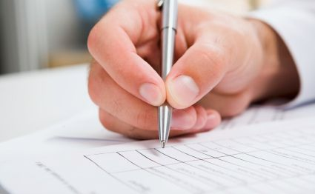 Rod and Delwyn would like it known, that they are qualified JP’s

Newsletter Editor
Julie

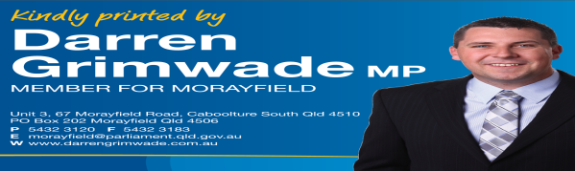E.Z. Squares would like to thank Darren Grimwade MP for the use of his facilities when printing our newsletters

