|  |  |  |
| --- | --- | --- |
| Volume 02 | Edition D23 | June 2013 |

**This is your committee;**

*Geoff Linck - Parker - President*

*Bert Bowden - V/President*

*Ted Newton - Treasurer*

*Gail Staniland – Assistant Treasurer*

*Delwyn Linck- Parker – Secretary*

*Ken McCulloch – Providore*

*Margie Webber - Co-Providore*

*Julie McCulloch – Newsletter Editor*

*Maureen Miller – Clogging Rep*

*Glenn Wilson - Caller*

*Rod Dinte - Co-Caller*

*The “committee” is working hard to make our club the very best it can be, “Please help us”, - by making suggestions, on how to make it even better! This is your club* how would you like it to be run?

***FROM THE PRESIDENT***

***I would like to personally thank all the members of the committee and the club who assisted in any way, with Snakes Alive.***

***An event like that cannot take place without the generous offer of your time, being setting up and decorating the hall, manning the door, making sandwiches and setting up supper, clearing up after supper and finally cleaning the hall. EZ Squares club should be proud that it has many members who so readily put up their hands when needed, often sacrificing the time they could be on the floor dancing.***

***Geoff Linck-Parker***

Great dancing was had by all that joined in the fun of our annual Snakes Alive weekend. This was a fantastic weekend with many fun sessions put before us and some moves that both baffled and excited eager dancers. Our MC for the dancing event was none other than Mr. David Cox.

With dances ranging from: Round Dancing, to Plus, Fun Squares and even Learners brackets.

Great to see all the lovely outfits that came on the Friday night and the Saturday sessions.

Here’s hoping that all that joined the fantastic weekend took away with them a very enjoyable time, and nursed back their feet to good health.

Photo’s to follow.

Well done to the committee for organizing and hosting this great event.

Bring on Snakes Alive 2014

EZ SQUARES CABOOLTURE

On Saturday afternoon 18th May, on our “Snakes Alive Weekend” thinking that live snakes were on display after reading our “SNAKES ALIVE” sign at the front of the hall one lady asked where the live snakes were. Sadly we had to explain that we had no snakes to show her, after explaining that it was a square dance event we couldn’t persuade her to stay and watch the dancing which was a pity as the weekend was a lot of fun and laughter.

Our feature caller David Cox kept the dancers on their toes with his exuberant calling which really enthused the dancers to listen and dance the weekend away dancing many different formations to varied genres of music.

Friday and Saturday nights started with Round dancing sessions called by Phyllis Stewart followed by square dancing for the remainder of each night. Saturday morning arrived with David back again to call mainstream with a difference followed after lunch by a session of plus.

The afternoon saw the basic/beginners show how well they have progressed during the year. They danced to our own Glenn Wilson calling alongside David Cox which was to the delight of the newer dancers having the opportunity to dance to a world renowned caller during their first year of dancing.

We welcomed our visitors from clubs far and wide who we thank for their attendance and we are sure they enjoyed the dancing as much as we at EZ Squares Caboolture enjoyed having them dance with us.

Delwyn Linck-Parker

***Article taken from Banana Benders Bugle***

THE “DANCING” IN SQUARE DANCING

In many of the definitions, the calls are described by stating that the dancers are to “walk” to get to the specified destination. Grand Square and Promenade are two examples, and there are many more. For everyone’s information, the terms “walk” and “dance” are to be considered synonymous or the same.

The dance step should be a smooth, effortless gliding step in which the ball of the foot touches and slides across the surface of the floor before the heel is gently lowered to the floor. The length of stride should be fairly short with the movement coming mostly from the knees down. The dance step must be coordinated with the beat of the music. In general terms, short gliding steps on the balls of the feet make a comfortable dance step.

If done correctly, the dancing will make a shuffling, sandpaper-like sound on the floor. This is music to a caller’s ears.

Square dancers should dance smoothly and considerately, and not do anything that could cause another dancer to feel uncomfortable or confused. The light, sliding step is what should be used. A good square dancer’s feet should never be lifted from the floor. If the dancers “walk” to get from one point to another, it creates a “clomping” sound that is not only annoying, but is certainly not dancing. The heels of the dancer’s shoes or boots will create this sound. However, this same footwear can be used for dancing with great success.

When the music starts, good dancers are in a "ready" position and they are focused on the music and the caller. Let's describe this position.

A. Chin up!

By reminding yourself to keep your chin up every once in a while, you will give the perception that you are confident and happy to be dancing. When dancers learn something new or lack confidence in what they are doing, the chin tends to go straight down subconsciously. An additional benefit is that keeping your chin up enables you to literally "look up" at your fellow dancers as you dance, which will be understood as a sign of respect.

B. Shoulders Back! Dance Tall!

With any of these tips, thinking of the opposite provides an instant reason for why the tip looks good. In this case, the opposite would be hunched shoulders. Since square dancing involves the hands in a lot of movements, the shoulders back in a confident, relaxed position will make it easier to react to calls. Turn at the shoulders as well as the hips to make hands available for calls. Keep your nose over your toes and your body under control and in balance at all times. Good posture is generally a good recipe for success.

C. Arm and Hand Style.

When standing in the squared set, each couple should join hands in what is considered a "Couples Handhold". Normal couples have the man on the left side of the lady. Their adjacent hands (man’s right hand, lady’s left hand) should be joined with the man's hand palm up and the lady’s hand palm down. The elbow should be bent and the hands held just above the height of the elbow. The other hand and arm should be relaxed by their side. When dance action begins, both hands should be in "ready dance position", which means that each dancer is ready to use either hand as required to execute the calls.

An unpleasant feature of bad handholds is roughness, which means that a man (usually the man, but not always) applies awkward or painful forces to a lady. In most cases, he can't do it unless his hold is really a strong grip; and he can't take a strong grip except by clenching something between his fingers and opposed thumb. So, the way to prevent roughness is to teach the dancers, particularly the men, to keep their thumbs out of the action when they take handholds (most of the time).

Touching hands provides instant feedback in formation awareness. Good dancers touch hands as quickly as possible, providing an anchor for themselves and the others in the square. Dancers who simply do their part without touching hands negatively impact the square’s success and detract from the overall social experience. The best dancers are aware that hand-touching is more for the square than for the self.

D. Knees Flexed and on the Balls of Your Feet

Simply keeping your knees flexed and staying on the balls of your feet can completely change how you move and make your steps look smooth. Dancers who are flat footed and have their knees locked will usually move slower and be a step behind as they have to engage muscles to get out of that position before they can dance the next step.

E. Smile!

Remember: Dancing is an artistic expression using the body, including expressions of the face. This may not be a skill that separates dancers of different proficiency levels, but it definitely separates dancers with different attitudes! Whether you messed up, your partner, or if it was someone else, brush it off with a smile. It makes the dancing more fun.

DANCE, DANCE, DANCE!

Glenn Wilson

**YOUR PARTICIPATION IS NEEDED.**

**On behalf of the square dancers of our club the committee has accepted an invitation to put on a square dancing display at Kilcoy on Wednesday 21st August 2013 for their Seniors Day. We would like as many dancers as possible to participate on the day to help make their event a success.**

**As Kilcoy is quite a distance away we hope to arrange car pooling. I have spoken to the organizers and they have said that there is different entertainment on all day. I know that this event is during the week and some of us work but let’s all who can, try to attend and not leave it to a few. As you can read by the attached extract from the letter I received the theme is country & western with a prize for the best dressed.**

*We are very pleased to have the EZ Squares Caboolture Dance Club available for our Seniors Day event on the 21st August 2013. The Country and Western Extravaganza commences at 10.00am and winds up at 2.00pm at the Kilcoy Memorial hall. We will be providing a free morning tea (tea and cookies) and a free lunch (roast beef and gravy roll) for all in attendance. If your group can provide a demonstration for about 20- 30 minutes it would be great, we have a band from Homestead Country performing for the day. I will need to know numbers for catering purposes, the week before the event. Wear your country gear prizes for best dressed Look forward to meeting you all.*

*Kind Regards*

***If you would like to participate please let Geoff or myself know by the end of July so we can start arranging transport. Also if you are willing to drive and take other members let us know.***

***Many thanks in anticipation of your attendance***

***Delwyn Linck-Parker***

***Red, White and Blue: Party night***

Another fantastic party night was had, with great company, fantastic dancing even good food. So good to see there is so much excitement in the way we dress up for this occasion. A great deal of thought had gone into some of the outfits. Photos to follow:-

Gentle Reminder: Please Dancers! Whilst dancing, be mindful that we have dancers that may have some sort of arthritic or arm/shoulder, hand or hip problems that may be aggravated whilst dancing and cause some suffering afterwards. Please look after each other especially now that the weather has a slight chill to the air.

**Dates to Remember;**

**24thAug-** Sunshine State Round Up venue: Bribie Island

**27th-29th Sept-33rd** Qld State Square Dance Convention venue: Ferny Hills

**26th Aug -** Visit to Light house Squares

**29th Oct -** Party night theme “Nautical but Nice”

**29th Oct -** Light House Squares visit to our club

**19th Nov -** Graduation and Club Birthday

**26th Nov** - AGM

**3rd Dec -** Xmas Dance break up

**CLOGGING NEWS**

There is no Clogging for the first 2 weeks of June , due to the Caboolture Show. We will be back on the floor 16th June.

We are looking at the nominations for the Queensland Showcase for 2013. Which dance will be the most fun? If you are going to the Convention, get your enrolment in now.

Don't forget Aussie Clog, July 26, 27, 28 th. this is part of the Clogging culture. A weekend of being with friends, a weekend of learning new steps and new dances and plenty of Clogging and eating and entertainment. Don't miss it!

Maureen

Clogging Representative.

***Happy Birthday/Anniversary for all those special people that celebrate in the months of April, June, July & August ☺***

*Kitchen News.*

On behalf of our “Providore’s” who would like to extend their appreciation of thanks to everyone that brings a little something for supper to share each and every week. It seems that dancing makes us hungry. : )

Birthday Wish goes out to Mr. Dinte alias Rod Happy 70th Birthday to you from all your square dance colleagues. Hip Hip Hooray!

*A reminder to all our dancers to please use the sanitizer on hands between dances, and before supper. The sanitizer bottles are provided at various locations around the hall. “ Keep those germs at bay!” NO ONE wants to be sick!!*

Maggie:

Maggie has successfully had her operation and can’t wait to get back on the floor, so watch out all.

I have been asked to convoy a huge ***THANK YOU*** , To Maggie for her kind gesture and loaning of her beautiful square dance out fits which allowed the newer members of E.Z Squares to feel a big part of Snakes Alive.

Thank You “MAGGIE” ☺

ALL EZ SQUARE CLUB MEMBERS ARE INVITED TO A BREAKFAST

OF PANCAKES ON THE DECK FOLLOWED BY A GAME OF BAREFOOT BOWLS

AT PINE RIVERS BOWLS CLUB CNR SPARKS AND FRANCIS RD

BRAY PARK

WHEN……………Saturday 13th July 2013

BREAKFAST AT 9 am FOLLOWED BY BOWLS AT 10am

COST TO MEMBERS………………ADULTS $10.00

CHILDREN (under 12) $5.00

NON MEMBERS……….ADULTS $20.00

CHILDREN (under 12) $10.00

NUMBER’S AND MONEY MUST BE IN BY 2nd JULY 2013: - See Ted and Gail

*Please! While our Officials are talking- show some consideration and listen to what they are saying.*

*Check the notice board for: Information on upcoming events for our club and also other clubs’ events.*

*Party Nights are Theme Nights, if you choose not to come in costume, please if possible wear square dance attire as other clubs may join us for these special occasions. : )*

Weekly Admission once annual membership is paid:

Child: $2.50

Adult: $5.00

Family: $12.50

Annual Membership Fees Due NOW for 2013

Child: $5.00

Adult: $10.00

Family: $25.00

If annual membership has not been paid:

Child: $3.50

Adult: $7.00

Family: $15.00

**WISE CRACKS**

**A mate of mine recently admitted to being addicted to brake fluid. When I quizzed him on it he reckoned he could stop any time....  
  
I went to the cemetery yesterday to lay some flowers on a grave. As I was standing there I noticed 4 grave diggers walking about with a coffin , 3 hours later and they're still walking about with it. I thought to myself , they've lost the plot!!**

**My daughter asked me for a pet spider for her birthday, so I went to our local pet shop and they were $70!!! Blow this , I thought , I can get one cheaper off the web**

**I was driving this morning when I saw an RACQ van parked. The driver was sobbing uncontrollably and looked very miserable. I thought to myself that guy's heading for a breakdown.**

**My neighbour knocked on my door at 2:30am this morning , can you believe that , 2:30am?! Luckily for him I was still up playing my Bagpipes.   
  
Paddy says "Mick , I'm thinking of buying a Labrador ."Blow that" says Mick "have you seen how many of their owners go blind?"**

**PUNS CAN BE FUN**

**I stayed up all night to see where the sun went. Then it dawned on me.  
  
This girl said she recognized me from the vegetarian club, but I'd never met herbivore.  
  
I'm reading a book about anti-gravity. I just can't put it down.  
  
I did a theatrical performance about puns. It was a play on words.  
  
They told me I had type-A blood, but it was a Type-O.**

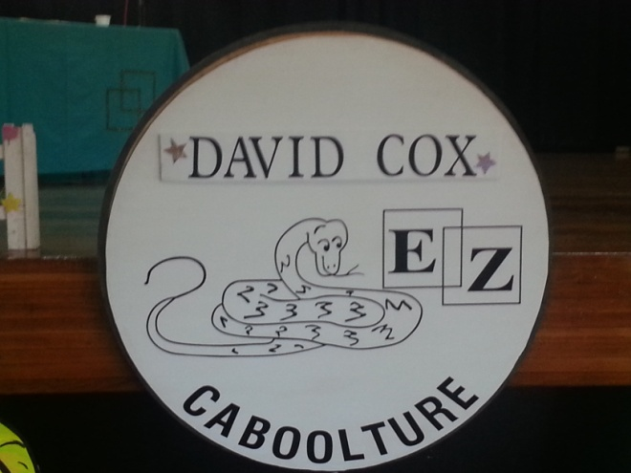

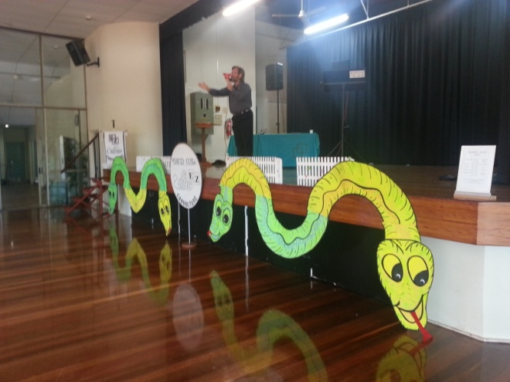

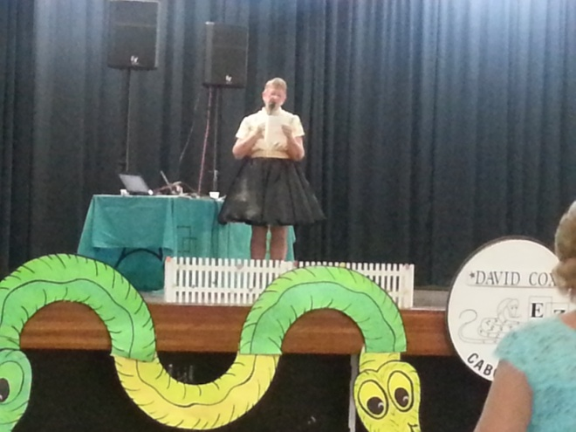

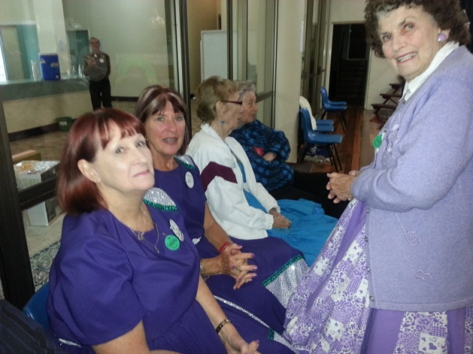

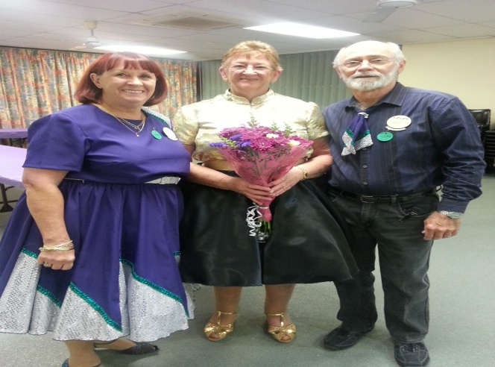

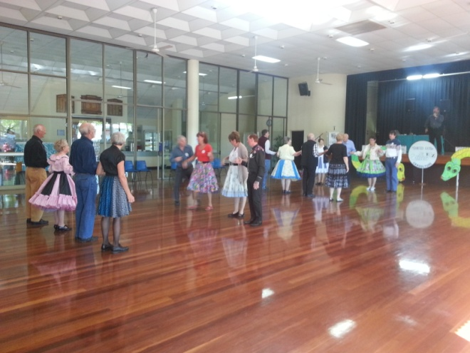

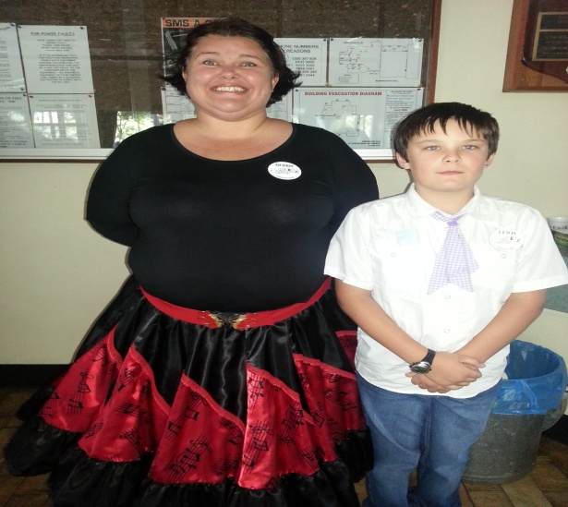

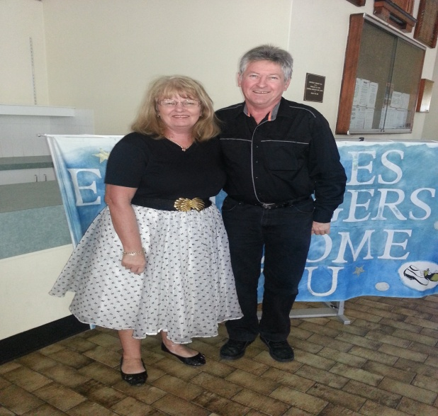



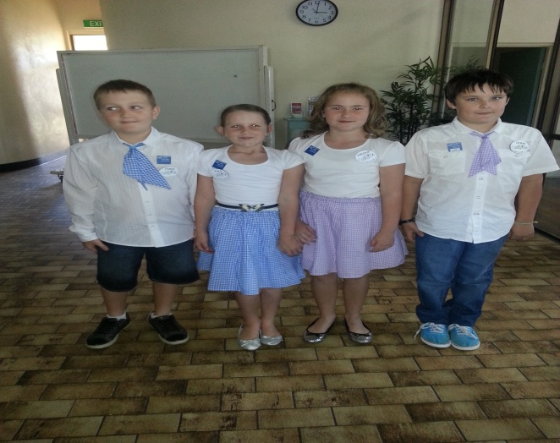

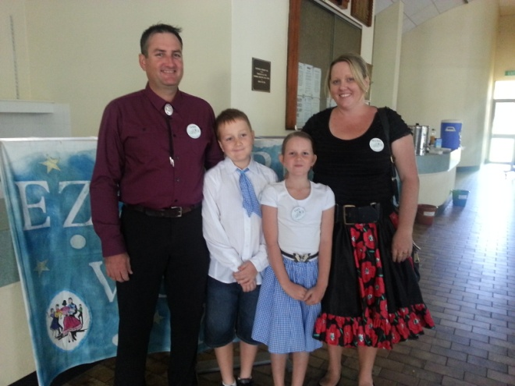

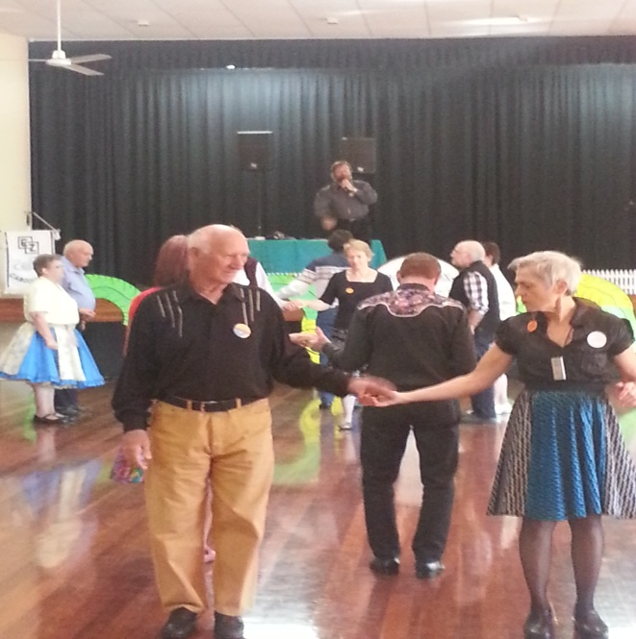

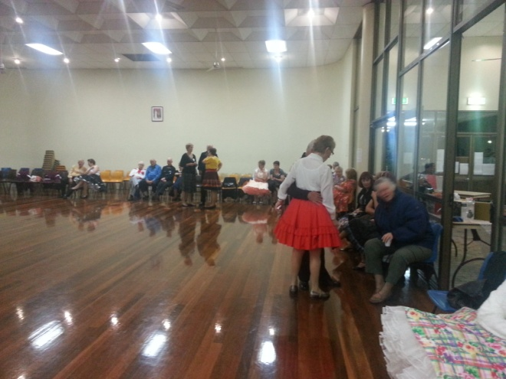

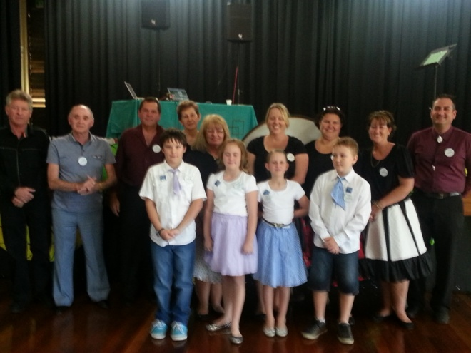



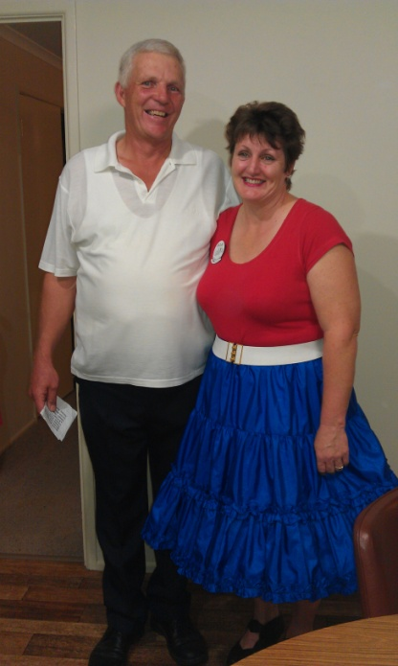

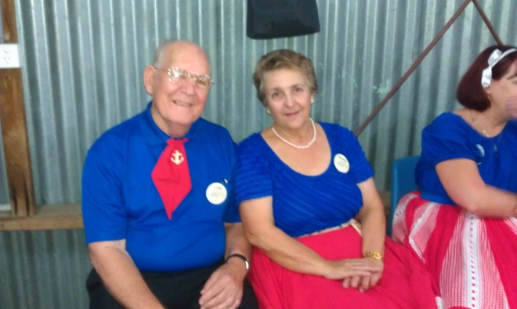



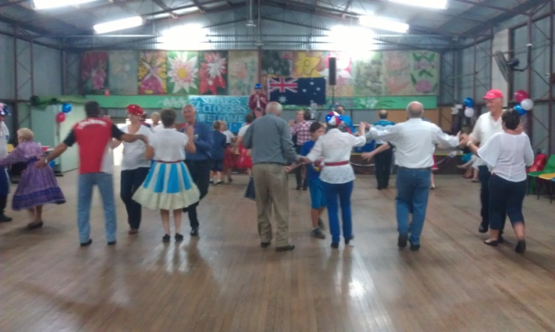

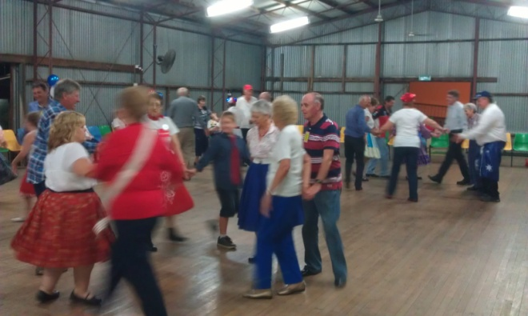

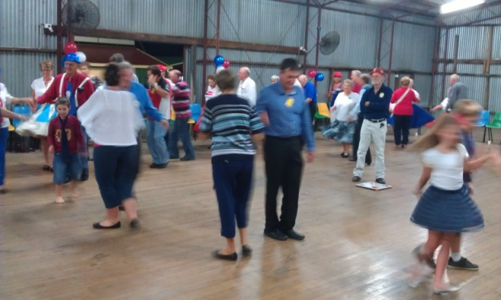

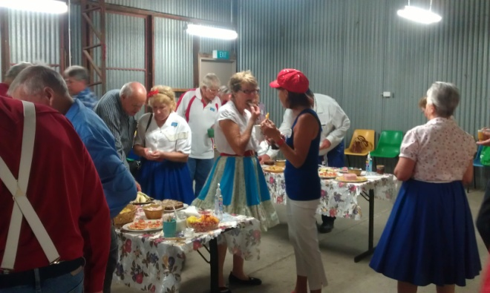

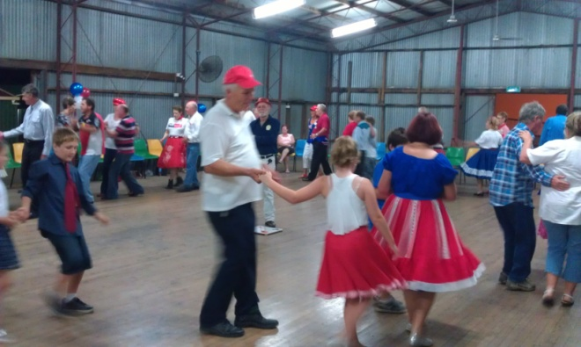

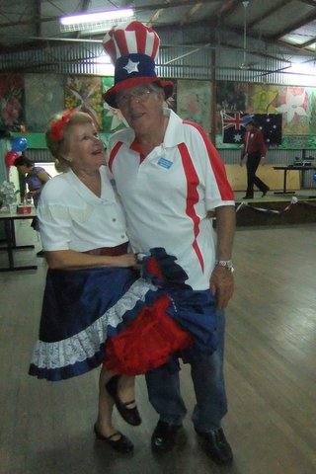

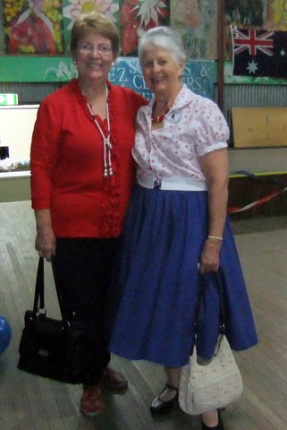

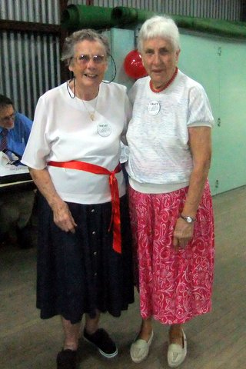

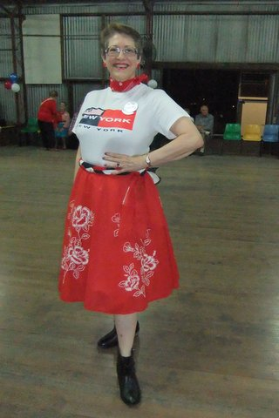

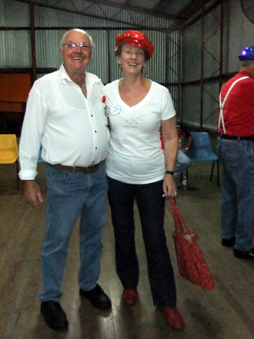

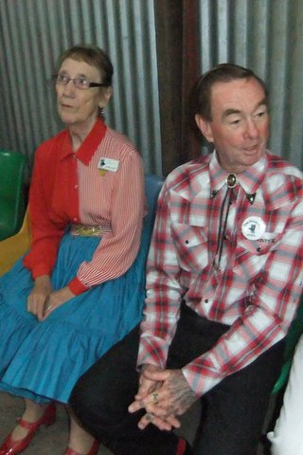

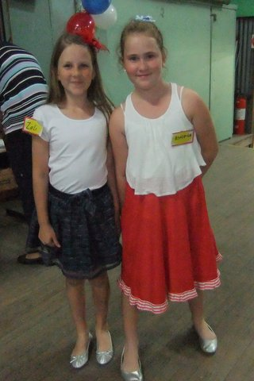

*E.Z. Squares would like to thank* ***Darren Grimwade MP*** *for the use of his facilities when printing our newsletters ☺*

