|  |  |  |
| --- | --- | --- |
| Volume 01 | Edition D21 | February 2013 |

**This is your committee;**

*Geoff Link - Parker - President*

*Maureen Miller - V/President/Clogging Rep*

*Bert Bowden - Treasurer*

*Arthur Trumper – Assistant Treasurer*

*Delwyn Link- Parker – Secretary*

*Ken McCulloch – Providore*

*Margie Webber - Co-Providore*

*Kaye Clouston - Publicity/Liaison Officer*

*Julie McCulloch – Newsletter Editor*

*Glenn Wilson - Caller*

*Rod Dinte - Co-Caller*

*The committee are working hard to make our club the very best it can be, “Please help us”, - by making suggestions, on any matter.*

Welcome back to another fun filled year of Square Dancing. This year we hope to welcome many new dances to our club, good dancing, and good friendship will develop along with some laughter as we are all put through our paces by our incredible callers. Have fun, smile lots as that is what it is all about! ☺

We have now witnessed, a number of very keen dances that are trying out with the first 3 free nights of February, E.Z Squares welcome to all new dances.

**FROM YOUR PRESIDENT**

Welcome experienced and new or intending dancers to the 2013 year of square dancing.

On behalf of the committee we are looking forward to another fun and successful year for the club.

I wish to remind you that the annual general meeting is to be held on 12th March, immediately following an early finish of dancing. During this meeting your new committee elections will be held for which nominations are to be submitted by 26th February. Nomination forms are available now at the entry desk.

Remember club membership is now due and this is your entitlement to vote for your committee for your club at the AGM.

We are looking forward to seeing as many as possible attend our first social get together for the year on 10th March at

Bullocky Rest for a BYO picnic /BBQ.

***Just a reminder:***

***This would be the best time to bring to the attention of all club members that nominations will happen where all positions for the committee are up for grabs, please consider taking on the privilege of helping to run a well organized club. If considering please talk to a member of the current committee who will point you in the right direction.***

*The club would like to say once again, WELL DONE! To our 7 graduating students for 2012! We look forward to another great year of dancing with all of you.*

**For Sale- 3 new club shirts**

**Ladies size 12 & 16**

**Men’s size L**

**Selling for $23.00 each**

**If interested see Delwyn**

**Cooee from the Caller**

Welcome to 2013,

It’s the start of another Square dance year.

To all the existing club members, welcome back, I hope you’ve had a good break.

I hope Santa was good to you and that you haven’t broken too many New Year’s resolutions yet.

To our new learners (and I hope there’s a lot of you), welcome to E.Z. Squares dance club.

I really hope you enjoy what we do here and decide to stay and have fun with us.

The caller and 8 dancers form a team, and work together to produce the desired outcomes.

Just like any sports team, there can only be one coach and maybe an assistant.

In our Club we have the caller and a co-caller and their job is to direct the way the dance is done. The dancers listen and react and perform the dance as called. To do that requires a little concentration and to be able to remember to moves that you have been taught.

The more experienced dancers are able to help the less experienced by being in the right place at the right time. Newer dancers in particular, find it difficult to concentrate if the caller is calling and other dancers in the square are talking as well.

We have a really friendly group here at Caboolture and we all want to make the night as enjoyable as possible. If there is something you don’t understand, ask one of your fellow dancers or the caller after the bracket is over and we can explain it or sometimes walk through the movement or sequence that is giving a little trouble.

Because square dancing involves people in close personal contact, etiquette and hygiene are very important to us all. The club provides hand cleaner and etiquette is taught as part of the dance.

You might see some of our dancers or callers wearing square dance dress. This is not expected of newer dancers and is not a requirement to dance at our club. Some larger square dance functions do require square dance dress as part of entry conditions.

There is sometimes a shortage of Male or Left Hand dancers. If there a disproportionate number of Ladies, some may be required to learn the Left Hand dancer position. This is quite normal in Square Dancing (and also in Rock ’n’ Roll and Ball Room dancing).

These ladies doing the Left Hand dancer position are known as “Convertibles” and most clubs could not manage without them. They often wear a sash so that the caller knows that they are dancing that part.

In closing, take Square Dancing for what it is meant to be - A fun pastime, with friends that will keep your body fit and your mind healthy and you might learn a thing or 2.

Glenn Wilson

*Kitchen News*

On behalf of our providore’s we would like to extend our appreciation of thanks to everyone that brings a little something for supper to share each week.

Admission for all new learners for the month of February is free, after this time there will be a small fee per week of:

Child: $2.50

Adult: $5.00

Family: $12.50

Annual Membership Fees Due before AGM 12th March 2013

Child: $8.00

Adult: $10.00

Family: $25.00

If annual membership has not been paid:

Child: $3.50

Adult: $7.00

Family: $15.00

*Clogging News.*

*Welcome back to clogging for 2013.  
   
 Thankyou Stephen for coming back to teach us again this year and Thankyou to everyone for joining us again for another good year of clogging.  
Bring a friend, talk to people you know and invite them along to our classes. We hope to start a new beginners class 10 th February.  
   
STORM KING have you registered? March 8,9,10th. To be held at the YMCA  
CAMP WARRAWEE. if you have never been before, please come along, it is a great weekend of clogging with a great bunch of cloggers. Please ask someone for the details.  
   
Next on our program will be the Caboolture Urban Country Music Festival. May 3-6th.Mark it on your diaries, another good weekend of clogging and great for our club. Lets show the locals why we love clogging.  
   
Lots of great new dances on the list this year, if you need help obtaining cue sheets or music, come and me.  
   
Membership in the EZ Club is due now for 2013.  
   
Maureen Miller  
Clogging Representative  
Vice President.*

***Happy Birthday/Anniversary for all those special people that celebrate in the months of January, February and March ☺***

*With summer upon us , we would like to remind our dancers to please use the sanitizer on hands between dances, and before supper. The sanitizer bottles are provided at various locations around the hall. “ Keep those germs at bay!” NO ONE wants to be sick!!*

**Up and coming Event**

Nassa Shukayr will be visiting our club exclusively this year on Tuesday 23rd April 2013.

Nassa comes from San Antonia Texas USA

*Venue*: E.Z.Squares club

*Time*: 7.00pm plus dancing

7.30pm mainstream

10.00pm Supper

*Cost:*  $6.00 per adult

Child and family concessions available

*Theme*; Red, White and Blue

Come as an Aussie , A Brit or American – maybe your Dutch or a

Frenchman too, come wearing your

Red, White and Blue.

**Dates to Remember**

**5th Feb- First dance for 2013**

**12th Feb - Beginners welcome**

**10th March- 1st club get together BYO picnic lunch and drink at Bullocky Rest area**

**12th March- AGM**

**23rd April - Nasser Shukayr’s Caller visit from U.S.A**

**17th/18th May - Snakes Alive Burpengary**

**30th June- Party Night theme to be advised**

**26th August -visit to Light house Squares**

**29th October- Party Night theme to be advised**

**29th October- Light House Squares visit to our club**

**26th November- Graduation and Club Birthday**

**3rd December- Xmas Dance break up**

**Looking back**

*Xmas in the Park*

2nd of December 2012 annual end of year break up.

What a perfect day – weather spectacular, friendly faces – great conversation and then there was SANTA! Every year something different, I can’t wait till next Xmas – Oh to be Naughty or Nice that is the question? What about Santa’s helper? What can I say? “Spectacular”

Food: Ken, Geoff, Delwyn, Maureen and Julie on the serving, great job done – down to a fine art.

To all that help set up and pack things away Thank you, more hands light work as they say.

We hope everyone had a wonderful day. Thank you to the Committee for doing such a great job both on this occasion and throughout the whole of last year.

*E.Z.Squares Xmas Break up:*

4th December 2012 marked one of the hottest days on record, reaching a staggering 40 degrees! Dancing on the night sure was challenging, but many clubs decided to beat the heat and joined E.Z Squares for their last dance of 2012. Five squares got up to dance and enjoyed the many callers, both amateur and professional. Thank you to everyone who helped to set up the hall and those that prepared the props, it was very much appreciated!

E.Z. Squares would like to thank the providore’s for their hard work and dedication when providing supper both for this break up and each week at the club.

*Northside Promenaders Xmas Break up*

6th of December 2012 was the night of Glenn’s final dance for the year and Xmas break up for Northside Promenaders. What a beautifully decorated hall, a credit to those involved, great dancing, great calls and a very enjoyable evening, topped off with a scrumptious supper. Many thanks to all involved.

*Minimbah Mini Square Dancers Break Up:*

E.Z.Squares Caboolture takes pride in Sponsoring Minimbah Mini Squares in learning the art of Square Dancing.

These 8-11 year olds have embraced Mr. Mac alias “Ken” to teach them this most foreign way of dance.

For many they have spent the last 12months going through the motions of moves and

steps- spending no longer then 20 minutes a week, this being done in both Kens and the students own time at lunch break.

Ken enjoys seeing the students laugh and enjoy dance he says, “You know, they must enjoy square dancing, as they keep coming back week after week!”

The break up was organized for the evening of the 7th of December so the students and parents alike could come and enjoy square dancing. The evening ran from 6.30pm to 8.30pm followed by a supper provided by E.Z. Squares.

Ken ran the evening with some assistance from E.Z Squares callers, Glenn Wilson and Rod Dinte.

Ken would like to thank all those E.Z Square dancers that came to lend a hand, we had 2 squares of our own – a total of 6 squares on the floor all laughing and enjoying themselves.

Ken you did E.Z Squares proud- who would have thought that the youngest and newest members of Minimbah Mini Squares would be dancing so well after such a short time.

Talking to teacher’s parents and children what wonderful comments it’s not hard to see that they enjoyed themselves immensely.

So Mr. Mac! When is the next Minimbah Mini Squares dance event?

*To E.Z. Squares,*

*On Friday the 7th December, I attended the Minimbah Mini Squares Break up with my daughter Ashleigh.*

*I was amazed at the attendance on the night and how much the kids have learnt in such a short time. It was great to see the children and their families participating and enjoying this style of dance.*

*There was plenty of smiles and laughter throughout the evening. Everyone commented on what a great night was had by all.*

*The catering on the night was done by E.Z. Squares and what a magnificent job they did.*

*On behalf of myself and I’m sure everybody else, I would really like to THANK E.Z. Squares for such an enjoyable evening and can’t wait until our next function.*

*Thank you,*

*Sue Pooley*

*Minimbah State School*

*P & C Secretary*

***SNAKES ALIVE -2013***

***Caller for the weekend is Mr. David Cox from NSW.***

***The committee is looking forward to all the hard work ahead of us to host Snakes Alive on the 17th/18th May 2013.***

***This will be held in Burpengary Hall on Station Road, Burpengary.***

***Admission : $25.00 weekend ticket***

***Session Tickets: $10.00 evening ticket***

***Daily ticket: $ 8.00***

***Program:***

***Friday night***

***7.00 - 7.30pm E.Z. Rounds***

***7.30 – 10.30pm Mainstream***

***Saturday Day***

***10.00 – 12.00pm mainstream with a difference***

***1.00– 3.00pm Plus with Pleasure***

***3.00 – 6.00pm Clogging***

***7.00 – 7.30pm Ezi Rounds***

***7.30 – 11.00pm Gala Squares***

***Each year we call upon the members of our club for kind donations for raffles. Once again I would like to ask for this kind gesture to take place. If you are able to donate it would be much appreciated, please see one of our committee members***

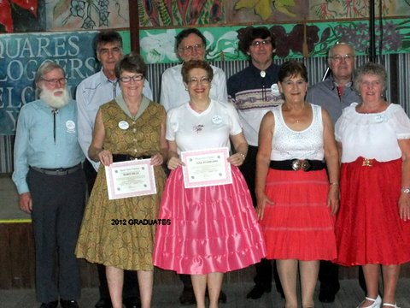





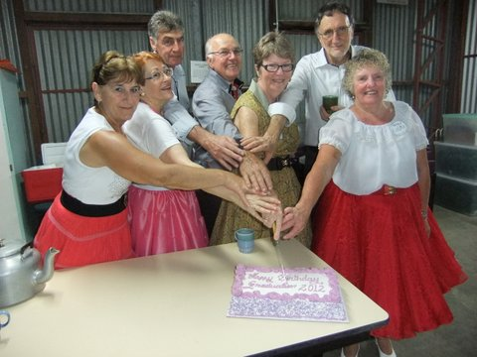

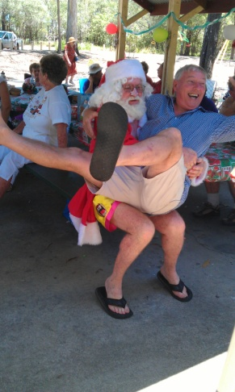



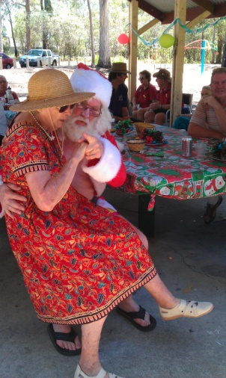

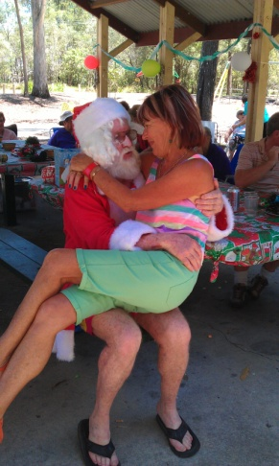

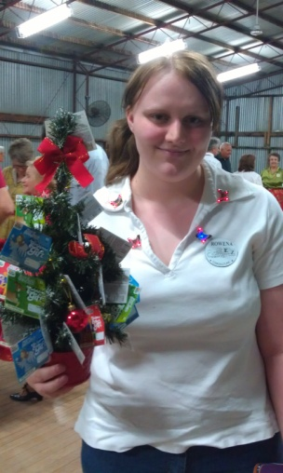

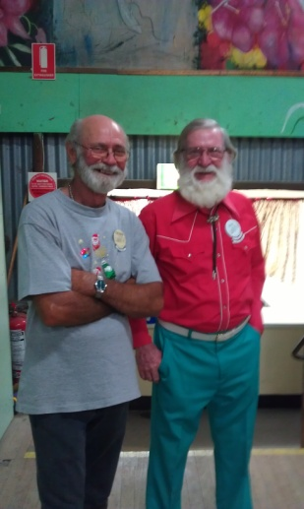

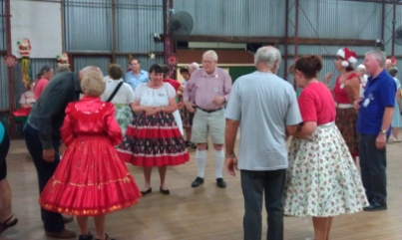

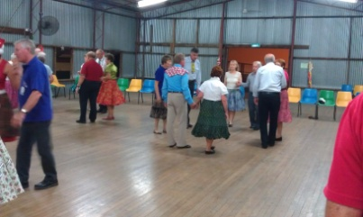

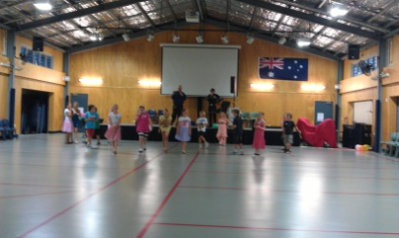

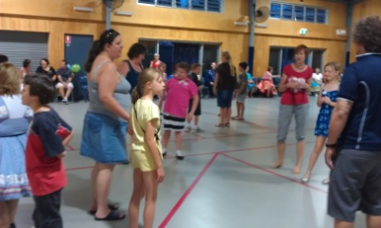

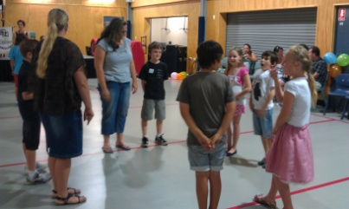

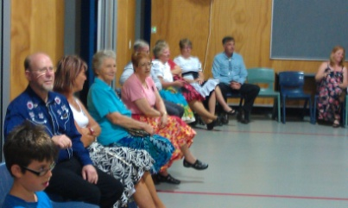

Julie

Newsletter Editor

*E.Z. Squares would like to thank* ***Darren Grimwade MP*** *for the use of his facilities when printing our newsletters ☺*

